# 

# Appendix 1: Diagnosis in the individual areas of PEP2030

Warsaw, 2019



Table of contents

Appendix 1: Diagnosis in the individual areas of PEP2030 1

1. Introduction 4

2. Water resources, including water quality 4

Introduction 4

Water resources in Poland 7

State of river waters (including dam reservoirs) 10

State of the lakes 13

Trends of changes in concentrations of selected pollutants measured in the sediments of rivers and lakes of Poland 19

Transitional and coastal waters 20

Baltic Sea 23

Groundwaters 26

Summary 28

3. Air 32

Particulate matter 37

Ozone 45

4. Land surface, including soils 49

5. Environmental hazards 55

Biosafety, including genetically modified organisms 55

Acoustic climate 56

Electromagnetic fields 62

Ionising radiation 64

6. Natural resources 68

Water and marsh ecosystems 79

Biodiversity in agricultural areas 80

Forests 83

Landscape 86

Summary 88

7. Waste 89

8. Geological resources 96

9. Environmental technologies 99

Eco-innovations 99

Eco-management and audit scheme (EMAS) 108

10. Climate change – mitigation and adaptation measures 109

Mitigation measures 110

Climate change and its effects 115

Adaptation measures 126

11. Environmental education and access to information about the environment 127

Sustainable consumption patterns and environmental education 127

Access to environmental information 135

12. Instruments of the national environmental policy 137

Entities involved in environmental management 137

Environmental protection financing system 144

Forms of nature conservation 150

Environmental impact assessment system 156

Integrated permits 161

# Introduction

In the course of works on the shape of the *2030 National Environmental Policy*, a detailed diagnosis of the current condition in all the areas covered by the scope of the PEP2030 was developed. The starting point for the study was the diagnosis prepared for the *Responsible Development Strategy (SOR)*.

The works on the diagnosis were coordinated by the Ministry of the Environment with the support of the members of the inter-ministerial PEP2030 team. **The diagnosis includes extensive fragments of reports by the Chief Inspectorate for Environmental Protection (GIOŚ**), furthermore, studies of other ministerial bodies (IMGW, KZGW, GDOŚ, PGL LP, IOŚ – KOBIZE) and Statistics Poland were used, supplemented and updated by aspects important from the point of view of other ministries.

It should be emphasised that when describing the state of individual components of the environment, it is not possible to adopt a uniform time period for the data. The manner of monitoring the indicators in selected areas differs in terms of research methodology and data availability. Measurements are also carried out by different entities.

The main objective of the diagnosis is to provide up-to-date and reliable information on the condition of the environment (also in the territorial aspect), which shall constitute the basis for State intervention in this area.

# Water resources, including water quality[1]

## Introduction

"Poland is distinguished by relatively low water resources of approx. 1580 m3/year per capita, which constitutes only approx. 35% of the European average value"[2]. The effect of this is the occurrence of difficulties in water supply in parts of Poland. In particular, in the southern part of the country, water-intensive industry and the development of demographic processes as well as natural geographical and hydrographic conditions result in the occurrence of strong water deficits. In the south, there is also a significant variability in the flow of water in rivers during heavy rainfall and the flow of significant volumes of flood water, including runoff from mountain areas. All these factors hinder rational water management, and the relatively small retention capacity of artificial reservoirs does not allow for effective elimination of problems resulting from periodical excesses and deficits of surface water. Due to low rainfall, the most endangered region of Poland is the area of the broadly defined Polish lowlands – mainly Wielkopolskie and northern Mazowieckie. In the area of Wielkopolskie, the condition of water resources is also affected by intensive agriculture and lignite mining. The main problem for water supply to the population continues to be the low availability of high-quality water, despite a marked decline in water consumption rates by industry and households over the last decade. At the same time, it should be noted that groundwater resources in Poland are estimated at approximately 16 km3, while approximately 2 km3 are currently exploited.

Human economic activity and certain natural processes, as well as global climate change, are increasing the frequency of extreme weather events, including floods and droughts. In the last twenty years, droughts have become particularly frequent in Poland. This is mainly due to the increase in air temperature during the growing season and the occurrence of rain-free periods or periods with repeated precipitation values below average.

In the agricultural drought monitoring system run by the Institute of Soil Science and Plant Cultivation in Puławy – National Research Institute (IUNG-PIB), meteorological conditions are determined by means of a climatic water balance (CWB). Particularly in recent years, in spring and early summer, CWB values are decreasing, which means that drought periods are increasingly severe. This coincides with the period of the greatest demand for water by crops, especially cereals.

The intensification of agriculture, the unification of natural habitats, the construction of drainage systems and urbanisation have led to changes in the soil cover, resulting in less water being retained in catchment areas now compared to the past. The circulation of water and matter in the catchment areas is faster than years ago. All these factors increase the frequency of droughts and floods. When the water retention capacity in the catchment area decreases, natural fast runoff paths for rainwater and meltwater are formed along the surface. These phenomena intensify during heavy rainfall and intense snow melting.

In the light of climate change predictions, it is expected that the intensity of primarily short, torrential rainfall shall increase, up to 50-75 mm in the central and southern part of the country, which may lead to an increase in the frequency of local floods. In this context, it is important to service and maintain irrigation and drainage systems. A telling example of their inadequate condition is the failure during the flood of 2010. Many areas were flooded only because of the malfunctioning of these systems. Surface water resources and their use to secure an adequate supply of water for all residents require appropriate technical facilities. There is therefore an urgent need to implement measures that would mitigate the negative impact of a temporary excess or shortage of water on business activity and the state of the natural environment.

The current state of water resources in Poland – both in terms of quantity and quality – is, apart from natural factors, the result of many years of underfunding of water management and scattered management responsibilities. Since access to an adequate amount of water resources of good quality is a prerequisite for development, it is necessary to increase the available water resources, improve their ecological and chemical quality. Rational management of water resources used for supply to residents and economic development should provide for sustainable consumption and recovery, while ensuring a sufficiently high level of waste water treatment.

Poland is situated in the catchment areas of three seas: The Baltic Sea (99.7% of the country's area), the North Sea (0.1% of the country's area) and the Black Sea (0.2% of the country's area)[3]. In Poland, 9 river basin districts have been designated: the largest Vistula and Oder rivers and seven smaller international river basin districts: Dniester, Danube, Mamonovka (Banovka), Elbe, Neman, Pregolya and Prokhladnaya. Water regions were subsequently established within the river basin districts.

*Fig. 2.1. River basin districts in Poland*

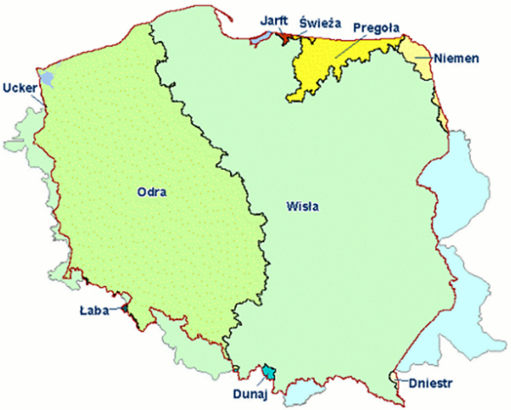

*Map legend: Jarft – presently Mamonovka (Banovka); Świeża – Prokhladnaya; Pregoła – Pregolya; Niemen – Neman; Odra – Oder; Wisła – Vistula; Łaba – Elbe; Dunaj – Danube; Dniestr – Dniester.*

*Source: GIOŚ, State of the Environment in Poland. Report 2018, Biblioteka Monitoringu Środowiska (Environmental Monitoring Library), 2018, p. 112.*

Monitoring of surface water quality is carried out in surface water bodies (SWB) within the framework of the State Environmental Monitoring System. Research and assessment of the state of water in rivers is carried out by Voivodship Inspectorates for Environmental Protection. SWB is a division unit designated for water management by the National Water Management Authority. A surface water body is defined as a separate and significant surface water element, such as: (a) a lake or other natural reservoir; (b) an artificial reservoir; (c) a watercourse, stream, brook, river and canal or parts thereof; d) internal sea waters, transitional waters or coastal waters[4]. 4586 river SWBs (including dam reservoirs) were identified within the territory of Poland[5].

The assessment of the condition of SWBs consists of an assessment of the ecological state or potential and an assessment of the chemical state of the waters. The ecological state is determined for natural SWBs, i.e. those with hydromorphology not significantly altered by human activity. The ecological potential is determined for artificial or heavily modified SWBs. Both assessments consist of the classification of biological quality elements and the supporting physicochemical and hydromorphological indicators. Physicochemical indicators include water parameters describing thermal conditions, oxygen, salinity, acidity and concentration of nutrients (nitrogen and phosphorus compounds), as well as the presence of substances particularly harmful to the aquatic environment in water (such as petroleum-derived hydrocarbons, cyanides, volatile phenols, formaldehyde and a number of heavy metals). The ecological state and potential are determined by a five-point scale. For ecological state, these are: very good/good/moderate/poor/bad, and for ecological potential: maximum/good/moderate/poor/bad.

The assessment of the chemical state of a SWB shall be determined by examining concentrations of priority substances[6] and other pollutants in the area of water management indicated in the Regulation of the Minister of the Environment of 21 July 2016 on the method of classification of the condition of surface water bodies and environmental quality standards for priority substances (OJ L item 1187). The assessment of the chemical state is expressed on a two-point scale: chemical state good / below good.

The assessment of the state of a SWB is expressed on a two-point scale: chemical state good / below good. The classification of the state follows the "*one-out, all-out*" principle. This means that in order to achieve good ecological state, the SWB must achieve at least good ecological state/potential and good chemical state. At the same time, the classification of both assessments is determined by the results of measurements of the indicator with the worst assessment result. Depending on the monitoring programme, even more than 100 indicators may be measured. The large number of measured parameters results in the fact that only SWBs with water of high quality in almost every respect can be categorised as being in a good state. The number and type of indicators tested depend on the monitoring programme planned for the given SWB, the type of which is adapted to the objective of the planned study. The implementation locations shall be selected in such a way as to ensure the representativeness of the results within the scale of the catchment areas and river basin districts.

Due to the large number of SWBs identified in Poland, it is impossible to monitor all of them. Therefore, when presenting the assessment of the ecological state/potential, a distinction is made between results for monitored and unmonitored SWBs, which are classified by extrapolation. Due to a relatively low level of confidence, the results of the classification of ecological state/potential of unmonitored SWBs are presented by assigning two classes to the SWBs assessed in this way: ecological state/potential "at least good" and "below good".

## Water resources in Poland[7]

The report regarding the state of water resources in Poland has been prepared on the basis of data from the hydrological monitoring network of the National Hydrological and Meteorological Service (PSHM) for the hydrological year 2016 (period from 1 November 2015 to 30 October 2016) and the groundwater monitoring network of the Polish Hydrogeological Survey (PHS) for the hydrological years 2016-2017.

In the hydrological year 2016, the total flowing water resources in Poland amounted to 41 438.9 millionm3 (including 5 073.4 millionm3 of water inflow from abroad and 36 365.5 millionm3 of outflow from catchment areas within Poland).

The average precipitation within Poland in the hydrological year 2016 was 698.9 mm (in the case of including the catchment areas supplying rivers flowing into Poland, the average precipitation was 684.5 mm). The water runoff layer from Poland was 115.2 mm.

In the Vistula river basin, the total flowing water resources in 2016 amounted to 23 799.1 millionm3 (including 2 675.1 millionm3 of water inflow from abroad and 21 124.0 millionm3 of outflow from Poland). The average precipitation in the Vistula river basin in the 2016 hydrological year was 704.4 mm (in the case of including the catchment areas supplying rivers flowing into Poland, the average precipitation was 706.6 mm). The water runoff layer in the 2016 hydrological year from the Vistula river basin within the borders of Poland was 108.9 mm.

In the Oder river basin, the total flowing water resources in 2016 amounted to 10 527.7 millionm3 (including 2 398.3 millionm3 of water inflow from abroad and 8 129.4 millionm3 of outflow from Poland). The average precipitation in the Oder river basin in the 2016 hydrological year was 656.0 mm (in the case of including the catchment areas supplying rivers flowing into Poland, the average precipitation was 662.5 mm). The water runoff layer in the 2016 hydrological year from the Oder river basin within the borders of Poland was 68.4 mm.

In the Baltic Sea catchment area (Rega, Parsęta, Wieprza, Słupia and Łeba basin), the total flowing water resources in 2016 amounted to 4 324.4 millionm3. The average precipitation in the catchment areas of the Baltic Sea in the hydrological year 2016 was 850.8 mm and the water runoff layer from this area was 250.8 mm.

In the years 1951-2016, the average value of total flowing water resources in Poland amounted to 60 400 millionm3. Against this background, in the hydrological year 2016, the volume of flowing water resources in Poland was lower and accounted for 68.6% of the average value.

Underground water supply contributes, on average, 52.5% of the annual volume of the river outflow in Poland, under average hydrological and meteorological conditions. After the extremely dry year 2015 and in view of the widespread drought in the country, in 2016 a significant decrease in the retention level was continued in shallow aquifers with a free water table, while the flow of rivers in the low periods was formed exclusively from underground water supply. Exploitable aquifers with a confined water table – being the main source of collective water supply – were not subject to any significant decrease. The year 2017 was average in terms of groundwater retention and outflow to rivers.

Ordinary groundwater (not classified as medicinal water, thermal water or brine) resources available for development (DR) are determined in the areas and balance units designated as river basins selected for water balance, which are hydraulically related to groundwater and include supply zones of groundwater intakes. The resources available for development are determined as available groundwater resources (AR), in accordance with the Act of 9 June 2011 on Geological and Mining Law (OJ L of 2019, item 868, as amended) and the Regulation of the Minister of the Environment of 18 November 2016 on hydrogeological documentation and geological engineering documentation (OJ L item 2033), as well as the Methodological Guide, in the course of preparing hydrogeological documentation approved by the Minister of the Environment. The available groundwater resources are determined in long-term average quantities in accordance with the course of their renewability appropriate to hydrogeological conditions prevailing in the balance units. Available resources are determined by the method of mathematical modelling of groundwater flow, predicted in conditions of acceptable level of resources development of the balance unit, within the environmental objectives set for achievement and maintenance in protected ecosystems. The mathematical model of the balance unit is created on the basis of a detailed analysis of the results of the existing geological, hydrogeological and hydrological identification, supplemented with additionally designed research and field measurements. As of 31.12.2017, available groundwater resources were identified for 80% of the surface area of Poland. Documentation works are underway for the remaining part of the country and shall be completed in 2019.

In the balance areas, not yet covered by completed documentation of available groundwater resources, the groundwater resources available for development were identified in 2003 using simplified hydrological methods as prospective groundwater resources (PR). Detailed information on groundwater resources available for development is collected and processed in the database of available resources maintained by the Polish Hydrogeological Survey (PHS).

**As at 31 December 2017, the identified resources of ordinary groundwater available for development in the entire country amounted to approximately 12.73 km3/year (approximately 35 million m3/day).**

This total value includes:

9.82 km3/year (approx. 27 million m3/day) of available resources (AR), identified under the hydrogeological documentation procedure, in accordance with the Act of 9 June 2011 on Geological and Mining Law, for a total surface area of approx. 80% of the Polish territory;

2.91 km3/year (approx. 8 million m3/day) of prospective resources (PR), estimated as prospective resources for the remaining part of the country (approx. 20% of the area of Poland), until the available resources are documented in these areas.

For the Vistula river basin district, the total available and prospective groundwater resources amount to approx. 7.03 km3/year (approx. 19.25 million m3/day), which – taking into account the surface area of this district (approx. 183.2 thousand km2) – results in the average value of the modulus of ordinary groundwater resources available for development equal to 105.1 m3/(day·km2). For the Oder river basin district, the total available and prospective groundwater resources amount to approx. 5.35 km3/year (approx. 14.65 million m3/day), which – taking into account the surface area of this basin (approx. 118.0 thousand km2) – results in the average value of the modulus of resources available for development equal to 124.2 m3/(day·km2).

*Fig. 2.2. Map of the status of documentation of available groundwater resources in Poland (as at 31.12.2017)*

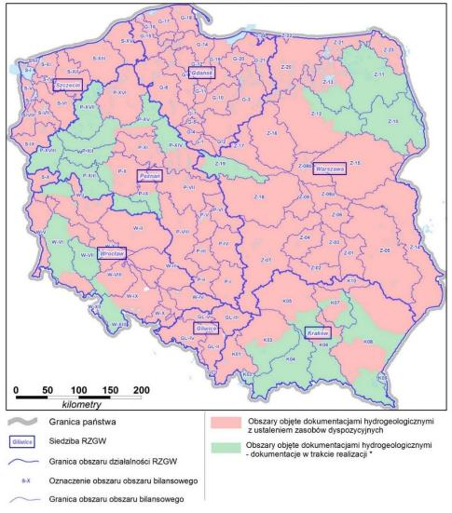  
*Map legend: kilometry – km; Granica państwa – Country border; Siedziba RZGW – Regional Water Management Board (RZGW) seat; Granica obszaru działalności RZGW – RZGW operation boundary; Oznaczenie obszaru bilansowego – Balance area marking; Granica obszaru bilansowego – Balance area boundary; Obszary objęte dokumentacjami z ustaleniem zasobów dyspozycyjnych – Areas covered by hydrogeological documentation with identification of available resources; Obszary objęte dokumentacjami hydrogeologicznymi – dokumentacje w trakcie realizacji - Areas covered by hydrogeological documentation (underway)*

*Source: Polish Association of Sanitary Engineers and Technicians in Częstochowa, Security of collective water supply in areas under anthropogenic pressure, ed. G. Malina, Częstochowa, 2018, p. 48, as in: Biuletyn Państwowej Służby Hydrologicznej (Bulletin of the National Hydrological Service), Tasks of the National Hydrological Service in 2017, SYNTEZA, 2018.*

## State of river waters (including dam reservoirs)

The assessment of the ecological state/potential of the waters of rivers and dam reservoirs was based on verified monitoring data from the years 2011-2016, applying the inheritance principle. 1974 SWBs were assessed in this manner on the basis of the measurement results.

On the national scale, 0.5% of the assessed natural SWBs achieved very good ecological state and 16% – good ecological state. Among the artificial and heavily modified SWBs, the maximum potential was achieved by 0.25% and good – 9% of the assessed SWBs.

*Tab. 2.1. Assessment of the state of river surface water bodies monitored in 2017*

|  |  |  |  |  |  |  |  |  |  |  |  |
| --- | --- | --- | --- | --- | --- | --- | --- | --- | --- | --- | --- |
| **ASSESSMENT OF RIVER SURFACE WATER BODIES** | | RIVER BASIN | | | | | | | | | |
| DNIESTER | DANUBE | JARFT | ELBE | NEMAN | ODER | PREGOLYA | PROKHLADNAYA | VISTULA | TOTAL |
| **ECOLOGICAL STATE CLASSIFICATION** | VERY GOOD | 0 | 0 | 0 | 0 | 0 | 1 | 0 | 0 | 0 | 1 |
| GOOD | 0 | 1 | 0 | 0 | 1 | 10 | 0 | 0 | 23 | 35 |
| MODERATE | 1 | 2 | 0 | 0 | 8 | 105 | 14 | 1 | 202 | 333 |
| POOR | 0 | 0 | 0 | 1 | 2 | 34 | 2 | 0 | 79 | 118 |
| BAD | 0 | 0 | 0 | 0 | 1 | 5 | 1 | 0 | 18 | 25 |
| NUMBER OF CLASSIFIED NATURAL SWBs | 1 | 3 | 0 | 1 | 12 | 155 | 17 | 1 | 322 | 512 |
| **ENVIRONMENTAL POTENTIAL CLASSIFICATION** | GOOD | 0 | 0 | 0 | 0 | 0 | 14 | 0 | 0 | 22 | 36 |
| MODERATE | 0 | 0 | 0 | 0 | 0 | 92 | 0 | 0 | 75 | 167 |
| POOR | 0 | 0 | 0 | 0 | 0 | 43 | 0 | 0 | 38 | 81 |
| BAD | 0 | 0 | 0 | 0 | 0 | 25 | 0 | 0 | 18 | 43 |
| NUMBER OF CLASSIFIED HEAVILY MODIFIED OR ARTIFICIAL SWBs | 0 | 0 | 0 | 0 | 0 | 174 | 0 | 0 | 153 | 327 |
| **CHEMICAL STATE ASSESSMENT** | GOOD | 0 | 0 | 0 | 0 | 0 | 22 | 0 | 0 | 70 | 92 |
| BELOW GOOD | 1 | 2 | 2 | 2 | 12 | 379 | 12 | 1 | 393 | 804 |
| NUMBER OF CLASSIFIED SWBs | 1 | 2 | 2 | 2 | 12 | 401 | 12 | 1 | 463 | 896 |
| **STATE ASSESSMENT** | GOOD | 0 | 0 | 0 | 0 | 0 | 1 | 0 | 0 | 3 | 4 |
| BAD | 1 | 3 | 2 | 2 | 14 | 511 | 20 | 1 | 601 | 1155 |
| NUMBER OF ASSESSED SWBs | 1 | 3 | 2 | 2 | 14 | 512 | 20 | 1 | 604 | 1159 |

*Source: Own elaboration based on the assessment of water bodies – rivers and dam reservoirs in 2017, http://www.gios.gov.pl/pl/stan-srodowiska/monitoring-wod (accessed: 05.02.2019).*

The assessment of the ecological state/potential of the waters of rivers and dam reservoirs was based on verified monitoring data from the 2017, applying the inheritance principle. 839 SWBs were assessed in this manner on the basis of the measurement results.

On the national scale, 0.2% of the assessed natural SWBs achieved very good ecological state and 6.8% – good ecological state. Among the artificial and heavily modified SWBs, good potential was achieved by 11% of the assessed SWBs. Bad ecological state/potential of biological elements was found in just below one hundred SWBs. The most frequently obtained class of biological elements was class III (moderate state or potential). Bad ecological state or potential of biological quality elements (class V) was most often determined by the state of ichthyofauna, but this element is currently not included in the classification of ecological potential for dam reservoirs. However, the state of macrophytes, also not classified in dam reservoirs, reached class V only in individual cases.

In the case of physicochemical quality elements, the pH and hardness indices most frequently exceeded environmental quality standards for the good state. Since these are parameters of significant natural variability, it is possible that this condition does not result from water pollution. Works are currently underway to even more strongly tie the criteria for classifying the state of physicochemical elements to the state of biological elements, including a revision of the indicators used for classification. Quite often, the state below good was also demonstrated by indicators of contamination with biogenic elements (nitrogen and phosphorus) and organic matter. On a scale of several years, the basic indices of physicochemical pollution measured in the estuary sections of the Vistula and Oder rivers are subject to relatively small and irregular changes. Some decline was noted in the case of total phosphorus, especially in the Vistula river. It should be noted that the actual pollution load carried by rivers is associated with recorded concentrations, also indirectly depending on the volume of water flow, which in wet years is usually higher than in dry years.

***Chemical state***

The chemical state in 2017 was examined in 896 SWBs, of which 10.3% were found to be in good chemical state and the remaining 89.7% – in bad chemical state.

During this period, the levels of 56 priority substances were measured. The measurements were performed by laboratories of the Voivodship Inspectorates for Environmental Protection, as well as, in the case of substances that were not measured by voivodship inspectorates – by an external contractor performing tests on behalf of the Chief Inspectorate for Environmental Protection.

Among the assessed SWBs, the chemical state identified as below good was caused by exceeding the environmental quality standards as defined in Directive 2008/105/EC[8] and the subsequent Directive 2013/39/EU[9]. Most frequently, the exceeded parameters were concentrations of polycyclic aromatic hydrocarbons (PAH), mercury concentrations[10] and less frequently cadmium and fluoranthene concentrations.

In 2016, the Chief Inspectorate for Environmental Protection commissioned analytical tests for 11 priority substances in water fauna. These were the first studies in the so-called biota conducted within the framework of the PMŚ. According to Directive 2013/39/EU[11], these were the substances: brominated diphenylethers, fluoranthene, hexachlorobenzene, hexachlorobutadiene, mercury and its compounds, PAHs – benzo(a)pyrene, dicofol, perfluorooctane sulfonic acid (PFOS), dioxins and dioxin-like compounds, hexabromocyclododecane (HBCDD), heptachlor and heptachlor epoxide.

Fauna samples were collected from 200 measurement points, including rivers (153 SWBs), lakes (40 SWBs), transitional waters (4 SWBs) and coastal waters (3 SWBs). The assessment was carried out on the basis of the results of the analysis of priority substances in the biota in relation to the Environmental Quality Standards (EQS) laid down in Directive 2013/39/EU[12]. At none of the tested sites were fauna samples found to contain hexachlorobenzene, hexachlorobutadiene, dioxin, dioxin-like compounds and hexabromocyclododecane at concentrations higher than the EQS values established for these substances. It should be noted that for hexachlorobenzene, hexachlorobutadiene and dicofol – levels above the limit of quantification (LOQ) of the applied analytical method were not recorded. EQS were found to be exceeded for the following substances: brominated diphenylethers, mercury and its compounds and heptachlor.

***State of the SWBs monitored in 2017 r.***

The general state was assessed for 1159 SWBs, of which only 0.3% were in good state, while 99.7% were in bad state (see Tab. 2.1). Assessment of water state in case of lack of information on chemical state was performed if the ecological state/potential results were below good. The condition for such SWBs was identified as bad. No extrapolation of the assessment to unmonitored SWBs was used.

The highest number of SWBs was assessed in the basins of the Vistula and Oder rivers, according to their area range in Poland.

## State of the lakes

In Poland, lakes occupy less than 1% of the country's surface area. The intensity of recreational pressure and need for economic use, on the one hand, and the need to protect sensitive habitats and species, on the other hand, require the introduction of appropriate protection and remedial measures.

*Fig. 2.3. Ecological state of the natural lake SBWs in 2017 (%)*

*Source: own elaboration based on data from WIOŚ[13]*

130 lake SWBs were monitored in 2017. Among them, 5% reached the maximum ecological potential, 24% – good, and the remaining did not reach the expected ecological potential (42% reached moderate ecological state, 18% – poor, and 11% – bad ecological state).

*Fig. 2.4. Ecological potential of heavily modified lake SWBs in 2017 (%)*

*Source: own elaboration based on data from WIOŚ[14]*

Fig. 2.4 shows the 21 studied strongly modified lake SWBs, of which 14% achieved good ecological potential, while the remaining 43% reached moderate, 24% – poor and 19% – bad ecological potential. None of the lake SWBs reached maximum ecological potential.

The biological indicator used to assess the ecological state or potential, which most often exceeded the environmental standards for lake SWBs, was mainly the PMPL index[15] describing the phytoplankton state (94 out of 212 lake SWBs for which the developed classification of biological elements indicated the ecological state or potential below good) and the ESMI Ecological State Macrophyte Index[16]. The state of the indicators described above demonstrates mainly the trophic state of the studied lakes, which indicates that the most frequently identified problem is the overfertilisation of lake water.

***Chemical state***

*Fig. 2.5. Assessment of the chemical state of lake SWBs monitored in 2017 (%)*

*Source: own elaboration based on data from WIOŚ[17]*

In the case of the Lubelskie Voivodship, it can be observed that the lake SWBs in good chemical state studied there constitute less than 40%. It is important to note that in the Mazowieckie Voivodship, Wielkopolskie Voivodship, Kujawsko-Pomorskie Voivodship and Podlaskie Voivodship, the chemical state of lake SWBs is below good.

*Fig. 2.6. Assessment of the chemical state of all lake SWBs monitored in 2017 (%)*

*Source: own elaboration based on data from WIOŚ[18]*

The classification of the chemical state was prepared for 148 lake SWBs in which the chemical indicators describing the occurrence of substances particularly harmful to the aquatic environment were studied. Exceeded values of the measured substances were not found in 7.4% of the monitored lakes, while in 92.6% of the monitored lase SWBs, the environmental standards for at least one of the 8 chemical substances were exceeded, which indicates a bad chemical state of these water bodies.

Studies conducted in water showed exceeded levels of lead and its compounds (6 lakes: Wigry, Pierty, Długie Augustowskie, Breżnik, Dmitrowo, Lubniewsko) and mercury and its compounds (lakes: Breżnik, Dmitrowo and Wigry) as well as benzo(g, h, i)perylene (20 lake SWBs).

The environmental standards for bioaccumulation of the following indicators were also exceeded: brominated diphenylethers - 87 lake SWBs, heptachlor – 39 lake SWBs, fluoranthene – 5 lake SWBs, benzo(a)pyrene – 79 SWBs and perfluorooctane sulfonic acid (PFOS) – 10 lake SWBs, naphthalene (1 lake SWB), nickel (2 lake SWBs), benzo(b)fluoranthene (15 lake SWBs), benzo(k)fluoranthene (14 lake SWBs), hexabromocyclododecane (1 lake SWB), heptachlor (6 lake SWBs).

In 10 lakes, exceeded levels of more than five priority substances were found. These were the following lake SWBs: Wigry, Długie Augustowskie, Berżnik, Stobno, Więcborskie, Trześniowskie (Ciecz), Wierzbiczańskie, Dominickie, Białe-Miałkie, Wieleńskie-Trzytniowe.

*Fig. 2.7. Ecological state of the natural lake SBWs in 2017 (%)*

*Source: own elaboration based on data from WIOŚ[19]*

Among the natural SWBs, 5% were in very good and almost 1/4 (24%) – in good ecological state. The remaining SWBs did not reach the expected ecological state (42% – moderate ecological state, 18% – poor, 11% – bad ecological state).

*Fig. 2.8. Assessment of the state of lake SWBs monitored in 2017*

*Source: own elaboration based on data from WIOŚ[20]*

In 2017, 99% of monitored lake SWBs (84.2%) were in bad condition and only 1% in good condition.

## Trends of changes in concentrations of selected pollutants measured in the sediments of rivers and lakes of Poland

The presence of high concentrations of heavy metals or organic compounds in sediments adversely affects the quality of surface water ecosystems. Contaminants present in the sediments may be toxic to aquatic organisms and may accumulate in the food chain to dangerous concentrations in tissues (biomagnification), especially for predators living in waters with contaminated sediments.

*Fig. 2.9. Average concentrations of selected heavy metals, sum of polychlorinated biphenyls and polycyclic aromatic hydrocarbons (BaP, BbF, BkF, IndP, Bper) in sediments of benchmark lakes in Poland monitored in the years 2009, 2011, 2013, 2015.*

*Source: GIOŚ/PMŚ*

In Poland, the levels of the most important elements and the most important organic substances from the perspective of water environment pollution, including priority substances, are subject to constant observation and assessment within the framework of the State Environmental Monitoring. Among the elements measured in the sediments, the concentrations of those included in the list of priority substances in the field of water policy (Cd, Pb, Hg, Ni) are also controlled. The samples of collected river and lake sediments contain organic compounds dangerous for the environment: polychlorinated biphenyls (PCBs) and polycyclic aromatic hydrocarbons (PAHs) – including benzo(a)pyrene, benzo(b)fluoranthene, benzo(k)fluoranthene, benzo(g,h,i)perylene and indeno(1,2,3-cd)pyrene.

The analysis of data from the measurement series within the benchmark monitoring network[21] for lake sediments, carried out every two years since 2009, shows that the highest concentrations of heavy metals among the group of priority pollutants are found for lead and the lowest for mercury. Average sum of PCB concentrations in samples of benchmark lake sediments are much lower than average contents of PAHs or heavy metals and remain at the level of a few µg/kg. It can be stated that the average concentrations of selected groups of contaminants in bottom sediments have been maintained at a very similar level for years. Only in the case of the sums of PAHs can a clear upward trend in the average concentrations of PAHs in benchmark lake sediments be observed, by approx. 0.2 mg/kg in the scale of two years (2013-2015).

Analysing the results of measurements on the annually monitored river sediments in the basin of the Vistula and Oder rivers, it can be observed that the present concentrations of chemical pollutants react to flood events. Monitoring results from years with high water levels in riverbeds (2010, 2013) are characterised by rapid decreases in average concentrations of heavy metals and organic pollutants in sediments. The largest one was recorded for lead – from 49.74 mg/kg in 2009 to 30.82 mg/kg in 2010. After the analysis of data for the purpose of determination of the pollution concentration trend, it can be concluded that the contents of particular parameters remained at a similar level in the period 2009-2015.

In general, the average contents of heavy metals, PAHs and PCBs in lake sediments are higher than in river sediments. This is primarily due to differences in sedimentation conditions, the content of organic matter and other elements forming the sediment, and the possibility of reintroduction of contaminants from the sediment to the water depths in still and flowing waters[22].

## Transitional and coastal waters[23]

1. ecological state/potential

The programme of monitoring the quality of transitional and coastal waters is implemented within the framework of the State Environmental Monitoring on the basis of designated so-called water bodies, which should be understood as separate and significant elements of surface waters, constituting the basic unit of water management. In the research and assessment of the state of transitional and coastal water bodies, the 2013-2015 period is the second part of the six-year (2010-2015) water management cycle. The second cycle of water management is currently underway (2016-2021). The assessment of the ecological state/potential of the SWBs was carried out on the basis of averaged values of the results of physicochemical tests of water samples and biological indicators from individual measurement stations located on the SWBs for the period 2011-2016. The ecological state and potential rating for a SWB is the weakest result of three partial assessments for biological, hydromorphological and physicochemical elements. The biological indicators of water quality causing the classification of ecological state or potential as "below good" were chlorophyll a and phytoplankton biomass as well as the number of macrozoobenthos organisms.

*Fig. 2.10. Average concentrations of selected heavy metals, sums of polychlorinated biphenyls and polycyclic aromatic hydrocarbons (BaP, BbF, BkF, IndP, Bper) in sediments of Polish rivers at measurement points tested in the years 2009-2015.*

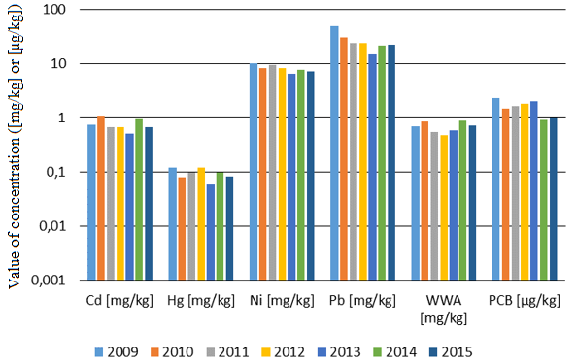

*Source: GIOŚ/PMŚ*

The assessment of the physicochemical elements below a good state or potential was influenced mainly by the results of water transparency studies (Secchi disk visibility), organic matter indices (TOC), observed occurrence of episodes of water oversaturation with dissolved oxygen and excessive concentrations of nutrients, especially total nitrogen and soluble forms of nitrogen (ammoniacal, nitrate, mineral nitrogen) and total phosphorus (Fig. 2.15).

1. chemical state

*Fig. 2.11. Average assessment of the ecological state or potential of transitional and coastal waters in the years 2011-2016.*

*Graph legend: VG – very good; G – good; M – moderate; P – poor; B – bad.*

*Source: GIOŚ/PMŚ*

The assessment of the chemical state of transitional and coastal waters was based on the results of 43 selected priority substances from the list of 44 substances measured by voivodship environmental inspectorates within the framework of diagnostic monitoring in 2011-2016 and 11 other pollutants measured in the biota, included in the Regulation of the Minister of the Environment of 21 July 2016 on the method of classification of the state of surface water bodies and environmental quality standards for priority substances.Of the 15 water bodies assessed in that period, 6 were in a good state and 9 in a state below good. The state below good was caused by exceeding the limit values for brominated diphenylethers, mercury and its compounds, benzo(g,h,i)perylene and heptachlor.

*Fig. 2.12. Average assessment of the chemical state of transitional and coastal waters based on 21 substances12 between 2011 and 2016 (%).*

*Source: GIOŚ/PMŚ*

## Baltic Sea

The state of the environment of the Polish zone of the Baltic Sea area has been regularly monitored since 1979 (since 1991 within the framework of the State Environmental Monitoring). Measurements and observations are carried out in accordance with the marine water monitoring programme adopted by the Council of Ministers in 2014. As part of the programme, measurements are carried out six times a year at stations located in deep and shallow water zones and 12 times a year at one high frequency station. "Hydrological measurements, chemical analyses and collection of biological material and bottom sediments are carried out during the expedition on board of the r/v "Baltica" in accordance with the procedures contained in the HELCOM[24] COMBINE[25] manual"[26].

Based on the studies conducted in 2016, the state of the marine environment of Polish marine areas in terms of eutrophication should be considered unsatisfactory (subGES). This is mainly due to the concentrations of total phosphorus, total nitrogen, chlorophyll a, water transparency and the content of dissolved oxygen near the bottom.

*Fig. 2.13. Assessment of the condition of the marine environment in 2016 in terms of eutrophication. The red colour indicates the state of the water in terms of eutrophication, which is assessed as inadequate, i.e. below good (subGES).*

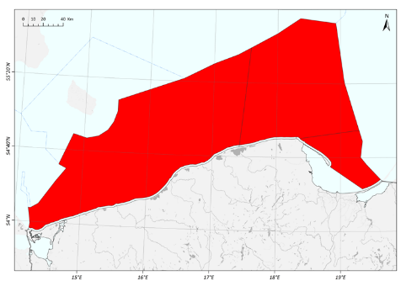

*Source: GIOŚ, State of the Environment in Poland. Signals 2016, p. 52.*

The state of waters in the Polish Exclusive Economic Zone in 2015 in terms of eutrophication was assessed as inadequate, i.e. below good (subGES).

Biogenic substances are essential for the development of phytoplankton in the marine environment. However, their surplus leads to excessive development of phytoplankton, the so-called **phytoplankton bloom**. Dead phytoplankton, which decomposes and consumes oxygen, sinks to the bottom which may lead, even in shallow areas with a depth of 6-10 m, to a decrease in the concentration of oxygen at the bottom, or even to oxygen deficiency.

Persistent organic pollutants (POPs) in the marine environment are of anthropogenic origin. The main sources of POPs are industry, management of public utilities (waste incineration) and agricultural chemistry. Studies on persistent organic pollutants in fish tissues have been carried out since 1998. (7 PCB congeners: CB28, CB101, CB118, CB138, CB153, CB180 (according to IUPAC), HCH and its isomers: α-, β-, γ-HCH, HCB). The list of compounds tested in fish was extended in 2012 (PBDE, HBCDD) and 2014 (PFOS, TBT and its derivatives: DBT, MBT, TPhT). In the Szczecin and Vistula Lagoons, compounds are measured in perch tissues, in the Gotland Basin – in herrings, in the Bornholm Basin – herring and flounder, and in the Gdańsk Basin – flounder.

Compared to previous research years, in 2016 a decrease in PBDE content in fish muscle tissues was observed in all monitored waters. In 2016, there was also a change in the threshold value of the permissible concentration of the sum of 6 PBDE congeners, which resulted in a drastic change in the state of the marine environment for all analysed waters. In previous years, the environmental state was determined as good (GES) on the basis of the available data. Currently, based on the new good state threshold value (TV) of 0.008 μg kg-1m.m., the marine environment should be considered unsatisfactory (subGES) in terms of pollution with polybrominated diphenyl ethers for all monitored waters.

*Fig. 2.14. The state of the marine environment in 2016 with respect to POP contamination in fish intended for consumption. The red colour indicates the state below good, while the green colour indicates good state.*

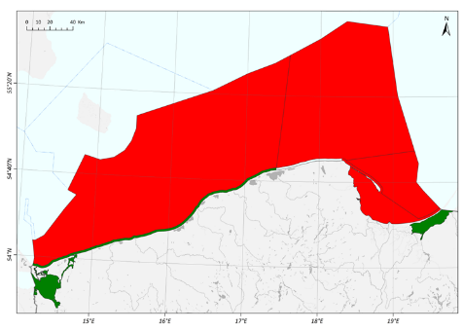

*Source: GIOŚ, State of the Environment in Poland. Signals 2016, p. 55.*

"The state of the Polish Baltic Sea zone in 2015 with respect to metal pollution has been shown to be below good in the waters of the Szczecin Lagoon, the Vistula Lagoon, the Bornholm Basin and the Eastern Gotland Basin. Good condition has been achieved in the Polish coastal waters of the Bornholm Basin and Polish coastal waters of the Gdańsk Basin"[27].

Noise in the marine environment

Maritime transport also has an impact on the acoustic climate of the environment, in particular the underwater ecosystems. The level of anthropogenic noise in the marine environment is increasing, for example, due to the increase in the number of ships operating at the same time in the Baltic Sea. Sources of underwater noise are typically the operation of ship engines, the operation of underwater hydrotechnical equipment (drilling rigs, dredgers, pile drivers), sonars and echo sounding equipment, geological exploration explosions, practice detonations in marine military training zones, underwater explosions accompanying munitions destruction. The sound from these sources can spread over long distances. While sound intensity can be easily measured, it is not easy to determine the environmental impact of sound. Underwater noise and acoustic disturbances are one of the most important threats to the life of marine fauna. For cetaceans, including porpoises occurring in the Baltic Sea, echolocation, functioning as a system of transmitting and receiving sounds, is the basic sense of orientation in water space. It is used to locate obstacles, organisms they hunt and for communication. The impairment of this ability to perceive sound interferes with the life processes of the porpoises, including reproduction. A pilot monitoring programme for underwater noise has been carried out since 2015 as part of the State Environmental Monitoring.

## Groundwaters

Within the framework of the State Environmental Monitoring, the chemical state of groundwaters is assessed at measurements points by defining quality classes (Class I, II and III mean good chemical state and Classes IV and V mean poor chemical state) and at groundwater bodies (GWBs). "By 2015, 161 groundwater bodies (GWBs) had been monitored, and 172 groundwater bodies have been monitored since 2016"[28].

*Fig. 2.15. Groundwater quality classes at operational monitoring points according to data from 2017*

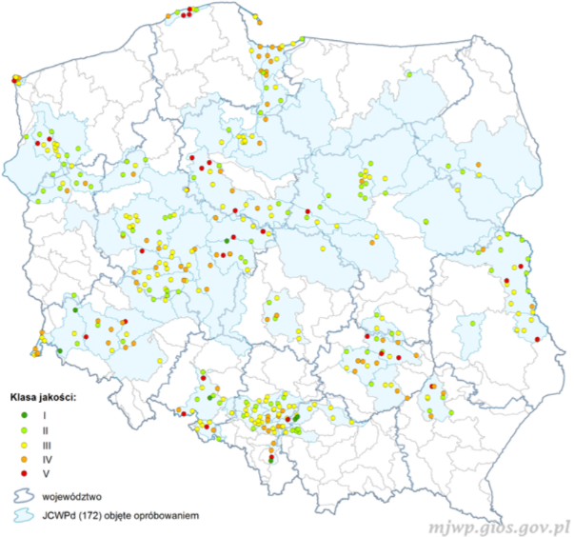

*Graph legend: Klasa jakości – quality class; województwo – voivodship; JCWPd (172) objęte próbowaniem – GWBs (172) measured.*

*Source: GIOŚ, Monitoring of Groundwater Quality, http://mjwp.gios.gov.pl/ (accessed: 12.02.2019)*

In 2017, operational monitoring of selected groundwater bodies was carried out within the framework of the State Environmental Monitoring. Samples were taken from 395 measurement points.

Since 2010, the assessment of the state of GWBs within the framework of the State Environmental Monitoring has been carried out with the use of classification tests. This enables the determination of the state of those waters, taking into account not only their chemical composition and the degree of utilisation of groundwater resources, but also the impact on the quality of waters abstracted for human consumption, on surface waters in direct contact with groundwater or on protected terrestrial ecosystems depending on groundwater.

*Fig. 2.16. Assessment of the state of groundwaters according to data from 2017*

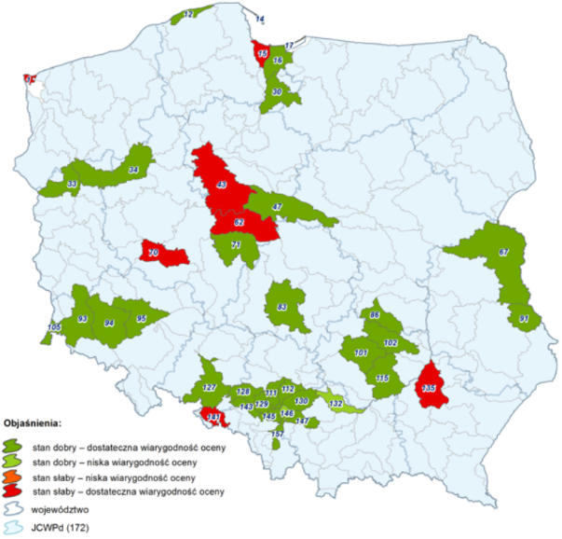

*Map legend (objaśnienia): stan dobry – dostateczna wiarygodność oceny – good state – satisfactory assessment reliability; stan dobry - niska wiarygodność oceny – good state – low assessment reliability; stan słaby – dostateczna wiarygodność oceny – poor state – satisfactory assessment reliability; stan słaby - niska wiarygodność oceny – poor state – low assessment reliability; województwo – voivodship; JCWPd – GWBs (172)*

*Source: GIOŚ, Monitoring of Groundwater Quality, http://mjwp.gios.gov.pl/ (accessed: 12.02.2019).*

According to the data from the Chief Inspectorate for Environmental Protection, most of the GWBs were found to be in a good state as a result of classification tests carried out in accordance with the adopted methodology for assessing the status of groundwater bodies.

*Fig. 2.17. Chemical state of GWBs (%)*

*Source: own elaboration based on Polish Geological Institute – National Research Institute, Interpretation of the Results of Operational Monitoring, Assessment of Chemical State and Preparation of a Study on the Chemical State of Groundwater Bodies at Risk of Failure to Achieve Good State According to Data from 2017, Warszawa 2018, p. 41.*

Of 172 groundwater bodies, good chemical state was found in 34%, of which 20 GWBs from the Vistula river basin and 12 GWBs from the Oder river basin. Poor chemical state was found in 66% of groundwater bodies. In the Vistula river basin, poor chemical state was found in 2 GWBs, and in the Oder river basin, poor chemical state was found in 5 GWBs[29].

As a result of the comparison of the current assessment of the state of GWBs with the results of the groundwater assessment according to 2016 data, it was stated that in the case of 34 analysed bodies, the overall groundwater assessment remained the same (for 30 bodies the assessment remained good, for 4 bodies – poor). For five bodies, the chemical state in 2017 compared to the 2016 measurement has changed – from good to poor in three cases and from poor to good in two cases[30].

## Summary

The most important factors causing pressure on surface waters are public utilities, agriculture and industry (particularly mining, energy, agri-food). Therefore, activities limiting the impact of anthropogenic pressure on the state of waters are also concentrated in these sectors and, since Poland's accession to the EU structures, they have been clearly strengthened by Community requirements.

*Fig. 2.18. Industrial and municipal waste water in need of treatment discharged into water or soil.*

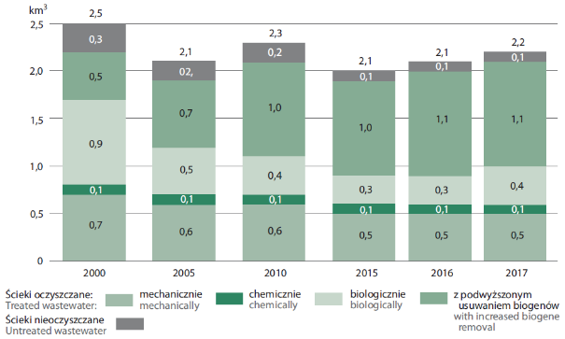

*Source: Statistics Poland, Environmental Protection 2018, Warszawa, 2018, p. 60.*

Changes in the treatment of municipal waste water in Poland have a significant impact on the quality of waters in the Vistula, Oder and other river basins. The amount of waste water discharged to water or land in 2017 compared to 2010 decreased by about 5% (from 2.3 km3 to 2.2 km3). Nearly 84.4% is industrial waste water, of which 87.7% is, however, the so called "assumed clean" cooling water which does not require treatment. In 2017, there were 2197.7 hm3/year of industrial waste water and municipal waste water requiring treatment. Of this amount, 95.1% of waste water was treated, of which 54.4% was treated with enhanced nutrient removal. Over the years, the amount of waste water treated in this way has doubled, which is an optimistic sign, as it allows to achieve an appropriate level of pollution reduction. 4.3% are untreated waste water discharged mainly directly from industrial plants. It is important, however, that the amount of untreated waste water in 2017 compared to 2010 decreased by approximately 40%.

In the period from 2010 to 2016, the efficiency of municipal waste water treatment plants in Poland increased by over 35% (data based on the National Programme for Municipal Waste Water Treatment (KPOŚK)). According to the data of the Statistics Poland statistical yearbook "Environmental Protection 2018", in the years 2000-2017, the share of the population using waste water treatment plants increased from 53% to 81%, while in cities this increase is respectively from 79% to 95% and in villages from 11% to 42%[31].

In 2017, the combined sewage system in villages reached the total length of 156.9 thousand km. As a result, 41% of the countryside population used the sewage system, and 90% in cities[32].

The increase in the capacity of municipal waste water treatment plants is a result of the implementation of the National Programme for Municipal Waste Water Treatment adopted by the Government of Poland in December 2003. This program was prepared for the purpose of building, expanding and modernising collective sewage systems and municipal waste water treatment plants. In July 2017, the Council of Ministers approved the Fifth Update of the National Municipal Wastewater Treatment Programme (AKPOŚK2017), which aimed at setting realistic dates for completion of delayed investments in agglomerations. Measures specified in the National Programme for Municipal Waste Water Treatment shall also contribute to increasing the attractiveness of Poland and its regions for investors, through the development of technical infrastructure, with simultaneous protection and improvement of the environment, health and development of territorial cohesion.

An important factor affecting the condition of surface waters and groundwaters is also the use of septic tanks by a significant part of the population in rural areas. In this context, the problem of emptying these tanks bypassing waste water treatment plants, despite their technological and functional capabilities, should be pointed out. It seems necessary to take measures to increase supervision of both – the users of such tanks and providers of emptying services, so that the sewage from the tanks is discharged only at treatment plants.

Water quality is affected by intensification of agricultural production (both large-scale animal husbandry and intensive plant cultivation). The current legal regulations, due to the existing gaps, do not ensure protection of the water environment against the adverse impact of large investments related to intensive agriculture. The impact of agriculture on the water environment is directly related to the intensity of soil use and the degree of concentration of animal production. In Poland, in the first half of the 1990s, there was a significant decrease in the use of phosphorus fertilisers, related, among others, to systemic changes. Since the midpoint of the first decade of the 21st century, stabilisation (with some fluctuations depending on the economic situation) of phosphorus fertilisers consumption has been observed. After a significant decrease in the use of nitrogen fertilisers in the 1990s and a certain stabilisation by the midpoint of the first decade of the 21st century, their use has increased in recent years.

With the entry into force of the provisions of the Act of 20 July 2017 – Water Law, the approach to the implementation of the so-called Nitrates Directive[33] has changed in Poland. Instead of cyclical identification of waters sensitive to pollution by nitrogen compounds from agricultural sources and environmentally sensitive area (ESAs), a Programme of measures aimed at limiting nitrogen outflow from agricultural sources is developed and implemented throughout the entire country. This programme includes measures and practices in the field of agriculture, including the limitation of agricultural use of fertilisers; indication of periods during which agricultural use of fertilisers is permitted, fertiliser doses and methods of fertilisation; indication of storage conditions for livestock manure.

High concentration of industry (including mining industry), especially in the catchment areas of the upper sections of the Vistula and Oder rivers, causes changes in water conditions and the necessity of discharging waste water to the surface river network carrying small volumes of water. As a result, in the southern part of the country, some of the waters carried within SWBs are of poor quality – in poor and bad ecological state. It is difficult to meet the standards of good water state in these areas, particularly because the concentration of industry is accompanied by high population density. This situation applies equally to the Vistula river basin and the Oder river basin.

In the case of groundwater, the main reasons for its poor quantitative status are water abstraction through large municipal and industrial intakes and mining drainage, which caused unfavourable changes in the location of the groundwater table.

The Baltic Sea is directly affected by these impacts on land (e.g. discharges of pollutant loads) and impacts resulting from the broadly understood maritime economy. According to the maritime law, maritime economy is included as an activity undertaken in the marine environment by various categories of entities. Experience shows that the sector-wide approach is gradually being replaced by an integrated approach, holistically treating parts of the maritime economy: activities of seaports, fishing, shipbuilding, exploitation of the resources of the global ocean, tourism and recreation, as well as maritime administration, education and rescue. Increasing attention is being paid to the sustainable development of coastal regions, which contributes to raising the living standard in these areas. Apart from maritime economy, a number of new activities concerning both land and sea pressures have been designed in the National Programme for the Protection of Marine Water (KPOWM). It includes, among others, activities related to the reduction of the amount of waste in the marine environment, as well as the popularisation of the Polish Code for Fishery Promotion and the development of port infrastructure. All activities in the KPOWM are to contribute to the achievement of good environmental status for the Baltic Sea.

Directive 2000/60/EC[34], the so-called Water Framework Directive, in its preamble states that the Community water policy requires a transparent, effective and coherent legislative framework, which should be read as a postulate to introduce legal provisions at the national level ensuring full and rational legal regulation of this area.

The scope of the water management reform achieved through the adoption of the Act of 20 July 2017 on Water Law has introduced instruments ensuring the achievement of the Water Framework Directive objective of full implementation of the basin water management policy that meets the criteria of functionality and safety, sustainable development, economic efficiency, sustainability of ecosystems and social acceptance in accordance with the principle of sustainable water management, including the economic use of water resources. It was necessary to develop legal, organisational, financial and technical solutions in water management that ensure sustainable and balanced social and economic development of the country, taking into account the needs of economic water use and ensuring the availability of water resources of appropriate quality and quantity.

It was also necessary to establish a real and effective water authority, understood as per Article 3 of the Water Framework Directive and its adequate impact on water management issues, including in particular water management planning, water resources protection and the introduction of a system of water law permits.

# Air[35]

Air quality has a major impact on human health and living conditions, ecosystems and climate change processes. Airborne pollutants significantly affect human health, causing many respiratory and circulatory problems, including cardiovascular disease, asthma, decreased lung function, lung cancer and chronic obstructive pulmonary disease. The greatest impact of air pollution on human and animal health is observed in industrial and urban areas. The groups most exposed to the negative effects of air pollution are young children, pregnant women and the elderly, as well as people with respiratory **or cardiovascular** diseases**.**

Due to the adverse impact of air pollution on human health and the condition of ecosystems, an assessment of air quality is carried out annually for the protection of human health and the protection of plants. The assessments carried out with a view to meeting the criteria established to protect human health currently include: sulphur dioxide (SO2), nitrogen dioxide (NO2), carbon monoxide (CO), benzene (C6H6), ozone (O3), PM10[36] and PM2.5 particulate matter, heavy metals: lead (Pb), arsenic (As), cadmium (Cd) and nickel (Ni) in PM10 and benzo(a)pyrene (B(a)P) in PM10[37]. Assessments related to plant protection criteria include sulphur dioxide (SO2), nitrogen oxides (NOx) and ozone (O3).

The system of air quality assessment and monitoring is based on measurements carried out within the national monitoring network in 46 zones: 12 agglomerations, 18 cities over 100,000 inhabitants, 16 voivodship areas which are not part of agglomerations or cities over 100,000 inhabitants. The assessment is carried out in accordance with applicable national and European law.

The results of annual assessments of air quality carried out by the Inspectorate for Environmental Protection as part of the State Environmental Monitoring unequivocally indicate that, at present, the inadequate condition of air quality in Poland is caused primarily by the so-called low emissions from the household and municipal sector and from transport. Excessive concentrations of PM10 and PM2.5 particulate matter and benzo(a)pyrene in the winter season and excessive concentrations of tropospheric ozone in the summer season are still a significant problem in Poland. In addition, individual cases of excessive nitrogen dioxide concentrations are observed[38], the main cause of which is the impact of emissions related to heavy traffic in the city centres and the emissions related to traffic on the main roads in the vicinity of measurement stations.

*Fig. 3.1 Emissions of SO2, NOx, NH3, NMVOCs and PM2.5 against the ceilings for 2020 set in the Directive on the reduction of national emissions of certain atmospheric pollutants[39].*

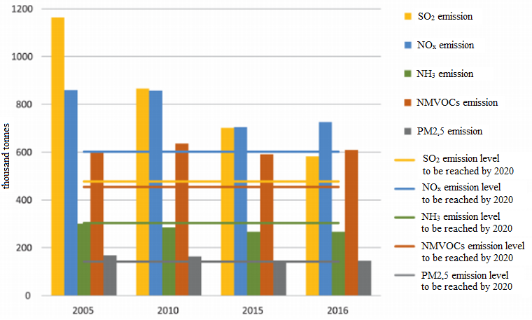

*Source: LRTAP, Eionet, as in: GIOŚ, State of the Environment in Poland. Report 2018, Biblioteka Monitoringu Środowiska (Environmental Monitoring Library), 2018, p. 104.*

After significant reductions in the emission of all pollutants to the air in Poland in the 1990s, the downward trend in the emission of sulphur dioxide clearly continued after 2000. Emissions of the other main pollutants nitrogen oxide (NOx), ammonia (NH3) and particulate matter are decreasing more slowly, while emissions of non-methane volatile organic compounds (NMVOCs) and particulate matter remain at similar levels.

Poland has achieved and complies with the emission limits set for 2010 in the Treaty of Accession of the Republic of Poland to the European Union with respect to Directive 2001/81/EC[40].

At the same time, within the framework of the Convention on Long-Range Transboundary Air Pollution, in order to counteract acidification, eutrophication and ground-level ozone, new emission reduction targets have been set for gaseous pollutants covered by the agreements mentioned above, and additionally, reduction targets for PM2.5 have been set in Directive 2016/2284 of the European Parliament and of the Council (EU)[41]. The new emission ceilings should be reached by 2020 and 2030 respectively.

*Fig. 3.2. Structure of emissions of the main pollutants in Poland in 2016 by sectors of the economy.*

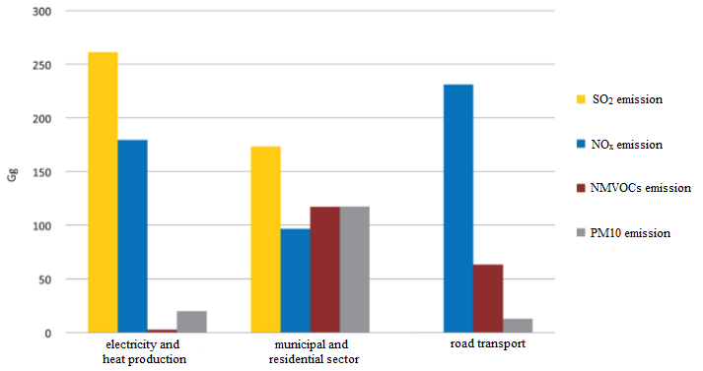

*Source: LRTAP as in: GIOŚ, State of the Environment in Poland. Report 2018, Biblioteka Monitoringu Środowiska (Environmental Monitoring Library), 2018, p. 105.*

*Fig. 3.3. Structure of PM10 primary particulate matter emissions in Poland in 2016 by sectors of the economy.*

*Source: KOBIZE, as in: GIOŚ, State of the Environment in Poland. Report 2018, Biblioteka Monitoringu Środowiska (Environmental Monitoring Library), 2018, p. 106.*

The structure of pollutant emissions in Poland results from the structure of fuel consumption and quality. These factors determine the amount of emissions of most air pollutants. Production technologies in the commercial power sector and fuel combustion technologies used in the household and municipal sector (Fig. 3.2 and Fig. 3.3) are also of great importance for the volume of emissions. It is worth noting that the energy sector has significantly reduced its emissions – in case of both NOx and SO2 – over the last several years. The issues of the emission of pollutants from the industrial sector, including in particular power generation, were regulated through the implementation of the provisions of the MCP[42] and IED[43] directives. As a result, this sector is no longer a significant environmental problem in terms of air quality.

Taking into account the scale and historical starting point, the Polish energy sector is undergoing dynamic changes. In just 10 years (2007-2017), the installed capacity[44] of renewable energy sources (RES) increased almost 5-fold: from 4% to about 20% of the total installed capacity in the Polish Power System (PPS). However, hard coal is still the primary energy medium in the national economy. Its share in the structure of primary energy consumption in Poland in 2016 was 39.84%. According to data for 2017, energy production from hard coal and lignite in Poland amounted to 78.4% of total energy production.

One of the results of the fuel consumption structure in Poland is also a large emission of polycyclic aromatic hydrocarbons (PAHs), including benzo(a)pyrene. These compounds are emitted mainly as a result of combustion of solid fuels in households. In 2015, the emission of PAHs from this source amounted to over 87% of the total air emissions of PAHs in Poland. Production processes, including processes related to the production of coke or aluminium, are also an important source of PAHs emissions.

Air pollution also has a negative impact on water status. Various chemicals in gases and particulate matter emitted from land-based sources and sea transport enter the sea from the air. As a result of the process of combustion of hydrocarbon fuels, harmful and toxic products in the form of carbon dioxide – CO2, carbon monoxide CO, sulphur oxides SOx, nitrogen oxides NOx, hydrocarbons HC, particulate matter PM and many other toxic substances affecting both the natural environment and human health and life are introduced into the atmosphere. The dynamic development of industry, transport and automotive production are significant contributors to the emission of these pollutants to the atmosphere. Intense ship traffic in coastal areas results in significant changes to their ecosystems. It is estimated that the maritime economy uses about 3% of the world's fuel production – often the worst fuels in terms of quality and high sulphur content. The combustion of this type of fuels releases approximately 7% of total atmospheric pollution by sulphur oxides and approximately 11-13% by nitrogen oxides.

However, it should be noted that 80% of the pollution of the marine environment comes from the land. The remaining 20% are attributable to marine sources, with only 4% of pollution coming from maritime transport.

Annex VI to MARPOL 73/78 is a provision that has a major impact on the construction and equipment of ships. This Annex concerns the prevention of air pollution from ships and introduces provisions for Sulphur Emission Control Areas (SECAs) and Nitrogen Emission Control Areas (NECAs).

It should be noted that the Baltic Sea has been a SECA since 19 May 2006 and at the 71st session of the Marine Environment Protection Committee (MEPC), the International Maritime Organisation (IMO) established the Baltic Sea and the North Sea, including the English Channel, as a NECA. New, stricter rules on nitrogen oxide emissions from ships shall apply from 1 January 2021.

In addition, Directive 2016/802[45] concerns the reduction of the sulphur content of certain liquid fuels. Its contents refer to the regulations of the International Maritime Organization, which forced the reduction of sulphur content in marine fuel to 0.1%, from 1 January 2015 in SECAs, and from 2020 shall globally limit the use of fuels with sulphur content above 0.5%. Meeting the requirements may involve switching to more expensive fuel with reduced sulphur content, e.g. Marine Gas Oil, installing the so-called scrubbers on ships, spraying the exhaust gases with water, or switching to liquefied natural gas (LNG) propulsion entirely.

On 16 April 2018, the European Commission published the "Report from the Commission to the European Parliament and the Council on implementation and compliance with the sulphur standards for marine fuels set out in Directive (EU) 2016/802 relating to a reduction in the sulphur content of certain liquid fuels". The report shows that the mandatory use of marine fuels with a sulphur content of 0.10% in SECAs contributes effectively to achieving the Directive's objective of reducing the harmful effects of sulphur dioxide emissions from ships on human health and the environment. More than 93% of the ships inspected in the SOx Emission Control Areas complied with the stricter sulphur content requirements, which led to a significant reduction of sulphur dioxide concentrations in the air in the regions bordering the SECAs.

The state of air in Poland depends mainly on the size and spatial distribution of emissions from stationary and mobile sources, as well as transboundary flows and physicochemical transformations occurring in the atmosphere. These processes affect both the formation of the so-called background pollution resulting from the establishment of the dynamic equilibrium state in the further distance from the emission sources, as well as the extent to which increased concentrations occur in the area of direct impact of the sources. Unfavourable meteorological conditions (windless conditions – stills, low temperature, fog, lack of rainfall, inversion) are particularly important in the case of low emission sources, e.g. household hearths, local boiler plants and car traffic. Furthermore, in the case of some Polish cities, topographical conditions have a significant impact on the level of air pollution, i.e. the location of emission sources e.g. in mountain valleys or river basins, making it difficult to disperse pollution – lack of ventilation wedges and concentration of industry in agglomerations or in their immediate vicinity, as is the case in the Kraków and Upper Silesian Agglomeration. These factors are compounded by errors in urban planning, in particular the construction of ventilation wedges, which makes it more difficult to ventilate cities. The reasons for not meeting the air quality standards should also be attributed to insufficient public awareness of the health effects of burning waste in domestic hearths.

Air pollution also affects rural areas, in particular due to the use of heating systems with insufficient pollutant emission parameters by private households.

## Particulate matter

Suspended particulate matter is a mixture of very small solid and liquid particles composed of both organic and inorganic compounds. Particulate matter may include hydrocarbons, elementary carbon, silicon, aluminium, iron, trace metals, sulphates, nitrates, chlorides, and ammonium compounds, but the composition may vary with site, season and weather conditions. "Particulates of fine and very fine dust either originate from direct emissions – mainly from municipal sources and transport – or are formed in the atmosphere as a result of reactions between substances in the air. The precursors of the latter (so-called secondary aerosols) are mainly: sulphur dioxide (SO2), nitrogen oxides (NOx), volatile organic compounds (VOCs) and ammonia (NH3).

In particulate matter, a fraction with a particle size of less than 10 μm (PM10) is distinguished which includes a fraction with a particle size below 2.5 μm (PM2.5). Both fractions are subject to assessment concerning their effect on human health. The health impact of fine particles (PM10) and very fine particles (PM2.5) depends on the number of particles retained in different parts of the respiratory system. PM2.5 has the ability to reach the deepest parts of the lungs, where it is accumulated or dissolved in biological fluids. As a result, it may be the cause of exacerbated asthma symptoms, acute respiratory reactions, decreased lung function and, consequently, chronic obstructive pulmonary disease, etc."[46].

Despite the observed decrease in emissions of particulate matter precursors (particularly sulphur dioxide) and actions taken to reduce concentrations of particulate matter in the air, the smallest fractions in particular, exceeding the standards for PM10 and PM2.5 remains the most important problem of air quality in Poland. These exceeded values occur both in relation to the daily (PM10) and annual (PM10 and PM2.5) standards.

Exceeding the daily limit values for PM10 concentrations usually occurs in the winter. In all voivodships, exceeded values are most often related to particulate matter emission from individual heating of buildings and from transport. Emissions from industrial plants, heating plants, power plants and adverse meteorological conditions (including long-term inversions, wind stills) should be mentioned as further causes of exceeded values.

*Fig. 3.4. Zone classes based on 24-hour concentrations of PM10 as a result of the assessment of air quality in 2017 (health criteria), where Class A – concentration level of PM10 does not exceed the limit value, Class C – concentration level of PM10 exceeds the limit value.*

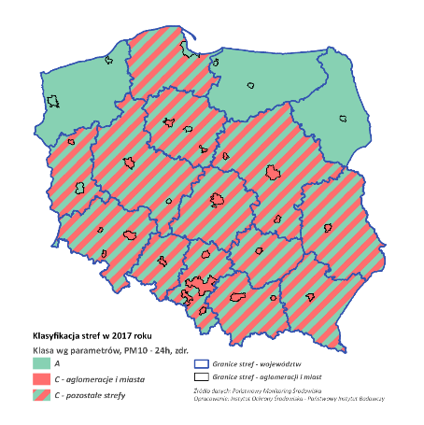

*Map legend : Klasyfikacja stref w 2017 ­– Zone classification in 2017; Klasa wg parametrów PM10 - 24h – Class acc. to parameters, PM10 – 24h; aglomeracje i miasta – agglomerations and cities; pozostałe strefy – other zones; Granice stref – województw – Zone borders ­– voivodships; Granice stref – aglomeracji i miast – Zone borders ­– agglomerations and cities; Źródło danych: Powiatowy Monitoring Środowiska ­– Data source: County Environmental Monitoring; Opracowanie: Instytut Ochrony Środowiska – Państwowy Instytut Badawczy – Elaboration: Institute of Environmental Protection – National Research Institute*

*Source: Chief Inspectorate for Environmental Protection – Inspection for Environmental Protection, Assessment of the Air Quality in Zones in Poland for 2017, Warszawa, 2018, p. 52.*

In the assessment of air quality for 2017 concerning PM10 carried out as part of the State Environmental Monitoring, among 46 zones subject to assessment based on 24-hour concentrations, only 12 zones were classified as Class A. The rest, i.e. 34 zones, have been classified as Class C[47].

Exceeded values of the PM10 daily limit value occur in large cities and agglomerations as well as in smaller cities and towns and even in rural areas, especially in valleys and depressions where the topography is conducive to the accumulation of pollutants.

Due to the topography, dominant heating method and population density, exceeded values of acceptable levels for particulate matter are most frequent in cities and agglomerations located in southern and central Poland (Upper Silesian Agglomeration, Kraków Agglomeration, Rybnik-Jastrzębie Agglomeration, Łódź Agglomeration). For example, in 2017, in 9 out of 12 Polish agglomerations, the number of days on which the average daily concentration of PM10 exceeded 50 µg/m3 was greater than 35, which means that the limit for this pollutant was exceeded. In three Agglomerations, i.e. Szczecin, Trójmiasto (Tri-City) and Białystok, this limit was not exceeded. The number of days with exceeded values determined on the basis of measurements at the station with the highest number of days with exceeded values was 24 each for the first two agglomerations and 13 for Białystok.

*Fig. 3.5. Number of days with exceeded values of the 24-hour limit value for PM10 in 2017 at measuring stations located in agglomerations, with an exceeded values limit of 35 days (red line).*

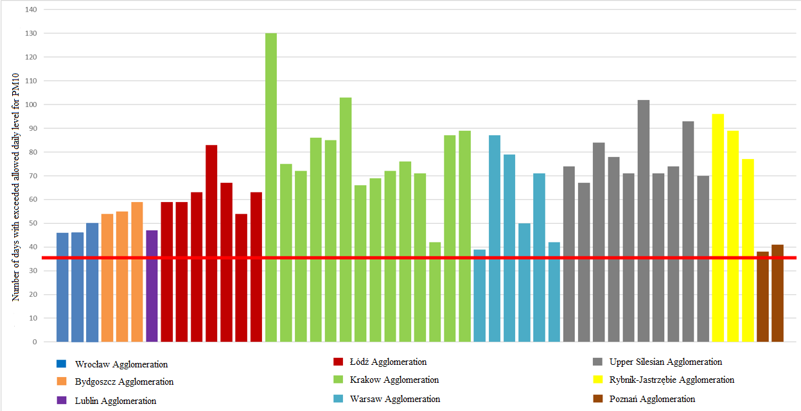

*Source: GIOŚ*

The agglomerations with the highest number of days with exceeded values of the PM10 admissible level for particulate matter are the Kraków Agglomeration, in which in 2017 the number of days with exceeded values at measurement stations ranged from 42 (number of days at the station with the lowest number of days with exceeded values – minimum number of days with exceeded values) to 130 days with exceeded values (number of days at the station with the highest number of days with exceeded values – maximum number of days with exceeded values); Upper Silesian Agglomeration, where 67 to 102 days with exceeded values were recorded at measurement stations, and Rybnik-Jastrzębie Agglomeration, where, depending on the station, 77 to 96 days with exceeded values were recorded.

As part of the State Environmental Monitoring, measurements of PM2.5 have been carried out since 2010 at urban background stations located in agglomerations and cities with over 100 000 inhabitants in order to determine the average exposure of the people to PM2.5. Those measurements shall be used to calculate the national average exposure indicator and the city-specific average exposure indicator for cities with over 100 000 inhabitants and agglomerations.

*Fig. 3.6. National average exposure indicator for PM2.5 over the period 2010-2017 for: (a) the national exposure reduction target (yellow line), (b) the exposure concentration ceiling (red line).*

*Source: GIOŚ, State of the Environment in Poland. Report 2018, Biblioteka Monitoringu Środowiska (Environmental Monitoring Library), 2018, p. 98.*

The national average PM2.5 exposure indicator for 2017 was 22 µg/m3 and its value exceeded both the national PM2.5 exposure reduction target and the exposure concentration ceiling.

*Fig. 3.7. Average PM2.5 exposure indicators for the years 2011-2017 in relation to: (a) the national exposure reduction target – 2020 target for urban background areas of large cities and agglomerations (black line), (b) the exposure concentration ceiling – 2015 ceiling for urban background areas of large cities and agglomerations (yellow line), (c) the limit value – 2015 target for the entire country (red line).*

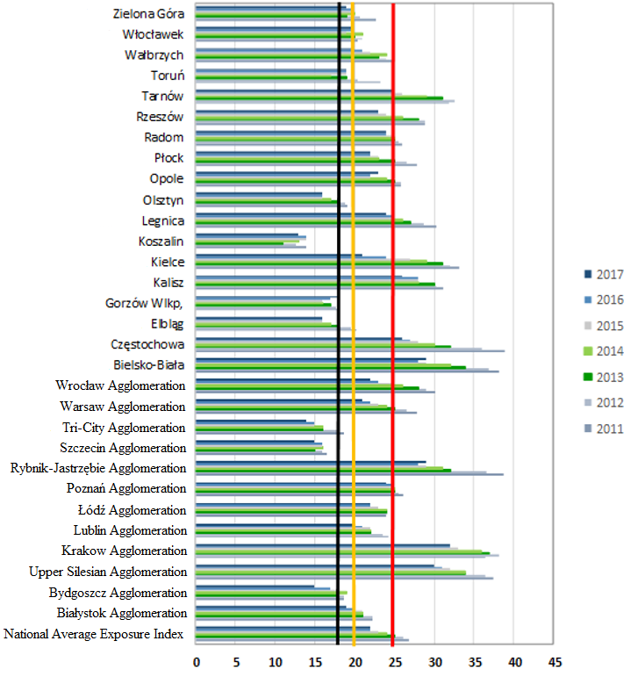

*Source: GIOŚ/PMŚ.*

In 2017, only 4 cities (Koszalin, Gorzów Wielkopolski, Olsztyn, Elbląg) and 3 agglomerations (Szczecin, Tri-City and Bydgoszcz) achieved the national PM2.5 exposure reduction target (18 µg/m3). Cities: Zielona Góra, Toruń, Włocławek and Wałbrzych as well as agglomerations: Lublin and Białystok complied with the exposure concentration ceiling (20 µg/m3).

Despite a decrease in the value of part of the average exposure indicators for 2017 compared to 2016 and 2015, in all large cities as well as central and southern agglomerations of Poland, the average PM2.5 exposure indicators exceed the exposure concentration ceiling (20 μg/m3). In the Agglomerations: Upper Silesian, Rybnik-Jastrzębie, Kraków and in three cities with over 100 thousand inhabitants: Bielsko-Biała, Częstochowa and Kalisz, measurement sites for the average PM2.5 exposure, the acceptable level (25 μg/m3) has been exceeded.

The average exposure indicator values for rural areas of southern and south-western Poland are close to the national exposure reduction target (18 μg/m3) – "Osieczów" station – 16 μg/m3 and "Złoty Potok" station – 20 μg/m3. The comparison of the calculated average exposure indicators clearly shows that the greatest potential for the reduction of PM2.5 concentration in the air is demonstrated by cities and agglomerations from the following voivodships: Śląskie and Małopolskie, which confirms the significant impact of low emissions on the concentration of PM2.5.

It is estimated that air pollution by PM2.5 is responsible for more than 400 000 premature deaths in the European Union, including nearly 80% of deaths from respiratory diseases and lung cancer (EEA, 2014).

Particulate matter can also affect vegetation both directly – through leaf surface deposition and indirectly – by changing soil chemistry. Their impact reduces the resistance of plants to biotic stresses such as fungal diseases, viral diseases, pathogens and pests[48].

Polycyclic aromatic hydrocarbons (PAHs) are also important air pollutants in terms of effects on health. These compounds have proven carcinogenic and mutagenic properties. In the assessment of air quality, the indicator of PAHs air pollution level is benzo(a)pyrene determined in PM10 suspended particulate matter.

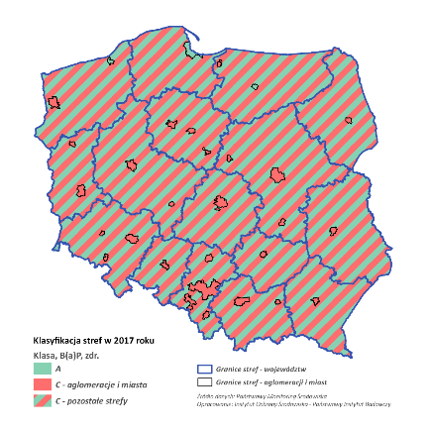*Fig. 3.8. Classification of zones in Poland for benzo(a)pyrene on the basis of annual air quality assessment for 2017 (health protection).*

*Map legend : Klasyfikacja stref w 2017 ­– Zone classification in 2017; Klasa B(a)P, zdr. – Class, B(a)P, health; aglomeracje i miasta – agglomerations and cities ; pozostałe strefy – other zones ; Granice stref – województw – Zone borders ­– voivodships ; Granice stref – aglomeracji i miast – Zone borders ­– agglomerations and cities ; Źródło danych: Powiatowy Monitoring Środowiska ­– Data source: County Environmental Monitoring ; Opracowanie: Instytut Ochrony Środowiska – Państwowy Instytut Badawczy – Elaboration: Institute of Environmental Protection – National Research Institute.*

*Source: Chief Inspectorate for Environmental Protection – Inspection for Environmental Protection, Assessment of the Air Quality in Zones in Poland for 2017, Warszawa, 2018, p. 85.*

The assessment of air quality for the year 2017 for benzo(a)pyrene carried out as part of the State Environmental Monitoring showed that out of 46 zones subject to assessment, 3 zones were classified as Class A (Tri-City Agglomeration, cities: Olsztyn and Koszalin). As many as 43 zones were classified as Class C. Such a large number of zones categorised as Class C is associated with a very low threshold value defined for benzo(a)pyrene[49] which is difficult to meet and the structure of fuel consumption in households. The source of air pollution with benzo(a)pyrene is incomplete combustion of fuels. Therefore, the highest concentrations of benzo(a)pyrene and other polycyclic aromatic hydrocarbons occur in the autumn and winter in densely developed areas where houses or apartments are heated individually with coal or wood.

## Ozone

Ozone is a powerful photochemical oxidant that can have a significant impact on human health. "Increased concentrations of ozone in the air above the legal limits may lead to inflammatory reactions of the eyes or respiratory tract diseases, including exacerbation of asthma symptoms and decreased lung function"[50]. It can also lead to exacerbating cardiovascular diseases. Ozone can cause drowsiness, headache and fatigue, as well as a drop-in blood pressure[51]. In addition, increased ozone concentrations destroy vegetation and cause accelerated corrosion of materials.

"Tropospheric ozone is a secondary pollutant and is produced by photochemical reactions of nitrogen oxides and volatile organic compounds"[52]. In addition to precursor emissions, its concentration is also significantly influenced by meteorological conditions. "The formation of ozone is favoured by sunny weather, high air temperatures. Ozone has the ability to be transported over long distances, therefore its concentrations in Poland depend to a large extent on its concentration in the air masses flowing into Poland – mainly from southern and south-western Europe"[53].

*Fig. 3.9. Classification of zones in Poland for O3 on the basis of air quality assessment for 2017 (target level, health protection). A and C refer to the classification of zones for human health impact: zone A – areas where ozone concentrations did not exceed the target level; zone C – areas where ozone concentrations exceeded the target level.*

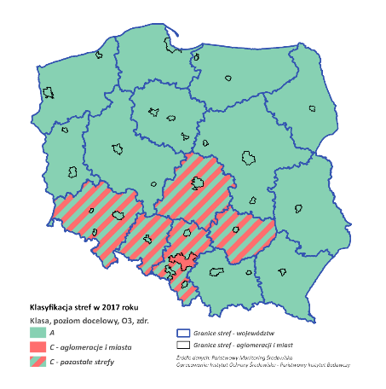

*Map legend : Klasyfikacja stref w 2017 ­– Zone classification in 2017; Klasa, poziom docelowy, O3, zdr. – Class, O3 target level, health; aglomeracje i miasta – agglomerations and cities; pozostałe strefy – other zones; Granice stref – województw – Zone borders ­– voivodships; Granice stref – aglomeracji i miast – Zone borders ­– agglomerations and cities; Źródło danych: Powiatowy Monitoring Środowiska ­– Data source: County Environmental Monitoring; Opracowanie: Instytut Ochrony Środowiska – Państwowy Instytut Badawczy – Elaboration: Institute of Environmental Protection – National Research Institute*

*Source: Chief Inspectorate for Environmental Protection – Inspection for Environmental Protection, Assessment of the Air Quality in Zones in Poland for 2017, Warszawa, 2018, p. 44.*

A Class C designation does not mean that air quality does not meet the criteria throughout the entire zone. Nor does it mean that intensive efforts are required to improve air quality across the entire zone. It means, however, the need to take appropriate action in relation to selected areas in the zone (usually of limited range).

In the annual assessment of air quality for the year 2017 concerning ozone, carried out within the framework of the State Environmental Monitoring, in terms of meeting the target level set for health protection, the classification was based on the number of days with an 8-hour concentration exceeding 120 µg/m3 averaged over the period of 1-3 years. In this assessment, only within 6 zones in the country (out of 46 zones in total) there were areas where the target level in terms of health protection was exceeded.

The classification of zones for ozone in relation to the target level shall take into account concentrations between one and three years (subject to available measurement results), that is to say concentrations in 2015, 2016 and 2017. The year 2015 was characterised by a relatively frequent occurrence of unfavourable meteorological conditions favourable for the formation of ozone in the atmospheric air. In addition to ozone precursor emissions, this was the main reason for frequently exceeding the target ozone concentration level. In 2016 and 2017, the frequency and intensity of occurrence of meteorological conditions favourable for the formation of ozone in the atmosphere were lower than in 2015.

In the annual air quality assessment for 2017, the level of the long-term health objective (maximum 8-hour concentration of 120 µg/m3) was exceeded in 42 zones. In the remaining 4 zones (in the Szczecin Agglomeration, cities: Toruń, Olsztyn and Elbląg), this level was met.

The main reason for exceeding the long-term target for ozone is the impact of natural emission sources or natural phenomena not related to human activities and the occurrence of meteorological conditions favourable to the formation of ozone in the atmosphere. Additional causes are emissions of ozone precursors in urban areas and air pollution inflows from outside the country (transboundary nature of pollution).

*Fig. 3.10. Average number of days with exceeded values of the 8-hour moving average of the target concentration of ozone (120 µg/m3) from the period 2015-2017 for the area of Poland; modelling results at the resolution of 5 km.*

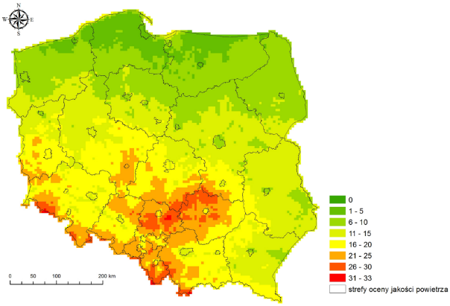

*Map legend: strefy oceny jakości powietrza – air quality assessment zones.*

*Source: GIOŚ, State of the Environment in Poland. Report 2018, Biblioteka Monitoringu Środowiska (Environmental Monitoring Library), 2018, p. 89.*

The current system of international cooperation for the protection of the ozone layer is based on the Vienna Convention for the Protection of the Ozone Layer, concluded in Vienna on 22 March 1985. The Convention was the first successful attempt to establish a framework and principles for joint action by different countries for the protection of the ozone layer. The Republic of Poland acceded to the Vienna Convention on 13 July 1990.

The Montreal Protocol on Substances that Deplete the Ozone Layer was drawn up on 16 September 1987 as a follow-up to the Convention concluded two years prior. The signatories undertook to take action to save the ozone layer. In the case of Poland, the Protocol entered into force on 11 October 1990. On 1 January 2019, the 5th amendments to the Montreal Protocol – the Kigali Amendments – entered into force. In order to protect the health of the population and the natural environment in Poland, a number of pollution reduction instruments have been established to help achieve good air quality. The most important of these are permits to emit gases and particulate matters into the air, integrated permits, emission standards for plants, fuel quality standards and air protection programmes in areas where air quality standards have not been met. Furthermore, the energy consumption in the Polish economy is gradually decreasing.

On 9 September 2015, the National Air Protection Programme was adopted, the implementation of which is to enable the achievement of permissible levels of particulate matter and other harmful substances in the air resulting from the binding provisions of law in the shortest possible time. It is worth noting that in order to strengthen the effectiveness of activities resulting from air protection programmes and short-term action plans, local governments have received an additional tool under the amendment of the Environmental Protection Law (the so-called Anti-Smog Law) of 10 September 2015. (OJ L, item 1593). Pursuant to Article 96 of the Act of 27 April 2001 – Environmental Protection Law (OJ L of 2018, item 799, as amended), the Voivodship Assembly may, by way of a resolution, impose restrictions or prohibitions on the operation of plants involving the combustion of fuels in order to prevent a negative impact on human health or the environment. At the same time, the resolution specifies the types or quality of fuels allowed or prohibited for use. Due to the unsatisfactory condition of air quality in Poland, at the request of the Prime Minister Beata Szydło, the Economic Committee of the Council of Ministers on 25 April 2017 presented recommendations to the Council of Ministers – the "Clean Air" programme. It should be emphasised that measures to improve air quality were also included in other key documents, including the Strategy for Responsible Development – Clean Air Project, as well as in the Electromobility Development Plan – Energy for the Future. An important step in this process is the publication of the Regulation of the Minister of Development and Finance of 1 August 2017 on requirements for solid fuel boilers (OJ L, item 1690, as amended). The Regulation requires the entities responsible for marketing solid fuel boilers with a rated thermal input of 500 kW or less to apply the design requirements established to ensure that the emission limit values for carbon monoxide, organic gaseous compounds and particulate matter laid down in the Regulation are complied with. In addition, it prohibits the use of "failure grates" in the construction of boilers.

# Land surface, including soils[54]

Soil is an important and usually non-renewable natural resource and is defined as the superficial, biologically active layer of the Earth's crust resulting from the soil-forming process of a geological formation as a result of weathering processes. The soil consists of mineral particles, organic matter, water, air and living organisms. It is one of the main elements of the natural environment and the habitat of a large number of living organisms.

In the Polish legal system, soil protection is related to a broader concept of land surface protection and includes also protection against pollution and other forms of degradation, including ground layers underneath the soil. According to the provisions of the Act of 27 April 2001 on Environmental Protection Law, the surface of the Earth is defined as the relief of the land, soil and groundwater, whereby soil means the upper layer of the lithosphere, composed of mineral parts, organic matter, soil water, soil air and organisms, including the upper layer of the soil and subsoil, land – means the upper layer of the lithosphere, located below the soil, to the depth of human influence, while groundwater – means groundwater within the meaning of Article 16(68) of the Act of 20 July 2017 on Water Law, which is located in the saturation zone and is in direct contact with the soil or subsoil.

In the traditional approach, the importance of soils was limited to their production functions in agriculture and forestry. In fact, in addition to providing us with food, biomass and raw materials, soil has many other environmental, economic, social and cultural functions.

Soil is the basis for the development of life and biodiversity. It plays an important role in storing, filtering and transforming nutrients, substances and water. It is a carbon sink. The role of soil in landscape design and protection of geological, geomorphological and archaeological heritage is also important.

The land surface, including soil, provides space and resources for human life and economic development. It is necessary to carry out various production processes (e.g. cultivation of plants, extraction of raw materials) and it is also a place of various social and economic activities (e.g. construction of road, industrial, service and housing infrastructure).

Soil resources should be used in such a way as to ensure that they are in the best possible condition for future generations.

The structure of land use in Poland (according to the Statistics Poland) is determined by agricultural and forestry functions, constituting the largest share in the country's area (about 90%), where forests, including tree and shrub groups, constitute about 30%. Urbanised and developed areas take up about 5% of the country's area, and among them the dominant group are areas with a transport function. Of the remaining area, about 4% is underwater land (2%), ecological land (0.1%), wasteland (1.5%) and miscellaneous land (0.3%)[55].

*Fig. 4.1. Structure of land use (%).*

*Source: Own elaboration based on the data from Statistics Poland, Environmental Protection 2017, p. 47 (for the years 2000-2016) and Environmental Protection 2018, p. 35 (for the year 2017).*

Over the last two decades, there have been no significant changes in the land use structure in Poland. Whereas significant importance for soil protection should be attached to land use planning principles affecting the re-use of brownfield sites in order to prevent soil being excluded from agricultural and forestry use.

Soil is the basic production resource of agriculture, so its good condition in Poland represents a potential for the production of high-quality food. In Poland there are mainly levisols, brown, podsolic and rusty soils, mainly from postglacial formations. The soil cover in Poland is characterised by a mosaic-like structure with the predominance of soils of the medium quality class (IVa and IVb) – 35.2% and poor and very poor soils (V and VI) – 37.3%. Agricultural land of high suitability for agricultural production are relatively rare: soils of Classes I-III constitutes about 25% of the total area and therefore should be subject to special protection.

In addition to very slow soil formation processes, they are also subject to degradation processes (chemical, physical and biological). Human activity modifies the properties of soils in many directions, which affects their functions. The degradation processes include the following phenomena: pollution, erosion, organic matter decline, thickening, salinisation, acidification, sealing. An important result of these processes is loss of soil fertility, reduction of soil biodiversity, lower water retention capacity, disturbance of the gas and nutrient cycle and slower decomposition of pollutants. Among the identified numerous threats to soils, the issue of soil pollution and the issue of organic matter decline and erosion seem to have the highest priority from the point of view of environmental protection in Poland. Soil pollution should be considered as a hazard of the highest level, as it affects human health and the environment regardless of the area affected. The risk of soil erosion is also important in terms of nutrient displacement and water pollution, as well as the reduction of soil fertility. The need to counteract the decline in soil organic matter is linked to the need to maintain fertility. In addition, it is also important that humus is an important part of the lithosphere carbon reserves and therefore limiting organic matter decline in soils is important to prevent climate change. At present, the poorly perceived phenomenon of sealing may become a problem in the future.

Pollution of the soil surface shall be assessed on the basis of the exceeding the acceptable levels of substances causing risk in the soil or in the land. The tolerable content of a substance constituting a risk is considered to be that below which no function of the land surface is significantly impaired.

Pollutants have a toxic effect on soil organisms, potentially disrupting habitat functions and limiting biodiversity. The transport of pollutants to water and their absorption by plants may cause health hazards as a result of their penetration into the food chain. On the basis of the assessment of the quality of agricultural products carried out by the competent authorities, it can be concluded that they confirm no significantly exceeded values of the maximum residue levels of various types of organic compounds.

The economic sectors affecting soil pollution include mainly waste management, industry, transport, energy production, mining and agriculture. Soil pollution in Poland is strongly differentiated due to different intensity of industrial production and its nature.

Within the framework of the State Environmental Monitoring in the field of land and soil quality, research is conducted in order to observe changes in a wide range of chemical properties of soils used for agriculture, occurring under the influence of agricultural and non-agricultural human activity. Monitoring of the chemistry of arable soils in Poland has been carried out since 1995. At 5-year intervals, soil samples are taken and analysed from permanent monitoring stations located throughout the country. The summary of the data obtained in the fifth sampling edition shows that in 2015, for most of the characteristics describing soil properties and quality, there were no significant changes in 20 years compared to the baseline situation. The analysis of data for 2015 with the use of pollution assessment criteria specified in binding regulations indicates that 98% of arable soils in agricultural areas in Poland are not contaminated with trace elements. Furthermore, in the analysis of trace elements, no trend of accumulation in the surface layer of soils in the case of areas used for agricultural purposes was observed.

Also, the results of measurements of the content of polycyclic aromatic hydrocarbons in individual years do not indicate an increase in the content of the sum of these compounds over the last 20 years. The PAHs content in soils within agricultural areas away from emission sources is generally low. The content of other organic pollutants in soils has so far, as in other countries, been measured to a much lesser extent and the information is limited. In industrial and urbanised areas, the highest PAHs contents are recorded in the vicinity of coking plants and petrochemical plants, as well as in areas related to road transport.

There is currently no consistent information regarding local land and soil pollution in a single system, both at regional level and for the entire country. The General Director for Environmental Protection maintains a register of historical pollution of land surface and a register of environmental damage (including environmental damage to the surface). The register of historical pollution of the land surface has not yet reached its full functionality, as the process of identification of potential historical pollution is in progress and is carried out by starostas (county administrators). The lists drawn up by them will be incorporated in the existing registry.

An important indicator of soil quality is the content of organic matter. It determines physicochemical properties such as sorption and buffer capacity, soil retention properties and biological processes occurring in the soil. High humus content in soils is a factor stabilising the structure, reducing susceptibility to compaction and degradation as a result of water and wind erosion. Soils, are the second largest carbon sink after the oceans, having a significant impact on the carbon content of the atmosphere. Forest soils play a special role in this respect. Therefore, soil, as a carbon sink, deserves special protection because of its role in limiting climate change.

Significant reasons leading to a decrease in the content of organic matter are the deterioration of water conditions of soils (dryness, ineffective irrigation and drainage systems), introduction of simplified crop rotations (e.g. cereal monocultures), limitation of organic fertilisation. A decrease in the organic matter content leads to negative physical, chemical and biological changes in the soil and a decrease in soil fertility, biodiversity decline and localised erosion.

According to the data obtained within the framework of the State Environmental Monitoring, in 2015 the average humus content in the tested arable soils amounted to 1.94% with the median of 1.68% and did not differ significantly from the results of the previous measurement cycles. Within the entire group of analysed soils, the majority were classified in the range of average content (1-2%), their share amounted to 62.9%. With the exception of 2005, this share has remained relatively stable since 1995[56].

The quality of soil is also affected by its pH, which is one of the most important factors determining the course of many soil processes and has a significant impact on the formation of soil capability and fertility. Acidic soils are predominant in Poland. The share of acidic and very acidic soils amounts to approximately 50%. Acidification is mainly due to natural conditions, such as the mineralogical composition of the soil and the type of parent rock, as well as the content and transformation of organic matter. The anthropogenic factors of soil acidification include the use of nitrogen fertilisers, mainly in the form of ammonium sulphate and to a lesser extent urea and ammonium nitrate, as well as industrial emission of acidogenic air pollutants (SO2, NOx, NH3),originating fromthe combustion of minerals, most frequently coal and petroleum derivatives.

Soil protection from agricultural pressure is linked to the rational use of fertilisers, minerals and crop protection products, as well as the introduction of production methods in agriculture which comply with the general principles of integrated pest management.

The effect of fertilisation is optimised through the continuous improvement of fertilisation consulting, including the introduction of better soil tests and electronic advice systems that take into account not only the production aspects of fertilisation but also its environmental effects. Optimization of fertilization is possible due to the functioning of the agrochemical system of agricultural services in Poland, implemented by the National Chemical and Agricultural Station and 17 district chemical and agricultural stations carrying out, among others, soil fertility tests, and consulting fertilisation plans. The fertilisation consulting system is also widely implemented by the Agricultural Advisory Centres, which provide training in the scope of fertilisation (nutrient balancing, preparing fertilisation plans) and offer direct consulting services for farmers. Scientific institutions, including the Institute of Soil Science and Plant Cultivation in Puławy, which provides specialist computer software – Naw Sald and Macrobil – to help farmers optimise fertilisation, also contribute to the promotion of proper nutrient balancing and sustainable fertilisation methods.

One of the conditions for producing safe food is to prevent risks associated with the use of crop protection products. This objective is made possible by the mandatory application of the principles of integrated pest management, introduced on 1 January 2014. Monitoring the progress in the application of integrated pest management and supporting activities conducive to limiting the use of crop protection products is possible due to the implementation of the National Action Plan (KPD) for limiting the risk related to the use of crop protection products.

Erosion is also an important process of soil degradation. It involves soil particles removal by water or wind and transporting them to sedimentation locations. The factors causing erosion can be divided into two groups, i.e. natural factors (topography, soil, precipitation, wind and vegetation) and anthropogenic factors (soil/land use structure, farming system).

The direct consequence of erosion is the disruption of ecological, technical, economic and cultural functions of soil. Erosion exacerbated by anthropogenic factors is a socially and economically undesirable phenomenon, causing water pollution, decline of agricultural production, permanent land degradation and destruction of infrastructure.

In Poland, potential water erosion occurs in about 29% of the country's area, with medium to very strong erosion in about 13% of the area and wind erosion in 28.2% of the area.

Sealing is the most visible form of soil transformation by man and, at the same time, the most far-reaching form of soil degradation, regardless of the extent of the economic benefits it provides. Soil sealing is defined as the separation of soil from other ecosystem elements such as biosphere, atmosphere, hydrosphere and anthroposphere by artificial layers made of wholly or partially impermeable material. In 2016, an approx. 13.7% increase in the area of developed and urbanised land was observed in Poland compared to the data for 2005, while the total area of developed and urbanised land in Poland only amounts to approx. 5%. The initiated upward trend is therefore only visible on a local scale.

The causative factor of soil sealing is a strong dependence of economic development on soil loss and transformation of soil functions. The list of areas of socioeconomic life benefiting from sealing includes transport and communication; housing; healthcare; security; social development; physical and information technology environments; use of natural resources; provision of goods and services; communication; urban and spatial planning.

The issues of transforming natural topography are not without significance for the protection of land surface. Surface transformation is an unfavourable change in its structure and properties, as well as a disturbance in water conditions in a given area. Very often, the cause of morphological degradation are locations associated with the mining of minerals now and in the past (the so-called workings and sinks).

Data regarding devastated and degraded land requiring rehabilitation and management pertain to land that has lost all its value in use (devastated land) and land whose agricultural or forestry value has decreased as a result of natural or environmental deterioration or changes in the environment and industrial activity, as well as incorrect agricultural activity (degraded land).

Devastated and degraded lands were inventoried on the basis of criteria and principles specified in the regulations on the protection of agricultural and forestry land. Therefore, it is worth noting that these regulations are correctly applied to the rehabilitation of land after mining activities, and do not apply to contaminated land. Changes in the area of devastated and degraded lands are presented in the chart below, prepared on the basis of data from Statistics Poland.

*Fig. 4.2. Devastated and degraded lands (ha).*

*Source: own elaboration based on Statistics Poland – Local Data Bank, State and Protection of the Environment.*

In order to ensure effective protection and sustainable use of soils, all activities in this respect should be based on principles warranting prevention of soil degradation and maintenance of its functions, and in case of occurrence of these processes, restoration of proper functions to degraded soils, taking into account the current and planned use of soils.

# Environmental hazards[57]

## Biosafety, including genetically modified organisms

The use of the products of modern biotechnology in many areas of everyday life can pose a threat to the both human health and the environment. The task of the government administration is primarily to create conditions for conducting activities involving genetically modified organisms.

The development and possibility of application of biotechnological methods in agriculture and food production is one way of promoting modern methods for these sectors. The marketing of products obtained by biotechnological methods shall be preceded by their production in processes of contained use and testing within the framework of their deliberate release into the environment. Among other functions, this is to guarantee the high quality of these products. The use of biotechnological processes in various areas of life should serve the needs of society while ensuring the safety of the natural environment. The use of genetically modified organisms (GMOs) must be preceded by the authorisation of such organisms on the basis of an advanced procedure and analysis of risk through the use of a genetically modified organism for human health, animal health and the environment. The pre-marketing decision process for GMO products is based on scientific expertise and a reliable risk assessment.

The fundamental role that the law should play in the field of biotechnology is to protect human life, health and the environment. The principle of protection of human health and the environment was the guiding principle of both the authors of European law on genetically modified organisms and the authors of international regulations on the issue of transboundary movements of living modified organisms (LMOs).

The basic legal acts of the European Union regulating the issues related to genetically modified organisms are:

* Directive 2009/41/EC of the European Parliament and of the Council of 6 May 2009 on the contained use of genetically modified micro-organisms (OJ L 125 of 21.05.2009, p. 75), which lays down common measures for the contained use of genetically modified micro-organisms with the aim of protecting human health and the environment,
* Directive 2001/18/EC of the European Parliament and of the Council of 12 March 2001 on the deliberate release into the environment of genetically modified organisms and repealing Council Directive 90/220/EEC (OJ L 106 of 17.4.2001, p. 1, as amended); Polish translation section 15, vol. 6, p. 77, as amended). This Directive regulates the deliberate release of GMOs into the environment for purposes other than placing on the market (experimental purposes) and the marketing of GMO products. It implements the obligation to take into account the cumulative effects of a GMO on human health and the environment.

The issue of transboundary movements of genetically modified organisms in European Union legislation should be considered in two aspects. On the one hand, it concerns the movement of genetically modified organisms between the territories of the Member States of the Community, and on the other – it concerns the movement of GMOs between the Community (Community countries) and third countries. The issue of intra-Community movements of GMOs is regulated by Directive 2001/18/EC[58]. In accordance with the provisions of this Directive, any deliberate release of GMOs into the environment, as well as the marketing of GMOs as or within products, may be carried out after a decision has been taken to authorise such activities. At the same time, all Member States of the Community have the opportunity to express their views and reservations on the proposals for the activities in question.

A particularly important instrument of international law applicable to the transboundary movement, transit, transfer and use of all living modified organisms that may have a negative impact on the conservation and sustainable use of biological diversity, including threats to human health, is the Cartagena Protocol on Biosafety to the Convention on Biological Diversity. The Protocol shall not apply to transboundary movements of living modified organisms which are pharmaceuticals for human consumption covered by other relevant international agreements or activities of international organisations. The Republic of Poland ratified this document on 26 November 2003. It entered into force on 9 March 2004 and, as a result, Poland became a Party to this Agreement from that date.

The basic legal act regulating the issues of genetically modified organisms and micro-organisms is the Act of 22 June 2001 on genetically modified micro-organisms and organisms (OJ L of 2019, item 706). The material scope of this law includes:

* the contained use of micro-organisms and genetically modified organisms (GMMs and GMOs) and the establishment of genetic engineering facilities,
* the deliberate release into the environment of GMOs for purposes other than placing on the market,
* the marketing of GMO products,
* the competence of government administration bodies in matters relating to GMOs.

The aim of this act is to ensure biological safety and protection of the environment and human health in relation to activities involving genetically modified organisms. This law transposes European legislation and the scope of the *Cartagena Protocol on Biosafety.*

## Acoustic climate

Noise shall mean sounds at frequencies from 16 Hz to 16 000 Hz[59].

Noise is a stressor and a significant public health risk[60]. Long-term exposure to noise causes: irritability, sleep disorders, impaired perception and performance of generally any activity, contributes to the development of psychosomatic diseases.

The sources of environmental noise are roads, railway lines, tramways, airports and airplanes, power lines, industry, services, commerce, entertainment and any other activities related to the emission of acoustic energy.

Exposure to noise in Poland as well as in Europe generally shows an increasing trend, particularly in urban areas. The increasing exposure to noise at night is a worrying phenomenon.

According to the World Health Organisation (WHO) and the JointResearch Centre (JRC) of the European Commission[61], every year, traffic-related noise causes a loss of a total of more than 1 million years of healthy life by the citizens in the Member States of the European Union and in other countries of Western Europe[62].

The assessment of the acoustic climate of the environment in Poland is carried out within the framework of the State Environmental Monitoring on the basis of acoustic maps prepared in accordance with the Directive 2002/49/EC of the European Parliament and of the Council[63] every five years, starting from 2007. Furthermore, in the areas not covered by the acoustic mapping, the assessment of the acoustic climate of the environment is carried out by Voivodship Inspectorates for Environmental Protection on the basis of annual planned and intervention noise measurements and on the basis of noise measurements carried out by the legally obliged entities.

At present, acoustic maps are made with reference to:

* cities with over 100 000 inhabitants,
* major roads (i.e. roads with over 3 million vehicles of traffic volume annually),
* main railway lines (i.e. railway lines with over 30 000 trains of traffic volume annually),
* major airports (i.e. civil airports with over 50 000 annual take-off or landing operations – excluding those for training purposes).

Road noise

Road noise is the source of the greatest negative and burdensome acoustic impact on the environment both in urban areas, where the number of people exposed to this noise is still increasing, and in areas outside agglomerations. Road noise is particularly troublesome at night, as it causes significant sleep disturbance. At the same time, it should be pointed out that there is an increase in the traffic volume on the roads, as well as the construction of new roads.

*Fig. 5.1. Percentage distribution of short-term road noise in the light of the 1993-2015 survey.*

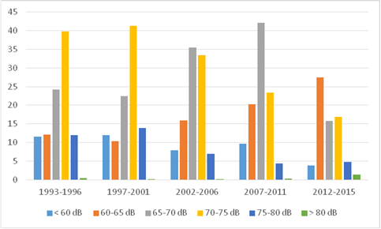

*Source: own elaboration based on data from the “Ehałas” database (GIOŚ/PMŚ).*

Comparing successive periods of noise monitoring studies, it should be remembered that since 2007 the Voivodship Inspectorate for Environmental Protection has been carrying out measurements at roads not covered by the process of preparing acoustic maps, i.e. at roads with fewer than 3 million vehicles per year. However, as the measurements of the WIOŚ show, roads with lower traffic intensity also exceed the permissible sound levels in areas protected from an acoustic point of view.

In total, in the years 2012-2015, the Voivodship Inspectorates for Environmental Protection in Poland took measurements of long-term noise in areas subject to acoustic protection at 698 measurement locations.

*Fig. 5.2. Percentage of long-term road traffic noise measurement points (expressed as the LAeqN index[64]) for individual classes of exceeding permissible sound levels in 2012-2016.*

*Source: own elaboration based on: GIOŚ, Summary of Noise Measurements in 2012-2016, p. 9, http://www.gios.gov.pl/ (accessed: 15.02.2019).*

*Fig. 5.3 Percentage of long-term road traffic noise measurement points (expressed as the LAeqD index[65]) for individual classes of exceeding permissible sound levels in 2012-2016.*

*Source: own elaboration based on: GIOŚ, Summary of Noise Measurements in 2012-2016, p. 9, http://www.gios.gov.pl/ (accessed: 15.02.2019)*

The noise level ranges comply with the Regulation of the Minister of Environment of 1 October 2007 on the detailed scope of data included in acoustic maps and their arrangement and manner of presentation (OJ L, item 1340, as amended).

*Tab. 5.1. Population of cities with over 100,000 inhabitants exposed to road noise, expressed as the LN index on the basis of acoustic maps prepared in the second round of mapping (year 2017)[66].*

|  |  |  |  |  |
| --- | --- | --- | --- | --- |
| LN 50–54 dB | LN 55–59 dB | LN 60–64 dB | LN 65–69 dB | LN over 70 dB |
| **1,510,600** | **862,000** | **313,530** | **64,500** | **19,600** |
| **Total: 2,770,230** | | | | |

*Source: own elaboration based on: EIONET, Strategic Noise Maps, https://cdr.eionet.europa.eu/ (accessed: 05.03.2019).*

Data from acoustic maps prepared within the framework of the second round of mapping (2012) indicate that the **exposure of the population in Poland to road noise** is a significant problem. Out of over 10 million people living in cities with more than 100 000 inhabitants, nearly 4 million people are exposed to noise at night.

The population exposed to road noise at night in areas for which there is no obligation to make acoustic maps is just over 23 000. This value was calculated in a simplified way on the basis of monitoring tests of road noise carried out by the Voivodship Inspectorates for Environmental Protection. For this calculation, the number of single-family buildings and the number of apartments in multi-family buildings exposed to noise were taken into account in the specific exceeded value ranges, assuming that, on average, 3 individuals live in a single-family house and 2 individuals live in a flat.

Industrial noise

According to the environmental protection regulations, its source are not only industrial plants or service providers, but also all activities (apart from the operation of roads, railway lines, airports, power lines) causing noise.

Measurements of industrial noise are usually performed as interventions – in response to complaints of residents regarding burdensome activities. The percentage of businesses exceeding noise limits has been on a downward trend over the last twenty years. In the 2002-2006 measurement cycle, 55% of industrial facilities surveyed in the entire country exceeded the permissible noise levels, and in the 2007-2011 cycle – 45% of facilities. In the last monitoring cycle (2012-2015) this percentage is 34[67].

Railway noise

The impact of railway noise on the environment is systematically decreasing due to the modernisation of railway lines and the application of technical solutions more friendly to the acoustic environment (contactless rails, anti-vibration mats, type and condition of brakes), a decrease in the number of trains, as well as the decommissioning of some railway lines. Since the 1990s, we have been observing a systematic decrease in the length of railway lines in operation and a decrease in the number of transported passengers and cargo[68].

Air traffic noise

The importance of air transport has increased significantly in recent years. Air traffic is intensifying, with more and more passengers and freight carriers using it. At the same time, the development of regional airports is being observed. Air traffic noise ranges are high due to the high noise levels during take-off and landing operations of all types of aircraft. It should be pointed out that there is a lack of effective environmental protection against air traffic noise. Measurements taken as part of the continuous noise monitoring around airports show that air traffic does not cause significant nuisance in residential areas for the entire year, but there are periods during the year when such nuisance may be significant within one day. The results of the assessment of air traffic noise indicate that exceeded values of acceptable sound levels outside the restricted use areas, i.e. exposed to excessive noise, are only found at individual points. It is important that airport operators, when monitoring noise around airports, control their arrival and departure routes in such a way that air traffic causes as little pressure as possible on residential areas. At the same time, attention should be paid to technological progress in the manufacture and operation of aircraft engines aimed at reducing the level of noise generated.

## Electromagnetic fields[69]

Electromagnetic field (EMF) is a natural element of the environment. However, since the beginning of the 20th century, we have witnessed rapid technological progress and development of broadcasting techniques. Our broadcasting and reception needs are growing, the number of personal, domestic and commercial devices is increasing, and the environment is under increasing pressure from artificially generated EMFs.

The main source of EMFs commonly found in the human environment are radio-communication installations, such as mobile phone base stations, radio and television stations, high voltage substations and power lines. Devices such as mobile phones, microwave ovens or Wi-Fi routers may also be a problem. It should be noted that the amount of radiation decreases quickly with the distance from the source, so conscious use of devices can significantly reduce our exposure to EMF radiation.

In Poland, the **level of electromagnetic fields** in the environment (electromagnetic background) is subject to observation and assessment within the framework of the State Environmental Monitoring (PMŚ). Voivodship Inspectorates for Environmental Protection carry out EMF monitoring, measuring the intensity of the electric component of the EMFs within a frequency range of at least 3 MHz to 3 GHz[70] (i.e. radio frequencies). The measurements are performed on **three types of areas** accessible to the populace, i.e. (a) in central districts or urban settlements with over 50,000 inhabitants, (b) in other cities and (c) in rural areas[71]. Since 2008, EMF monitoring has been carried out in a uniform manner throughout the country, and the requirements are set out in national law. On the territory of each voivodship, there are 135 measurement points tested within a three-year cycle. The points are located at a distance of not less than 100 m from the projection of the installation antennas on land surface.

The latest results of EMF monitoring obtained within the State Environmental Monitoring indicate that the values of electromagnetic fields in the environment (electromagnetic background) remain at a very low level. None of the measurement points at which the WIOŚ carried out monitoring measurements in 2016 exceeded the permissible EMF levels in the environment. The arithmetic means of all measurements made in 2016 was 0.36 V/m, which represents only 5% of the limit value, which for the frequencies measured is 7 V/m.

In order to distinguish between the different types of areas for which monitoring is carried out, the values are as follows:

* for central districts or urban settlements with a population exceeding 50,000 – 0.52 V/m,
* for other cities – 0.32 V/m,
* for rural areas – 0.22 V/m.

The analysis of the results of monitoring since 2008 shows a rather stable level of electromagnetic fields in the environment. The values of the electrical component for individual areas, over the years, do not vary significantly.

*Fig. 5.4 Average values of electromagnetic field strength in the environment obtained as part of the State Environmental Monitoring in 2017 (V/m).*

*Source: own elaboration based on: GIOŚ, Assessment of the Levels of Electromagnetic Fields in the Environment for 2017 – based on the results of measurements of the Voivodship Inspectorates for Environmental Protection, Warszawa, 2018, p. 25.*

The trend is that in highly urbanised areas, EMF levels are much higher than in other areas, which is associated with a higher number of installations emitting EMFs to the environment. “Within the specific types of areas monitored, the values are as follows: for central districts or urban settlements with a population exceeding 50 000 inhabitants – 0.55 V/m, for other cities – 0.39 V/m, and for rural areas – 0.21 V/m"[72].

The health effects of electromagnetic waves have been studied intensively for decades. Studies are carried out on animals, but data on human populations are also collected and analysed. Despite the large number of high-quality studies regarding the risk of developing cancer, especially in the brain, head and neck area as a result of increased exposure to electromagnetic fields, there has been no evidence of an increase in this risk[73]. Although monitoring results show that EMF values in the environment are at a low level, due to network developments and public concerns about the effects of EMFs on humans, continuous monitoring of EMF levels in the environment as well as of the operators and users of equipment emitting electromagnetic fields, including mobile phone base station operators, is necessary, based on applicable legislation, including criminal sanctions for exceeding the EMF limits.

In addition, information on average electromagnetic field levels is essential for the proper conduct of the procedures for locating new installations emitting electromagnetic fields and for the design of changes in the configuration of the transmitting equipment for existing installations.

## Ionising radiation

Ionising radiation is a phenomenon omnipresent on Earth. The radiation caused by sources permanently present in the nature is called background radiation[74]. It is essential for the functioning of all living organisms. Natural radioactive isotopes present in the Earth's crust are subject to constant transformations. In addition to the radioactive isotopes permanently present in the environment, further radionuclides, both natural and artificial, are released as a result of human activity. In Poland, about 68%[75] of the radiation affecting humans is ionising radiation resulting from natural background radiation. Natural radionuclides are released by the mining and energy industries (various types of spoil tips, heaps and settlement ponds), as well as during fertilisation with phosphorus and potassium compounds. Artificial radioactive isotopes are released in a controlled way e.g. during normal operation of nuclear reactors (power generation and research reactors) and during the use of diagnostic equipment and laboratories using radioisotopes. Uncontrolled releases of artificial radioactive isotopes occurred during experimental nuclear explosions, particularly in the late 1950s and early 1960s, and during nuclear accidents.

In Poland, ionising radiation is used for medical, scientific and industrial applications. The activity of a nuclear facility – the MARIA research reactor, located at the National Centre for Nuclear Research in Świerk, is crucial for these applications.  There are over 25 thousand radioactive sources in Poland. Their potential is widely used in cancer treatment, medical diagnostics, multiple research and industrial projects. The use of radiation is supervised by the President of the National Atomic Energy Agency (PAA) through a system of licensing, inspections, assessment and enforcement of nuclear safety and radiation protection requirements.

Monitoring of radioactive contamination enables the conclusion that the radiation situation in Poland is stable and does not threaten human health and the environment. Activities involving exposure to ionising radiation, including nuclear facilities (MARIA research reactor and spent nuclear fuel storage facilities) and the National Radiation Waste Repository located in Poland do not adversely affect the health of the population.

All available results of measurements of the power of ionising radiation dose, as well as concentrations of individual natural and artificial radioactive isotopes in all components of the environment, are collected and analysed by the President of the National Atomic Energy Agency. These results are collected from all monitoring systems and measurement programmes (in particular those carried out as part of the State Environmental Monitoring and those carried out with PAA funds). The collected data and information allow the President of PAA to assess the current radiation situation in Poland.

The monitoring of ionising radiation carried out in part by the President of the PAA is also an element of the State Environmental Monitoring coordinated by the bodies of the Environmental Protection Inspection[76]. This environmental monitoring subsystem includes:

* measurements at early detection stations for radioactive contamination,
* monitoring of Cs-173 concentration in soil,
* monitoring of radioactive contamination of surface waters and bottom sediments.

In Poland there is a network of early detection stations belonging to the National Atomic Energy Agency, the Central Laboratory of Radiological Protection, the Institute of Meteorology and Water Management and the Ministry of National Defence. These stations measure gamma radiation in the environment and determine the concentrations of radioisotope activity in air aerosols and atmospheric precipitation. The monitoring of radioactive contamination of food, drinking water and feeds is carried out by the so-called primary bodies (State Sanitary Inspection stations) and selected veterinary inspection bodies.

In 2016, the average daily values of gamma radiation dose rate in the air, taking into account cosmic radiation and radiation from radionuclides contained in the soil, varied in Poland from 68 to 141 nSv/h[77], with an annual average of 93 nSv/h.

In addition to natural radioisotopes, atmospheric air contains small concentrations of other isotopes, in particular Cs-137, which is a remnant of nuclear atmospheric explosions and nuclear accidents. Due to its relatively long decay time (30 years), it is a radioactive isotope which is a marker of environmental pollution by artificial radionuclides. As part of the State Environmental Monitoring, radionuclide Cs-137 is tested in air, water, sediments and soil.

*Fig. 5.5 Cs-137 activity in the average annual total precipitation in Poland in the years 2008-2017 (Bq/m2).*

*Source: own elaboration based on: PAA, Annual Report. Activities of the President of the National Atomic Energy Agency and the Assessment of the State of Nuclear Safety and Radiological Protection in Poland in 2017, Warszawa, p. 81.*

Total precipitation monitoring is carried out in the network of early detection of radioactive contamination at the stations of the Institute of Meteorology and Water Management – National Research Institute, located in Warszawa, Gdynia, Włodawa, Świnoujście, Gorzów Wielkopolski, Poznań, Lesko, Zakopane, Legnica and Mikołajki. The Cs-137 isotope concentration in the monthly total precipitation is determined as part of this monitoring. The results of the measurements indicate that the concentration of Cs-137 in the average annual precipitation in 2016 was at the level observed in the previous years.

"In 2011, increased deposition was reported due to the inflow of contaminated air masses from Fukushima”[78].

*Fig. 5.6. Average annual concentrations of Cs-137 in the waters of the Vistula, Oder and lake basins in the years 2007-2016.*

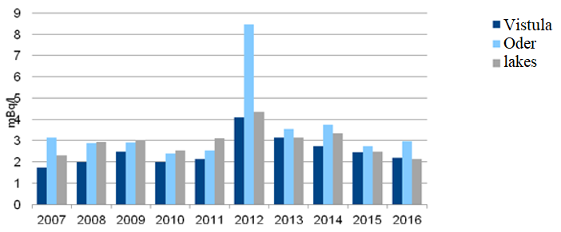

*.*

*Source: GIOŚ/PMŚ.*

Monitoring of radioactive contamination of **surface waters and bottom sediments** within the framework of the PMŚ is carried out in 18 measurement points located in the Vistula river basin (7 points), in the Oder river basin (5 points) and in six lakes. The results obtained from its implementation show that Cs-137 levels in surface water and sediments are very low and do not pose a threat to human health and the environment.

*Fig. 5.7. Concentrations of Cs-137 in the surface layer of soil in the years 1988-2016.*

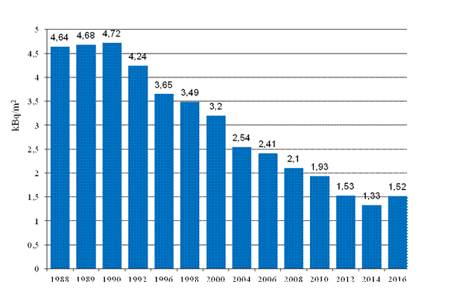

*Source: GIOŚ/PMŚ*

Monitoring of Cs-137 concentration in **soil** is carried out at 254 soil sampling points located throughout Poland. The points are located in meteorological gardens of the stations and posts of the Institute of Meteorology and Water Management – PIB.

The average Cs-137 concentration in soil in Poland decreased from 4.64 kBq/m2 in 1988 to 1.33 kBq/m2 in 2014. Changes in Cs-137 concentrations are caused by the radioactive decay of this isotope (T1/2 half-life is 30.15 years) and by migration processes in the environment, mainly caesium penetration into deeper soil layers.

The monitoring of radioactive contamination carried out under the State Environmental Monitoring reveals that the levels of Cs-137 in air, surface water, sediments and soil are low and do not constitute a threat to human health or the environment, and that the obtained results indicate that there have been no new releases of radioactive isotopes into the environment.

# Natural resources[79]

The natural environment is a natural capital and as such it constitutes a potential for the development of a specific space which can be described in terms of geography. Its resources (renewable and non-renewable) generate a stream of benefits defined as ecosystem services. The basic resources for economic and social development are energy potential, water resources, atmospheric air, climate, **spatial and landscape resources and associated biodiversity (habitat, species and gene resources)**, soil and geological resources, and non-economic uses of the environment. The state and availability of these resources and the limited capacity of ecosystems to sustain an equilibrium and provide services to the economy affect investment opportunities and the satisfaction of basic living needs. Modern environmental management, based on the principle of protection by sustainable use of natural resources, promotes their conservation for future generations and ensures high value standards, such as spatial order, and contributes to counteracting the marginalisation of areas. In the modern world, the requirements of environmental protection have become one of the most important determinants of social and economic development, and global climate change and growing pressure related to economic and social development have highlighted the importance of the state policy in managing natural environment resources and carrying out adaptation activities, reducing the effects of climate change. The observed unfavourable changes in the number and composition of plant and animal species most often result from faulty spatial management: rapid, uncontrolled urban development, settlement spreading within the areas of natural importance or in their immediate vicinity, crossing ecological corridors by transport infrastructure, unification and depleting landscapes. Invasive species pose a serious problem, threatening the stability of ecosystems and economies as well as human health. Changes in agriculture are also important – both intensification of cultivation towards large area agriculture and abandonment of agricultural use lead to the disappearance of ecosystems associated with agricultural crops and loss of traditional agricultural landscapes, which constitute a habitat for multiple species. The decline of green areas and the building inside ventilation corridors, cutting off open spaces from the city interior are detrimental to climatic conditions and the quality of life – the functions of protection against noise and particulate matter disappear – among other things, the ability to restore water resources and oxygen decreases[80].

The negative factors indicated in the diagnosis of the Responsible Development Strategy until 2020 (with an Outlook until 2030), such as inadequate air quality, low water resources, effects of progressing climate change, deficit of tools for creating spatial order significantly increase current development costs and generate losses caused by lack of investments, directing development funds to restore the desired quality of air, soil, water and treatment of diseases dependent on environmental factors. Taking appropriate action in the long term can help to avoid significantly higher macroeconomic costs of inaction. The objective is to increase the effectiveness of the environmental development potential, allowing its use to satisfy current development needs and increase the quality of life and preserve development resources for future generations[81].

***Biodiversity***

Nature enables and conditions human life. It is a source of numerous goods and services such as: food, raw materials, clean air, clean water, oxygen, unpolluted soil. It provides shelter, reduces the gradation effects of biotic factors, protecting against pests and pathogens. It makes a decisive contribution to the regulation of the Earth's climate processes. Its overarching feature is diversity, understood as the richness of the surrounding ecosystems, species and their gene resources. Diversity guarantees a balance between nature's elements and the proper functioning of ecosystems. The loss of biodiversity in ecosystems is a threat to the proper functioning of our planet, with further consequences for the economy and humanity[82].

Biodiversity is in crisis. Almost a quarter of Europe's wild species are threatened with extinction and most ecosystems are degraded to the point where they are no longer able to provide valuable services. This degradation means very high social and economic losses for the EU. The main causes of biodiversity loss (e.g. habitat conversion, over-exploitation of natural resources, introduction and expansion of invasive alien species and climate change) are increasing, undermining the beneficial effects of mitigation efforts[83].

The nature of the Member States of the European Union is highly endangered. It is a region with high population and consumption rates, which translates into high negative pressure on the environment. The results of the assessment of the conservation status of natural habitats, carried out in all EU Member States, show that the status of habitats and species is unsatisfactory and continues to deteriorate. The development of the communication infrastructure and the expansion of the construction industry takes nature away from new areas, destroying it and deepening the phenomenon of fragmentation of the natural space, without giving many species a chance for sustainable existence. In order to counteract these dangerous processes, the European Union already took a number of initiatives at the end of the 1970s and the beginning of the 1990s to preserve Europe's biodiversity. One of the most important instruments of these activities is the Natura 2000 network created on the basis of two European Union directives: The Birds Directive[84] and the Habitats Directive[85]. However, the introduction of these directives and their implementation in the Member States is still not sufficient.

In May 2011, the European Commission adopted a new strategy, setting out a framework for EU action in the next decade to meet the 2020 biodiversity headline target set by EU leaders in May 2010: “Halting the loss of biodiversity and the degradation of ecosystem services in the EU by 2020, and restoring them in so far as feasible, while stepping up the EU contribution to averting global biodiversity loss[86].

The EU Biodiversity Strategy 2020 includes six mutually supportive targets addressing the main drivers of biodiversity loss and aiming to reduce the key threats to nature and ecosystem services in the EU[87].

Objective 1 of the above-mentioned Strategy is the full implementation of the Birds and Habitats Directives by stopping negative trends in relation to the state of conservation of species and natural habitats covered by EU legislation. The objective is that by 2020, compared to 2010 (base year), 100% more assessments for habitats and 50% more assessments for species under the Habitats Directive are in a favourable or better conservation status than in the previous assessment of conservation status (at the level of the biogeographical region). In addition, 50% more assessments for birds protected under the Birds Directive would indicate a favourable conservation status (at EU level) or improved compared to the previous assessment. It should be stressed that the assessments cover all natural habitats and plant and animal species within and outside protected areas.

A detailed analysis of the state of preservation of natural habitats and species protected by natural directives concerning Poland is included in the further part of the material. In the overall assessment of the conservation status of natural habitats and species in biogeographical regions located in Poland, carried out on the basis of the national report on the implementation of the Habitats Directive based on Article 17[88] for the years 2007-2012, the relatively good conservation status of forest habitats and the poor conservation status of peat bogs, meadow areas and coastal dunes and habitats deserve special attention. In terms of species, mammals, fish and non-vascular plants are in a relatively good conservation status. The conservation status of the Baltic Sea species has been assessed as inadequately poor (100% of species)[89]. A full analysis of progress towards Objective 1 of the EU Biodiversity Strategy 2020 shall be possible after the submission of the national reports in 2019.

Poland is a country with a relatively large biodiversity. This is due to the transitional climate, varied terrain, geological structure and variability of the soil substrate, with no natural geographical barriers at the same time. In Poland, biodiversity is shaped primarily by relatively large areas: forests and wetlands, as well as agricultural areas. Forests in Poland currently occupy (in 2016) 9230 thousand ha[90],terrestrial hydrogenic habitats 4340 thousand ha (about 13.9% of the area of Poland, including ¼ of them peat bogs)[91]. Agricultural lands constitute about 46% of the country's area. A significant part of them, about 1/5, are permanent grasslands – various semi-natural ecosystems shaped and maintained through hay or grazing. Polish agriculture is characterised by a fragmented structure of farms and land – about 1.37 million farms, with average surface area of approx. 10.6 hectares. Agrarian fragmentation, which is economically disadvantageous, helps preserve the landscape and biodiversity.

The most numerous groups of species include algae, of which in Poland were found more than 10 thousand species. Fungi are the second largest group with 3 times fewer species than algae. The number of vascular plant species is 2750. According to estimates, the animal kingdom is represented in Poland by 47 thousand species (over 35.3 thousand species were recorded), of which 98% are invertebrates, among which the largest group are insects (as much as 75% of all animals). Among vertebrates, the most numerous groups of species are birds (458 species, including about 230 nesting species) followed by mammals (112 species)[92].

Among all native species occurring in Poland, the species threatened with extinction[93] include[94]:

* 1159 animal species, including 1080 invertebrate species (including 784 insect species, 6 crustacean species and 61 mollusc species) and 79 vertebrate species (13 mammal species, 34 bird species, 3 reptile species and 29 fish species, including 9 marine species),
* 488 vascular plant species, 83 moss species, 545 lichen species, 583 macrofungi species and 232 algae species.

*Tab. 6.1. Number of species/habitat types listed in the Annexes of the Habitats Directive occurring in Poland (some of which occur in both biogeographical regions and in the Baltic Sea marine area).*

|  |  |  |  |  |  |
| --- | --- | --- | --- | --- | --- |
| Groups of species/natural habitat types | Number of species/natural habitat types | | | | |
| Alpine  Biogeographical region | Continental  Biogeographical region | Baltic Sea marine area | Entire country | Including EU priority species/habitats |
| Natural habitats | 41  40 (data from 2010) | 71  73 (data from 2010) | 4  2 (data from 2010) | 81 | 17 |
| Plants | 21 | 42 | – | 49 | 10 |
| Animals | 92 | 128 | 7 | 143 | 13 |

*Source: GIOŚ/PMŚ, Report for the EC 2013[95].*

Natural habitats as well as plant and animal species that are rare and endangered on a European scale are protected under the so-called Habitats Directive[96]. There are currently 81 types of natural habitats in Poland, including 17 of principal importance, 49 plant taxa, including 10 of principal; importance and 143 species or groups of animal species excluding birds, including 13 of principal importance[97].

The Habitats Directive requires monitoring of the conservation status of natural habitats and species important for the EU in a given country. Not only is their current state of preservation being monitored, but also their prospects for protection in the foreseeable future. The monitoring of species and natural habitats has been carried out since 2006, with particular emphasis on special areas of protection within the framework of the State Environmental Monitoring. The main objective of the monitoring is to obtain data allowing for the **assessment of the conservation status** (condition) of the monitored habitat types and species.

Indicators concerning the size and structure of the species population, the quality of species' habitats and the surface area and degree of conservation of characteristic features of natural habitats are taken into account. Information is also collected on various threats to species and habitats, as well as on the applied methods of their protection, allowing to determine the prospects for the preservation of species and habitats. This enables the assessment of selected parameters of the conservation status and outlook for the protection of the species and natural habitat. For most species and habitats, monitoring is carried out every 6 years, and for rapidly changing habitat types and species with negative trends in populations or associated with unstable habitats – every 3 years. Based on the results of monitoring studies, the conservation status of species and natural habitats in biogeographical regions is assessed at the sites.

*Fig. 6.1. Conservation status of species and natural habitats in biogeographical regions and the marine area of the Baltic Sea.*

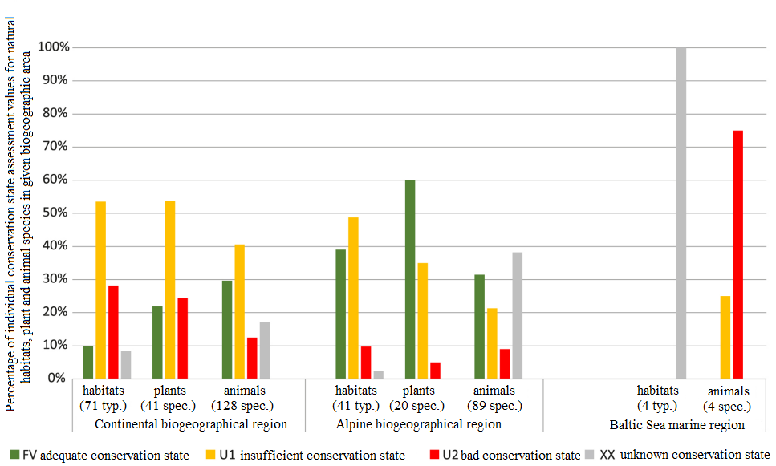

*Source: GIOŚ, State of the Environment in Poland. Report 2018, p. 30.*

Poland has the following biogeographical regions: continental and Alpine, as well as marine area of the Baltic Sea. According to the latest report for the European Commission prepared by Poland in 2013 and covering the period 2007-2012[98] (section concerning the conservation status was prepared on the basis of data from the State Environmental Monitoring), the species and habitats in the Alpine region (the Carpathians), "representing only 3% of the land area of the country"[99], demonstrated a much better conservation status. "This is mainly due to the region's characteristic inaccessibility of high mountain areas, also areas difficult in economic management and largely subject to area-based conservation, i.e. with significantly lower anthropogenic pressure than in the continental region. Within the continental region (97% of the land area of Poland), most habitats and species demonstrate unsatisfactory conservation status (U1)"[100].

According to the publication by GIOŚ – "State of the Environment in Poland. Report 2018" – in the case of animals, attention should be paid to the following facts:

* A relatively large "share (nearly one third) of animal species demonstrating appropriate conservation status (FV) (...) indicates the importance of Poland in their protection as a threatened species on a European scale"[101]. Furthermore, knowledge of some animal species is still incomplete, particularly in the Alpine region. "The inappropriate overall assessment of animals (U1 and U2) was determined not only by the population but also by the habitat parameter"[102].
* There are some successes in the protection of animal species and a stable (not deteriorating) situation for many of them. Three large predators remain in the country, with different conservation statuses (the best situation is for the wolf, as it inhabits new areas; the bear population seems stable, while the lynx is of some concern due to declining population size and food base). Three species of rare mammals are also in good condition, but with very limited occurrence: marmot and chamois (occurs only in the Tatra Mountains) and European bison (good assessment in the continental region – in the Białowieża Forest, Knyszyn Forest, Borek Forest and Mirosławiec Forest). There are also 7 dragonflies in good conservation status, as well as multiple species of bats.
* A cause for concern may be the conservation status of certain butterfly species, such as the *Colias myrmidone, Polyommatus eros, Coenonympha hero, Phengaris arion*, for which succession changes in habitats are partly responsible. Similarly, the situation of the European hamster is worsening with the intensification of farming. However, not in all cases, the reasons for the incorrect status are clear. The status of some species associated with the water and mud environment: *Astacus* (various causes), *Unio crassus* (various causes, including water pollution), *Rhynchocypris percnurus* (overgrowing and shallowing of water reservoirs), *Anisus vorticulus* (it is difficult to clearly determine the causes), *Emys orbicularis* (predation, poaching, plant succession in nests), is also disturbing. According to some experts, the overall situation of ichthyofauna is unsatisfactory due to negative impacts (pollution and engineering) commonly observed in Polish rivers.

According to the report to the European Commission of 2013, in both regions (continental and Alpine), the best preserved are thicket habitats and the worst – peat bogs (...). In the continental region, meadow and sward habitats (...) receive worse assessments. The predominantly inadequate conservation status (...) is also demonstrated in coastal habitats. In the Alpine region, rocky (...) and high mountain habitats (swards, snow patch habitats, herbaceous communities) as well as forest habitats stand out in a positive manner. It should be noted that the Alpine region is characterised by areas which are difficult to manage. This fact may have a positive impact on the conservation status of forest natural habitats, whereas in the case of semi-natural habitats, e.g. mountain hay meadows or matgrass swards, it hinders their protection. This is particularly evident in the current decline of the hay management in higher mountain locations. (...) in the continental region, many habitats received a bad assessment (...) due to the "surface area" parameter. This indicates a high fragmentation of natural habitats in the lower parts, as well as significant surface area decline of some of the habitat types occurring here. In the Alpine region, the reduction of the overall assessment of habitats was mainly influenced by the assessment of the "conservation outlook" parameter. The latter may indicate that some semi-natural habitats are subject to secondary succession and that the programmes and conservation measures undertaken are still insufficient"[103].

According to the aforementioned report for the European Commission of 2013, plant species which are characterised by "unsatisfactory conservation status (...) are species which are sensitive to the processes taking place in their habitats, as well as to various factors affecting their populations. They are threatened mainly by the disappearance of potential habitats and deterioration of their status, most often through eutrophication, progressive succession processes due to lack of use, drainage or mechanical destruction, and other factors not directly attributable to human activity. For many of the analysed species, the conservation status was assessed as inappropriate, mainly due to the small number of sites.

Throughout Poland, the conservation status received the worst assessment scores (...) for 11 plant species (17%), which: (a) are very rare, occur at single sites; (b) have extremely small populations, counted as individuals; or (c) despite the relatively large number of sites, demonstrate strong negative population trends especially at a deteriorating habitat"[104].

"Birds are an important element of the natural environment and at the same time – its good indicators. They are one of the most numerous groups of vertebrates"[105]. In Poland so far, 458 species[106] have been found, including about 230 common or locally nesting species[107]. "Among the domestic bird species, *Acrocephalus paludicola* (approx. 90% of the EU population in Poland) and *Haliaeetus albicilla* (approx. 45% of the EU population in Poland) are among the significant resources of Poland in the EU"[108].

"15 of the regularly nesting species in our country have been included, with the status of endangered or nearly endangered, in the Red List of Birds of Europe, developed on the basis of the criteria of the International Union for the Conservation of Nature IUCN in 2015 by the European Commission and BirdLife International. The list includes: *Clanga* – with the EN category (endangered) – threatened with extinction in the near future, *Limosa* , *Aythya ferina*, *Haematopus ostralegus*, *Vanellus* , *Numenius arquata*, *Alcedo atthis* , *Lanius* *excubitor*, *Acrocephalus paludicolaola* and *Streptopelia turtur* – with the VU category(vulnerable) – threatened with extinction, *Larus argentatus*, *Trudus iliacus*, *Anthus pratensis*, *Milvus* and *Fulica atra* with the NT category (near threatened)"[109].

Since 2006, within the framework of the State Environmental Monitoring, the **Polish Birds Survey** (MPP) has been carried out in Poland for particular species or groups of bird species, mainly those considered as endangered in the European Union countries, as well as in Poland, i.e. those listed in the annexes to the Birds Directive and/or in the Polish red lists. Monitoring is carried out on the basis of a representative observation network at the national and regional level. The assessed parameters of the population condition include, first of all, population size indices, less frequently, estimates of the total population size of the national population and prevalence indices. For selected species the reproduction results are also evaluated (Chodkiewicz et al., 2015).

"Data collected by the Polish Birds Survey (MPP) until 2017 estimate the average annual rate of change in population numbers for 163"[110] nesting bird species, i.e. approx. "71% of the national nesting avifauna"[111]. Using the trend classification used by the Pan-European Common Bird Monitoring Scheme PECBMS, it is estimated that 3% (5 species) of nesting species in Poland show a strong upward trend, and a further 33% (54 species) – moderately upward trend. The downward trend is observed for the population numbers of 26% of species, including 37 species – moderately downward, and 5 species – strongly downward. Populations of 44 species, 27% of the entire nesting avifauna, are stable in numbers. The direction of change in the numbers of 19 species remains uncertain[112]. The fastest growing species are *Cygnus*, *Phoenicurus*, *Picus viridis*, *Columba oenas*, *Phasianus colchicus[113].* The most rapid decrease in the population numbers is observed for *Coracias garrgulus* and *Larus canus*, as well as *Coturnix*, *Vanellus*, *Corydalla campestris, Gallinago media* and *Anthus pratensis*[114]*.* "In the years 2007-2016 the presence of *Calidris alpina schinzii* in Poland was not confirmed, only pairs performing courtship displays or individuals in the delta of the Świna river and in the Beka reserve on the Bay of Puck were observed"[115].

*Fig. 6.2. Rate of change in the population numbers of 160 species of nesting birds monitored under the MPP. Status as at 2017 (%).*

*Source: own elaboration based on: Inspection for Environmental Protection, Trends in the Population of Birds in Poland, Biblioteka Monitoringu Środowiska (Environmental Monitoring Library), 2018, pp. 41–362.*

The Pan-European index characterising a group of commonly occurring birds (referred to as indicator species) is the Farmland Bird Index (FBI 22[116]). It includes 22 common species of open area birds in our country. This index is calculated within the framework of the State Environmental Monitoring. In the first half of the last decade, the index showed a rapid decline in value, which was strongly correlated with the trend in farmland bird numbers across Europe. In the following years, the index increased significantly and in 2008 it returned to the reference level of 2000. In 2017, the value of the index was at the level of 0.80, i.e. 20% less than in the baseline year.

*Fig. 6.3. Changes in the Farmland Bird Index (FBI) and Forest Bird Index 34 (FBI34) between 2000 and 2017.*

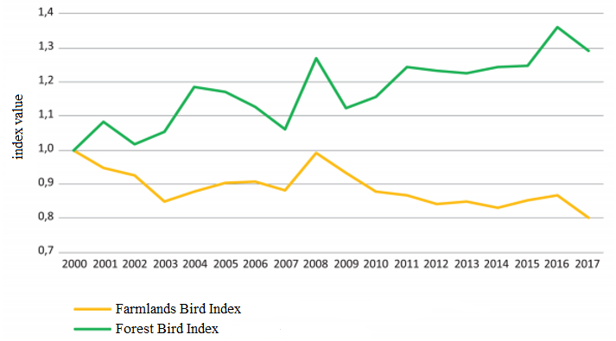

*Source: GIOŚ, State of the Environment in Poland. Report 2018, p. 60 as in: GIOŚ/PMŚ/Polish Society for the Protection of Birds.*

An index similar to FBI 22 is the index for birds (34 species) associated mainly with forest areas (*Forest Bird Index –* FBI34[117])[118]. This index is also calculated within the framework of the State Environmental Monitoring. Between 2000 and 2011, the population of widespread forest birds showed a clear upward trend and the aggregate index grew by about 2% per year. In the years 2012-2016, the index demonstrated similar values and was about 25% higher than in the baseline (2000). In 2017, it was 129.22%.

Within the framework of the State Environmental Monitoring carried out by the Chief Inspectorate for Environmental Protection, the assessment of the state of population conservation is also carried out in other systematic groups, e.g. mammals. Currently, the Chief Inspectorate for Environmental Protection is conducting a pilot project of wolf and lynx monitoring in Poland. As a result of this project, new monitoring methodologies for wolf and lynx shall be developed for monitoring the condition of the environment.

## Water and marsh ecosystems

Marshland ecosystems are particularly important in the management of environmental resources (in particular water and organic matter in soil) and in the preservation of the country's biodiversity. They play a significant role in the formation of organic carbon and nitrogen resources, they are biofilters purifying water circulating in the landscape from biogenic and heavy metals, they significantly affect climatic conditions and shape the landscape.

Hydrogenic terrestial habitats in Poland occupy 4 340 thousand ha, which constitutes 13.9% of the country's area. Approximately ¼ of them are peat bogs, while the remaining ones are wetlands on mineral substrate, associated with river floodplains. Inland open waters, including water bodies and watercourses (rivers, lakes, estuaries, ponds and dam reservoirs), cover about 3% of the country's surface area. Peat bogs, defined as living peat-forming ecosystems, occupy about 202,000 ha (0.6% of the country's area). The total length of watercourses is approx. 98 thousand km.

Wetlands are one of the most species-rich ecosystems in the world. Particularly important "for biodiversity are the large wetlands of river valleys, characterised by a high degree of habitat and species diversity"[119]. Fens, located mostly in their area, belong to the most abundant in species-rich ecosystems of the temperate zone. A significant number of rare and endangered species are associated with them, many of which with a biogeographical range centre in Central Europe. "For many species of animals and plants, valley sequences of wetland ecosystems serve as ecological corridors. Marsh valleys or mosaic complexes of eutrophic lakes, rushes and extensively used wet meadows and pastures are characterised by a particular richness of bird species. One of the richest types of forest ecosystems in terms of avifauna is the riparian forest associated with periodical floods of river waters.

Many ecologically unique species of flora and fauna occur, among others, on raised and transitional peat bogs or spring wetlands"[120]. Mid-field wetlands also play an important role in shaping the biodiversity of vast areas used for agricultural purposes[121].

Wetlands in the broadest sense of the term are now significantly transformed. Most of them are heavily degraded, which is especially true for fens, which, due to high productivity in the first years after drainage, were reclaimed for agricultural purposes in the vast majority of cases. For example, currently at least 14% of fens in Poland are preserved in relation to their original state. The reason for this situation is irrigation and drainage system built mostly up to 1970s in flooded river valleys, which do not have (usually as a result of failure to maintain them) damming facilities. It is estimated that they have a significant impact on the water conditions of about 60% of the river valley area.

Untransformed river valleys serve as flood protection. Polish rivers are still characterised by a high degree of naturalness in comparison with the rest of Europe. The Vistula, as the only large river on our continent, has preserved its natural character over a distance of over 300 km. Its valley, like the Oder valley, is one of the most important migration corridors in this part of Europe. River engineering (regulations and embankments of riverbeds) is sometimes the cause of large-scale changes in water conditions, which also has a significant impact on the condition of other wetlands. It is estimated that Polish rivers are regulated in about 40% of their total length.

Peat bogs play an important role in the prevention and reduction of climate change effects due to the permanent sequestration of atmospheric carbon in peat deposits. On the other hand, their degradation through drainage results in the release of significant amounts of carbon dioxide into the atmosphere. Degraded peat bogs are a significant source of greenhouse gases, pollution of surface and underground waters, their role in water retention in the catchment area also decreases. Their protection and restoration are therefore a priority not only for biodiversity protection, but also for management of other environmental resources.

## Biodiversity in agricultural areas

Objective 3 of the EU Biodiversity Strategy 2020 is to enhance the contribution of agriculture and forestry in maintaining and enhancing biodiversity. For agriculture, this objective is expressed by maximising "agricultural areas of grassland, arable land and permanent crops that are subject to biodiversity measures under the CAP in order to ensure the maintenance of biodiversity and a measurable improvement in the conservation status of species and habitats that depend on or are affected by agriculture and the provision of ecosystem services as compared to the 2010 EU baseline, thereby contributing to improved sustainable management"[122].

Agriculture as a branch of the economy is aimed at food production, but at the same time it has very important environmental functions. The objective of the Common Agricultural Policy (CAP), in accordance with Article 11 TFEU, is protecting the environment in order to promote sustainable development. The role of direct payments in environmental protection is explicitly mentioned in recital 37 of the preamble to Regulation (EU) No 1307/2013 of the European Parliament and of the Council[123], which states that through the mandatory "greening" element, direct payments aim at improving environmental performance. As part of the greening process, three greening practices have been made mandatory: crop diversification, maintenance of permanent grassland (PG) and maintenance of ecological focus areas (EFA), which have an impact on environmental protection and biodiversity conservation. Furthermore, apart from the greening of direct payments implemented since 2015, under the first pillar of the CAP, the cross-compliance principle is also implemented, which made the payment of full payments to farmers conditional, among others, on maintaining the land of the holding in good agricultural and environmental condition and on observance of a number of environmental requirements.

Under the second pillar of the CAP, in the perspective of 2014-2020, it was obligatory to allocate 1/3 of the funds of rural development programmes to measures for the environment and climate, which in the case of Poland means that the total public expenditure on this objective shall amount to EUR 4.46 billion (including the EU contribution of EUR 2.88 billion). Environmental and climate objectives are implemented in RDP 2014-2020 through the following measures: agri-environmental and climate measure, organic farming measure, payments for areas with natural or other specific constraints (LFA), afforestation activity and instruments supporting pro-environmental investments of agricultural holdings. The agri-environment-climate measure, which supports the voluntary use by farmers of environmentally friendly production methods, plays a particular role in the protection of biodiversity. This measure allows, among others, for the protection of valuable natural habitats within and outside Natura 2000 areas.

Biodiversity conservation must also be seen in terms of the genetic resources of crops and livestock. One of the manifestations of intensification of agriculture is the pressure to introduce highly productive, genetically homogeneous plant species and varieties adapted to modern conditions. In livestock production, traditional breeds are being displaced as a result of the desire to increase productivity and change rearing conditions. The narrowing of the gene pool of crops and animals used for agriculture is a negative phenomenon as it implies the loss of characteristics that could potentially ensure the stability of agricultural production in the future, especially in the event of changes in the environment. To this end, measures are being taken to conserve genetic resources in agriculture, including programmes to conserve animal genetic resources, gene banks, support for farmers using traditional animal breeds or plant species and varieties for agricultural production. In 1999, 32 programmes for the conservation of genetic resources were approved, covering 75 breeds, varieties and families of farm animals. Over the years, protection programmes have been revised and extended to include other livestock populations. In 2016, 83 breeds, varieties, families and lines of farm animals participated in protection programmes. Thanks to the protection of breeds, varieties, families and lines of farm animals, the population of native breeds has increased. These breeds are characterised by robustness and good health, longevity, good fertility, good adaptation to local, often very difficult environmental conditions. In addition, these breeds can be maintained with poor feed resources on the basis of permanent grasslands, which provides opportunities to manage and protect areas of high landscape value.

In order to conserve biodiversity in terms of animal genetic resources, it is necessary to continue the measures taken for the conservation of genetic resources in agriculture

One of the measures of RDP 2014-2020 is the agri-environment-climate measure (AECM). This measure promotes practices contributing to sustainable land management and biodiversity protection through the protection of valuable natural habitats and endangered bird species, the protection of endangered genetic resources of crops and farm animals, as well as the protection of landscape diversity. Of the 7 AECM packages, the following deserve special attention in the context of the protection of plant and animal genetic resources:

* Package 3. Preservation of orchards of traditional fruit tree varieties,
* Package 6. Preservation of endangered plant genetic resources in agriculture,
* Package 7. Preservation of endangered animal genetic resources in agriculture.

Package 3 "aims at protecting old varieties of fruit trees that have been largely abandoned"[124]. The support shall cover traditional varieties of apple (97 varieties), pear (36 varieties), sweet cherry (16 varieties), sour cherry (10 varieties) and plum (7 varieties) trees. In addition, other varieties traditionally grown in the territory of the Republic of Poland before 1950 may also be supported. Traditional orchards are also a refuge and feeding ground for rare and endangered animal species, including birds and pollinating insects, and thus contribute to biodiversity conservation.

Package 6 aims to preserve and disseminate endangered and rare species, varieties, ecotypes, diversify crops in rural areas, extend the availability of regional or amateur seed of varieties listed in the National Register and seeds of plant species threatened by genetic erosion. These include the following plants: emmer wheat, einkorn wheat, *Secale montanum* Guss., *Camelina sativa, Melilotus albus,* lentil, parsnip, *Anthyllis vulneraria*, buckwheat.

Package 7 is aimed at the preservation of native breeds of animals threatened with extinction by supporting their breeding in accordance with the programmes for the protection of genetic resources developed and implemented by the Zootechnics Institute – National Research Institute in Balice near Kraków. The following species and breeds of animals are supported:

* cattle (4 breeds): Polish Red, Lowland (Białogrzbiete), Polish Black-and-White, Polish Red-and-White
  + horses (7 breeds): Hucul, Małopolska, Śląska, Wielkopolska, Sokolska, Sztumska and Polish Konik,
  + sheep (15 breeds): wrzosówka, świniarka, olkuska, Polish mountain sheep – coloured, coloured merino, uhruska, wielkopolska, żelaźnieńska, korideil, kamieniecka, pomorska, cakla podhalańska, old-type Polish merino, blackhead, Polish Pogorze sheep,
  + pigs (3 breeds): puławska, złotnicka white, złotnicka spotted,
  + goats (1 breed): Carpathian goats[125].

In the 2018 campaign, the number of applications, the declared area and the number of animals in the Packages 3, 6 and 7 of the agri-environment-climate measures amounted to[126]:

* Package 3 – 721 applications, area 539.3 ha,
* Package 6 – 2936 applications, area 11,450.6 ha,
* Package 7 – 2765 applications, number of animals 79,023 pcs.

The programme of protection of plant genetic resources is one of the areas of the multiannual programme of the Minister of Agriculture and Rural Development, entitled "The Programme for the Protection of Plant Genetic Resources". "Creation of scientific basis for biological progress and protection of plant genetic resources as a source of innovation and support for sustainable agriculture and national food security", realised by the Plant Breeding and Acclimatization Institute – PIB, Research Institute of Horticulture in Skierniewice. A number of institutions also participate in the programme: Arboretum and the Department of Physiography in Bolestraszyce; Central Research Centre for Varieties of Cultivated Plants Experimental Station for Varieties Assessment in Karżniczka – Experimental Station for Variety Testing in Lisewo Malborskie; Institute of Natural Fibres and Medicinal Plants in Poznań; Institute of Soil Science and Plants Cultivation – National Research Institute in Puławy; Institute of Plant Genetics pf the Polish Academy of Sciences in Poznań; Polish Academy of Sciences Botanical Garden Center for Biological Diversity Conservation in Powsin; Warsaw University of Life Sciences (SGGW); Lower Vistula River Friends Society in Gruczno; University of Life Sciences in Lublin; University of Life Sciences in Poznań; University of Warmia and Mazury in Olsztyn - Hodowla Roślin Strzelce; Małopolska Hodowla Roślin – Breeding and Production Plant in Palikije; PlantiCo Growing and Horticultural Seed Production in Zielonki; „Spójnia” Hodowla i Nasiennictwo Ogrodnicze Sp. z o.o. in Nochów; Poznańska Hodowla Roślin Sp. z o.o. in Tulce.

Within the framework of the programme for the protection of genetic resources of utility plants, more than 80 thousand objects of crop genetic material and other plant species of importance for food and agriculture are preserved in their living state. They are characterised, evaluated and shared. Work is also underway to increase plant genetic diversity in rural areas and to raise public awareness of the importance of plant genetic resources.

Collections of plants maintained in the gene bank include: agricultural plants (cereals, root crops, special, herbal, fodder, reclamation and energy crops, small-seeded legumes, marginal coarse legumes), vegetable plants, fruit plants (including rootstocks of seed trees, rootstocks of stone trees, rare species of fruit plants, berry plants), melliferous and ornamental plants. Resources are stored in the form of seeds and vegetative form – most often field collections, but also in vitro and in liquid nitrogen, located in the Plant Breeding and Acclimatization Institute – National Research Institute Radzików (central seed storage facility) and in a number of other institutions.

Preservation of the gene resources of cultivated plants is the basis for the food security of the country. The collections collected in gene banks are a reserve of genetic material that can be used for breeding, science and education, for the production of improved varieties adapted to changing climatic conditions, as well as being important for the preservation of the surrounding nature and cultural heritage.

The gene resource collection is also used by farmers implementing Package 3. Preservation of orchards of traditional fruit tree varieties and Package 6. Conservation of endangered plant genetic resources in agriculture under PROW 2014-2020.

## Forests

Objective 3 of the EU Biodiversity Strategy 2020[127] is to enhance the contribution of agriculture and forestry to maintaining and enhancing biodiversity. In the case of forests, this objective refers to the adoption of forest management plans or similar instruments, in accordance with sustainable forest management, for all publicly owned forests and forest holdings above a certain size (defined by Member States or regions and listed in their rural development programmes) that receive EU rural development policy funding to deliver a measurable improvement in the conservation status of species and habitats that depend on or are affected by forestry and in the provision of ecosystem services compared to the 2010 EU benchmark. Analysis of changes in the bird index (34 species) associated mainly with forest areas (Forest Bird Index – FBI34) carried out as part of the Polish Birds Survey in the State Environmental Monitoring 2007-2012 indicates improving habitat conditions of forests in Poland for this group of animals.

*Fig. 6.4. Map of forest distribution in Poland in 2018*

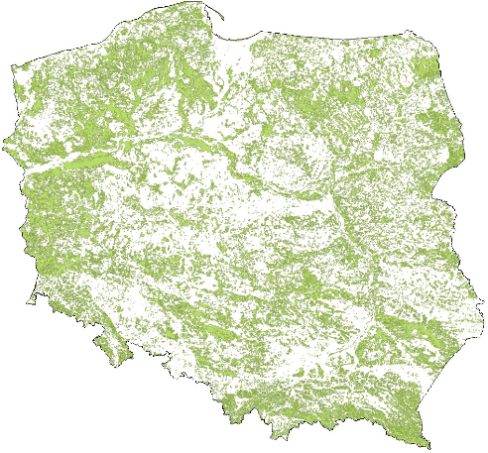

*Source: CORINE Land Cover, http://clc.gios.gov.pl/ (accessed: 19.02.2019).*

Forest areas, occupying almost 1/3 of the area of Poland, play an important role in maintaining the ecological security of the country. Forest management in Poland is carried out in accordance with the principles of universal forest protection, durability of their maintenance, continuity and sustainable use of all forest functions and increasing forest resources.

Sustainable, multifunctional forest management aims to preserve forests and their beneficial effects on climate, air, water, soil, natural resources and human health. The measures aim to ensure that the structure of forests is shaped so that the manner and rate of their use ensures the sustainable maintenance of their biological wealth, high productivity and regenerative potential. Forests should remain capable of fulfilling, both now and in the future, all important protective, economic and social functions at local, national and global levels, without harming other ecosystems.

The area of forests in Poland is 9.2 million ha[128], which corresponds to 29.6% forest cover. In 2017, the forest cover of Poland calculated according to the international standard was 2 percentage points lower than the European average (Poland's forest cover 30.9%, European average 32.8%), but similar to that of other large countries located in the Central European Plain (i.e. France – 32% and Germany – 33%). The forest cover in Poland has been systematically increasing since 1945. In accordance with the objective set out in the "National Programme for Increasing the Forest Cover", the forest cover of Poland should increase to 30% in 2020 (and to 33% in 2050). At present, the achievement of the target is facing increasing difficulties due to the low supply of land for afforestation.

In Poland, public forests are dominant, constituting 80.7% of the total forest area, of which 76.9% is managed by National Forest Holding State Forests (PGL LP), 2% are national parks, the remaining forests are owned by municipalities and other entities. Private forests account for 19.3% of the total forest area[129]. Concentration of the vast majority of forest areas in the country in public hands, gives much greater opportunities for the implementation of multifunctional forest management.

The dominance of state ownership in the governance structure has facilitated the introduction of a multifunctional forestry model that ensures the maintenance of a high level of biodiversity and the stability of ecosystems and their sequencing processes. This is evidenced by the fact that 39% of the State Forests area was covered by the Natura 2000 network areas in order to preserve specific types of natural habitats and species considered valuable and endangered on a European scale. The multifunctional and sustainable forest management of PGL LP enables the balance between the natural (protective), social and economic functions provided by the forests to be maintained. At the same time, it creates conditions for preserving the natural richness of forests, at the same time using their resources to satisfy social and economic needs and maintaining financial independence of the State Forests. Forests are the place where the game management is carried out.

Sustainable forest management ensures the supply of timber to meet the needs of various sectors, including wood, furniture, pulp and paper, construction and energy production (forest biomass). Timber resources in Polish forests reached the volume of almost 2.58 billionm3 (including 2.03 billionm3 in the State Forests)[130]. In terms of the volume of these resources, our country ranks fourth in the European Union. In the last 50 years, the supply of standing timber has doubled. Approximately 90% of the timber used in the country is supplied by the State Forests. Since 1990, the consumption of timber in Poland has more than doubled (to over 1m3 per person per year). Thanks to the growing resources, the State Forests are able to meet the growing demand, increasing the supply of timber to the market: from 17 millionm3 in 1990 to 38.3 millionm3 large timber net in 2015.

Forests are an important element in stabilising the local and global climate. It is estimated that the carbon content of forest biomass in Poland is 822 million tonnes[131], including 685 million tonnes in standing timber and 32 million tonnes in underground wood. The amount ofCO2 absorbed annually (including the use and absorption of gas by the soil) is estimated at 41.4 million tonnes, which translates approximately into 11.3 million tonnes of carbon. In comparison with European countries, Poland is one of the leaders in the amount of carbon bound in wood biomass in forest areas. This is largely due to the size of resources and the species, habitat and age structure of Polish forests.

Forests not only represent a significant carbon stock, but also have great potential to mitigate climate change, which can be enhanced by additional measures in the forest sector. Such actions also contribute to the increase of biodiversity. The forest area where additional activities shall be carried out shall also become an area of increased biodiversity.

Poland plans to establish a system of additional forestry measures to increase carbon sequestration. This system would be based on additional activities related to sustainable forest management. Within the framework of these activities, it is planned to develop long-term programmes of reconstruction of the species composition of stands and programmes of shaping their multi-stratum structure.

Forests significantly improve natural water retention and water management in catchment areas, stopping and reducing the outflow of rainwater. The water protection function is dominant in 21.7% of forests managed by PGL LP, and the method of forest management is aimed at improving water management. The role of forests in shaping favourable health and recreation conditions for the society is also important. The challenge for forestry is to develop methods of forest non-productive services valuation, which fits into a broader subject of ecosystem services valuation.

## Landscape

The landscape is the external image of all elements of the natural environment and human activity, as well as the universal resource of cultural message. Its resources consist of spaces changed to a different extent by human activity, in large part saturated with material souvenirs – starting from the landscape of cities, through fully anthropogenic agricultural areas to unique natural and near-natural complexes, such as the Białowieża Primeval Forest or Biebrza Valley.

In contrast to other elements of the environment, the resource potential of the landscape is least defined and recognised. There is a lack of universal education about it, its cultural, natural, social and economic significance and, what is extremely important, instruments for the protection of spatial order. This is a significant obstacle to rational management of spatial development, including effective protection of unique landscapes, important for the preservation of national identity. Meanwhile, the use of the unique potential of the Polish natural and landscape resources is an opportunity for the sustainable development of the country.

On 24 June 2004, Poland ratified the European Landscape Convention, hereinafter referred to as “ELC". The Parties to the ELC, while accepting its objectives, are obliged to take general and specific measures for the protection, planning and management of the landscape. General measures include the legal recognition of landscape as an important component of the human environment, establishment and implementation of a landscape policy, creation of procedures for public participation in the creation of this policy and inclusion of landscape issues in all other policies which directly or indirectly affect the landscape.

**Among the special measures (defined in Article 6 of the Convention), an important element of measures for the protection of landscape is raising awareness of the public and other entities with regard to the value of landscape, its role and changes introduced in it.**

According to the *Recommendation CM/Rec(2008)3 of the Committee of Ministers on guidelines for the implementation of the European Landscape Convention*, knowledge about landscape contributes to strengthening relations between society and its environment and constitutes the basis for sustainable development, which affects the entire process of defining landscape policy. "The high quality of the landscape is conducive to the formation of social bonds, and the inhabitants identify more strongly with the harmonious and rationally shaped environment. The environment of human life inspires and influences human activity, creating an inseparable connection with space. The economic importance of the landscape is important for the inhabitants of tourist resorts. It is the surrounding space that constitutes an element of territorial marketing within the framework of regional promotion and, at the same time, is a specific source of income"[132].

Awareness-raising aims to clarify the relationship between environmental characteristics and living conditions of society and the daily activities of authorities and society.

With this in mind, since 2010 the General Directorate for Environmental Protection (GDOŚ) has been undertaking activities aimed at raising public awareness in the field of relations between landscape and man, including, among others, the initiation and celebration of the Landscape Day.

An important step in the implementation of the ELC to the Polish legal system was the adoption of the Act of 24 April 2015 on the amendment of certain acts in connection with the strengthening of landscape protection tools (OJ L, item 774, as amended), hereinafter referred to as the Landscape Act. The Landscape Act, by introducing the obligation to prepare a landscape audit, takes into account the ELC regulations on identification and assessment of landscapes (Article 6C), as well as, partly, on definition of landscape quality objectives for identified and assessed landscapes (Article 6D) and introduction of instruments aimed at landscape protection, management and planning (Article 6E). In addition, measures are being implemented over legislative changes concerning the strengthening of legal protection of landscape. Pursuant to the Act of 27 March 2003 on spatial planning and development (OJ L of 2018, item 1945, as amended), a detailed methodology for conducting and scope of landscape audit were defined in the Regulation of the Council of Ministers of 11 January 2019 on landscape audits (OJ L of 2019, item 394).

The landscape audit shall be prepared in order to identify, characterise and evaluate the landscapes occurring in the territory of particular voivodships, as well as to define the principles of shaping landscapes recognised as the most valuable, so called priority landscapes.

When taking measures to protect and shape landscapes, it should be borne in mind that landscape includes many aspects of human life. It is a very complex concept, and at the same time understood in different ways by different social and professional groups. Public participation in landscape planning and planning as well as in spatial planning is a prerequisite for reaching compromises and balancing individual and public interests. Insufficient level of participation and the manner in which the relevant authorities carry out their activities make it difficult to understand and accept planning decisions, which results in social conflicts[133].

In order to achieve the objective set for voivodship self-governments, a holistic approach should be applied to landscape audit. In view of the above, activities aimed at developing the methodology of landscape identification and assessment (methodology of landscape audit) started already in 2013, when, as part of the implementation of the ELC regulations, GDOŚ organised the first national conference devoted to this issue. In the following year, GDOŚ commissioned the development of a methodology for identification and assessment of landscapes ("Identification and Assessment of Landscapes – Methodology and Main Threats", 2014), which was discussed in a very broad group during the next national conference. In 2015, the Ministry of the Environment commissioned the testing of the developed methodology in a selected pilot area ("Conducting a Landscape Audit – Testing the Methodology for Identification and Assessment of Landscapes", 2015).

Furthermore, within the framework of annual conferences organised by GDOŚ, devoted to current issues related to landscape, there is an exchange of information and integration of various circles dealing with the issues of landscape shaping and protection. Issues related to the protection and shaping of the landscape are particularly important due to implemented and planned investments, including linear investments. Well planned investments are those that have a limited negative impact on the environment and fit harmoniously into the landscape. It is crucial to make the society aware that interference in the environment starts with changes in the landscape and the quality of the landscape in the long term is inseparable from the quality of life. Therefore, it is very important to conduct education on the role of landscape at different levels[134].

Proper landscape shaping and conservation can play a key role in maintaining ecological connectivity in the environment. Spatial planning taking into account important elements of the landscape and natural environment is able to guarantee the maintenance and restoration of ecological communication in the environment.

## Summary

Poland is distinguished by its natural wealth, including relatively large biodiversity. The number of areas of high natural value subject to conservation measures is increasing. The value of nature is also evidenced by the large area of the Natura 2000 network of areas created for the protection of endangered species and natural habitats on a European scale. This network constitutes about 20% of the country's area.

However, the conservation status for most endangered species and natural habitats on a European scale is described as unsatisfactory. The reason for such an assessment is not only the population status for species or a specific structure and function for natural habitats, but also the status of those habitats, small surface area or poor conservation outlook, and sometimes also the scope. The fact that many rare species of fauna and flora as well as types of natural habitats (some of them preserved in good condition) occur in Poland makes Poland particularly responsible for the protection of the European natural heritage.

At present, there is a decrease in the number of many bird species (e.g. common farmland birds, open wetlands birds). At the same time, the number of some of them is increasing (e.g. common forest birds, *Haliaeetus albicilla, Nycticorax nycticorax*), while others are stable.

The abandonment of extensive agricultural use of valuable non-forest areas, intensification of agriculture, improperly functioning irrigation and drainage systems with negative impact on the maintenance of open habitats, including wetlands and wet and damp meadows, development of transport, tourism, industrial and energy infrastructure (small hydroelectric power plants, wind turbines) pose serious threats. These factors contribute in particular to secondary succession, habitat fragmentation, disappearance of habitats of rare species of wetland fauna and flora and landscape decline. Natural factors such as severe winters in the case of birds are also important.

# Waste[135]

Wastemanagement is one of the areas of environmental protection where we face many challenges. Waste is a potential resource if it is prepared for re-use, recycled or otherwise recovered. On the other hand, neutralised waste may be treated as a loss of resources and a manifestation of inefficiency of the economy. Recycling of waste is part of the bioeconomy concept whereby waste can be processed into value-added products such as feed, biomaterials, bioproducts and bioenergy.

Inappropriate waste management has a direct negative impact on the quality of all parts of the environment, and thus on the health of ecosystems and humans. Leachate from poorly operated landfills can contaminate water and soil. Landfills can also cause air pollution through the emission of odours, volatile pollutants and methane, contributing to climate change. Landfills occupy large areas (loss of space – most often valuable biologically active surface) and reduce the aesthetic value of the landscape. Irrational waste management is also a sign of environmentally inefficient use of resources.

A detailed analysis of the current state as well as objectives and directions of development of waste management at the national level have been included in the National Waste Management Plan 2022 (KPGO 2022) adopted by the Council of Ministers. KPGO 2022 is supplemented by voivodship waste management plans (WPGO) adopted by the Voivodship Assemblies. Investment requirements for achieving waste management objectives are set out in the WPGOs, which include investment plans as annexes. Therefore, the planning of the necessary infrastructure and the determination of the waste stream to be processed in the installations results from the analysis of the state of waste management in the voivodship, which was carried out within the framework of the project. In addition, with respect to municipal waste, investment plans include an indication of the planned investments with an estimate of the costs and the sources of financing, as well as a schedule for implementation.

Polish and EU law introduced a hierarchy of waste management procedures, according to which waste generation should be prevented in the first place (e.g. by reusing objects or materials), and if waste has already been generated, it should be managed by preparing it for reuse, recycling or other recovery processes. If waste cannot be used, it should be disposed of, with landfilling being the least desirable form of waste management.

The main factor determining the amount of waste generated is economic development, which affects both the intensity of production and the level of individual consumption and patterns of consumption. Analysing the dynamics of changes in the amount of waste generated in relation to the changes in GDP since 2000, a positive trend can be observed – a constant level of waste generation at over 50% increase in GDP. This can be considered as an effect of actions taken to rationalise waste management in Poland.

*Fig. 7.1. Industrial waste generated in Poland in the years 2010-2017 (million tonnes).*

*Source: Own elaboration based on LDB data – Statistics Poland, State and Protection of the Environment.*

In 2017, 114 million tonnes of industrial waste (i.e. excluding municipal waste) were generated in Poland. Since the beginning of the 21st century, the weight of industrial waste generated has remained relatively stable, at around 120 million tonnes.

The main source of industrial waste generation in 2017 was mining, in particular hard coal and lignite mining (over 25% of the total amount of industrial waste generated). The production and distribution of electricity, gas and steam accounts for approximately 15%, production of metals – 8.4%, and production of chemicals and chemical products – 4.7% of the total mass of industrial waste generated in 2017. The largest share in industrial waste generated in 2017 was accounted for by waste arising from washing and preparation of minerals (approximately 27.7%), waste from flotation enrichment of non-ferrous metal ores (approximately 24.8%) and ash-slag mixtures from wet removal of furnace waste (7.2%).

*Fig. 7.2. Management of industrial waste in Poland in the years 2000-2017 (thousand tonnes).*

*Source: Own elaboration based on LDB data – Statistics Poland, State and Protection of the Environment.*

Out of the total amount of industrial waste generated in 2017, 28.2% was transferred to other recipients, 8.7% was recovered, 6.8% was disposed of through storage, over 1.5% was disposed of in a manner other than storage, and about 0.5% was temporarily stored.

The data presented by GUS show that until 2005 there was a successive increase in the share of industrial waste recovered in the total weight of waste generated, with a simultaneous decrease in the share of landfilled waste. However, since 2006 the opposite trend has been observed. The increase in the share of waste sent to landfills is a disturbing phenomenon and may indicate that actions taken to increase the amount of recovered industrial waste are not sufficient. It may also be related to the fact that from 2014 onwards, the phenomenon of transferring waste to other recipients has been recorded, which may result in an increase in the number of illegal landfills, and thus in a reduction in the amount of recovered waste.

In the European Union countries, an average of 483 kg of municipal waste is generated per year per capita (data for 2016). In Poland, this indicator in 2017 amounted to 312 kg and is one of the lowest in the EU. The change in the municipal waste management system made in 2011 introduced new regulations assuming that municipalities are responsible for organising the municipal waste collection and management system in their area. Since the introduction of the "waste reform", data on municipal waste have shown an improvement in the situation in this area. In 2012, 84% of collected waste was stored at landfills, while in 2017 it was 41.8%. The share of segregated waste in the total amount of collected municipal waste increased from 10.5% in 2012 to 27% in 2017.

*Fig. 7.3. The amount of municipal waste generated per capita in 2017 in the EU countries (kg).*

No data

No data

No data

*Source: Eurostat – Municipal waste by waste management operations (env_wasmun).*

Since 2005, there has been a noticeable increase in the amount of collected waste: from 9.4 million tonnes in 2005 to 12.0 million tonnes in 2017 (from 2014, the amount of collected waste includes waste collected from all property owners, in accordance with the new waste management system introduced by the municipalities on 01.07.2013).

Out of the 12.0 million tonnes of waste collected in 2017, 27% were segregated. The collected municipal waste was subjected to landfilling (41.8%), recycling (26.7%), composting or fermentation (7.1%) and thermal transformation (24.4%).

*Fig. 7.4. Annual levels of recovery and recycling of packaging waste in Poland in the years 2014-2017 (%).*

*Source: own elaboration based on Statistics Poland, Environmental Protection 2017, Warszawa, 2017, p. 339. Statistics Poland, Environmental Protection 2018, Warszawa, 2018, p. 156.*

The Act of 13 June 2013 on packaging and packaging waste management (OJ L of 2019, item 542), which transposes Directive 94/62/EC[136], establishes, the general levels of recovery, including recycling of packaging waste. According to the Annex, the required level of recovery of packaging waste is 61%, including 56% for recycling. Comparing the levels achieved between 2015 and 2017, it can be seen that the required recovery and recycling rates were achieved in 2015 and maintained in later years. In 2014, the national targets were not met (60.3% recovery and 55.6% recycling), but it is worth noting that the targets set by the aforementioned directive (60% of recovery and 55% of recycling) were met.

*Fig. 7.5. Waste electrical and electronic equipment collection rate in Poland in the years 2007-2016 (%).*

*Source: own elaboration based on: GIOŚ, Report on the Functioning of the Waste Electrical and Electronic Equipment Management System[137].*

European Union regulations on waste electrical and electronic equipment management were implemented in 2006. The waste electrical and electronic equipment management system is supervised by the Chief Inspectorate for Environmental Protection (GIOŚ). Positive trends in the handling of "e-waste" are noticeable: annual increase in the level of collection of waste electrical and electronic equipment from 4.88% in 2008 to 47.99% in 2016. At the same time, an increase in the level of collection of electronic equipment in households is observed from 1.85% in 2008 to 33.66% in 2013 (from 2013 the level of collection of waste equipment is given in total without specifying the achieved level of collection of waste equipment from households). Calculated per capita, the amount of waste electrical and electronic equipment collected increased from 0.71 kg in 2007 to 5.58 kg in 2016.

The Act of 24 April 2009 on batteries and accumulators (OJ L of 2019, item 521) transposed the provisions of Directive 2006/66/EC[138], which obliges Member States to achieve the following minimum collection rates for waste portable batteries and accumulators:

(a) 25% by 26 September 2012,

(b) 45% by 26 September 2016.

*Fig. 7.6. Annual collection rates for waste portable batteries and waste portable accumulators in Poland 2010-2017 (%).*

*Source: own elaboration based on the reports of the Chief Inspectorate for Environmental Protection on the functioning of the management of batteries and accumulators and waste batteries and accumulators for the years 2010-2017[139].*

Despite a clear upward trend in the collection rates of this type of waste over the years 2010-2017, the data for 2017 indicate that Poland, by reaching an annual collection rate of more than 65%, met its obligation to reach the level of 45% imposed by Directive 2006/66/EC[140]. This situation is undoubtedly influenced by the annual increase in the sales of batteries and accumulators due to the growing demand for electrical and electronic equipment, which is largely powered by portable batteries or accumulators. It should be noted that the weight of portable batteries and accumulators placed on the market is growing faster than the generation of such waste. This is due, among other factors, to the improvement in the quality of batteries and accumulators, which manifests itself in their longer service life.

In 2005, European Union legislation on the treatment of end-of-life vehicles was implemented. Analysing the available data, a systematic increase in the number of end-of-life vehicles delivered to disassembly stations can be observed: from 151,000 in 2006 to over 365,000 in 2016. In the same period, the level of reuse and recycling of this waste stream increased from 84.7% to 94.7%, and the level of reuse and recovery increased from 85.8% to 97%[141].

The instruments supporting rational waste management are waste management plans. Waste management plans are developed at the national and voivodship level. The role of municipality, county and voivodship local government units in creating proper waste management habits among the residents in order to conduct rational waste management in accordance with the law is important. Rational management of waste generated by individual entities; households should be conducted by increasing the awareness of residents about possible threats to the environment arising from improper management of waste.

# Geological resources

Poland has large reserves of hard coal and lignite, relatively small reserves of conventional natural gas, small reserves of crude oil and yet undefined resources of shale gas[142]. "In total, approx. 400 million tonnes of minerals are mined in Poland, of which approx. 25% is hard coal, 22% natural aggregates, 15% lignite, 9% limestone and marl for the cement industry, 7% copper ore, 6% road and construction rock, 3% sands"[143].

Hard coal mining is currently carried out in two regions: The Upper Silesian and Lublin Coal Basins, and the documented recoverable resources as at 31 December 2017 amount to 60 496 million tonnes. The resources of the developed deposits currently account for 37.19% of the recoverable resources and amount to 22 497 million tonnes. In 2017, Polish mines extracted 56 824 thousand tonnes of hard coal. As at 31 December 2017, the documented recoverable resources of lignite in Poland amounted to 23 385 million tonnes, with all the resources being used for power generation purposes. The largest currently exploited lignite deposit "Bełchatów" (Bełchatów – "Bełchatów" Field and Bełchatów – "Szczerców" Field) covers over 70% of the national production, and the remaining part of the demand is covered by the deposits of Turów near Bogatynia and the deposits of the Konin region: Pątnów and Adamów. Lignite production in 2017 amounted to 63 060 thousand tonnes and, with unchanged demand, these resources will last for almost 350 years[144].

The main region in which natural gas deposits occur in Poland is the Polish Plain. The documented recoverable resources of natural gas as at 31 December 2017 amounted to 119.19 billionm3 (total recoverable and non-recoverable resources), while the resources of the developed deposits amounted to 94.48 billionm3 [145]. In 2017, the consumption of natural gas in Poland amounted to 19.1 billionm3 [146], of which approx. 4.1 billionm3 came from domestic production converted into high-methane natural gas. With unchanged share of gas imports in domestic consumption, domestic deposits shall be sufficient for about 30 years and for about 10 years if the demand was met entirely from own resources, assuming that there shall be no exploration and recovery strategy. These calculations do not take into account the potential of shale gas production, as these deposits are not yet documented. According to various sources, these resources may exceed the current reserves of natural gas from conventional deposits by several to more than a dozen times.

Crude oil is present in small quantities in Poland in the Carpathians, in the Polish Plain and in the Exclusive economic zone of Poland in the Baltic Sea. In 2017, the recoverable resources of crude oil and condensate amounted to 23,994 thousand tonnes (with annual production of 939.24 thousand tonnes)[147], while imports of crude oil amounted to 23,981 thousand tonnes[148].

Among chemical raw materials, the key role is played by native sulphur (resources as of 31 December 2017 – 503.85 million tonnes) and rock salt (resources as of 31 December 2017 – 85.27 billion tonnes)[149]. Sulphur deposits occur around Tarnobrzeg (Piaseczno, Machów, Jeziórko), south of Szydłowiec (Grzybów, Osiek) and near Lubaczów (Horyniec, Basznia). Rock salt deposits occur in the area of the Carpathian Foredeep (Bochnia, Wieliczka, Łężkowice, Siedlec), in the form of salt intrusions in the north-eastern Wielkopolskie and Kujawsko-Pomorskie (Inowrocław, Góra, Kłodawa, Izbica Kujawska, Rogóźno, Mogilno). There are deposits of potassium salt (polyhalite) over the Bay of Gdańsk.

Among the most abundant metallic resources in Poland are copper ore deposits (recoverable resources – 1931.95 million tonnes of ore containing 34.59 million tonnes of copper – 10% of world resources and 104.47 thousand tonnes of silver)[150] and zinc and lead (84.42 million tonnes of ore containing 3.63 million tonnes of zinc and 1.43 million tonnes of lead)[151].

The occurrence of deposits of thermal waters, medicinal waters, brines and medicinal peats has been documented in Poland. Thermal waters in Poland are found in a large part of the Polish Plain in vast reservoirs of regional importance, as well as in the Carpathians and their foothills and in the Sudetes, where the deposits have the character of small basins (Podhale) or are limited to tectonic zones. They are used mainly for heating purposes in several existing geothermal heat plants (including Bańska, Pyrzyce, Mszczonów, Uniejów, Stargard) and for recreational purposes (including Szaflary, Bukowina Tatrzańska, Białka Tatrzańska, Mszczonów). Most of the medicinal waters occur in the towns grouped in the southern part of Poland, including the Sudetes and the Carpathians, together with the Carpathian Foredeep. Over 70% of the total number of spas and resorts with medicinal waters in Poland are located in these regions. In addition, medicinal waters in a larger accumulation occur in Zachodniopomorskie and in several places in the remaining part of the Polish Plain. Medicinal waters are used for balneotherapeutic purposes in 42 spas and other localities, for bottling purposes, as well as for the production of spa products, i.e. salts, lyes, sludges, pharmaceutical preparations. Furthermore, in the area of Poland there are deposits of medicinal peat bogs (including Kamień Pomorski, Bronowo) used in balneology for baths and compresses and for manufacturing medicinal products, as well as brines used in the production of medicinal salt and bathing brine (Łapczyca)[152].

*Fig. 8.1. Structure of domestic extraction of minerals in Poland in 2017 (%).*

*Source: Eurostat, http://appsso.eurostat.ec.europa.eu (accessed: 12.03.2019)[153].*

Domestic extraction of minerals, as part of domestic extraction and expressed by the domestic extraction used (DEU) rate, amounted to 462.2 million tonnes in 2015. The dominant category in this case are non-metallic minerals.

The measure of the material intensity of the economy is the resource productivity index calculated as the ratio of GDP to domestic material consumption (DMC). The higher the value of this indicator, the less material is used to produce a GDP unit. The value of this indicator achieved by Poland, similarly as in the case of most other so-called new EU Member States, is much lower than the EU average, which proves the high material intensity of our economy. It is caused, among others, by the structure of the Polish economy with a significant share of heavy industry and agriculture. The productivity index of the Polish economy resources in 2015 amounted to 0.7 EUR of the generated GDP per kg of materials directly used in the economy, compared with the EU average of 2.2. In 2015, Poland was among the most material-intensive economies behind Estonia, Bulgaria and Romania.

Domestic material consumption (DMC) in 2017 amounted to 654 million tonnes. Since 2011, a decrease in the value of the domestic material consumption index has been noticeable. About half of the domestic material consumption is made up of non-metallic minerals (this category includes construction materials such as sand and gravel), biomass – 29%, fossil fuels – 20%, while the rest is made up of metal ores. The value of DMC for Poland recorded in 2015 was one of the highest in the European Union. Poland was among the top three countries with the highest material use, after Germany and France. The material uses per capita in Poland amounted to nearly 17 tonnes, while the EU average was below 13 tonnes.

It can be assumed that with the change in the structure of the economy, the productivity rate shall increase, among other factors, due to the use of better technologies or the increasing share in the economy of services that consume less resources than industry and agriculture. However, it should be remembered that the competitiveness of the economy and the possibility of building advanced services is only possible with an existing, strong industrial base. It is therefore necessary to pursue policies that shall result in an increase in resource efficiency.

The Raw Materials Policy, which has a direct impact on the environment, society and economy, is an integral part of the sustainable development policy. Rational management of geological resources is a prerequisite for long-term economic security of the country, and thus for national security.

The effectiveness of the Raw Materials Policy depends on its comprehensive and coordinated implementation. In order to ensure this effectiveness, in 2016 the Council of Ministers appointed the Government Plenipotentiary for Raw Materials Policy, and the Prime Minister established the Inter-ministerial Group for the Raw Materials Policy. Due to the importance of the management of natural resources for the functioning of the state and due to the work undertaken by the aforementioned Plenipotentiary, the issues related to geological resources are fully covered by the document entitled *Raw Materials Policy*.

The existing challenge is to define a product policy and support resource-efficient production systems. In comparison to the largest EU economies, Poland does not have a fully formed policy on supporting effective use of materials, and the law applied in Poland is most often limited to the application of minimum standards resulting from the requirements of EU law.

# Environmental technologies

## Eco-innovations

Eco-innovation or innovative environmental technologies are processes, products and services that produce environmental added value, i.e. that have a more favourable or less favourable environmental impact in relation to conventional solutions currently in use or that measure the parameters that indicate environmental impact. Compared to conventional solutions, eco-innovation should exhibit an innovative approach in terms of design, raw materials used for its production, manufacturing process, operation, recyclability or final disposal, in terms of the resulting performance, i.e. its functional or technological efficiency.

Eco-innovation contributes to improving resource efficiency in the economy and to reducing the negative impact of human activities on the environment. Apart from the ecological dimension, the economic and social aspects are also important – their introduction contributes to the reduction of operating costs, the use of new development opportunities, creating a positive image of the individual, and as a result to the increase of its competitiveness.

In order to enable comparisons in the field of eco-innovation, the European Union has set up an *Eco-Innovation Observatory* to collect data regarding this matter. On the basis of 16 indicators grouped in 5 thematic areas, the *Eco-Innovation Scoreboard* was created, which compares the results of eco-innovation achieved by individual EU-28 member states compared to the EU average[154].

The *Eco-Innovation Scoreboard* ranking includes five groups of indicators in itsindex. Three of them directly relate to eco-innovation. These are: outlays (government expenditure on environmental and energy R&D, total number of researchers, green investments of PE/VC funds), activities (companies introducing eco-innovations improving material and energy efficiency and holding ISO 14001 certificates) and results (patents, publications, media coverage of eco-innovations). The other two groups of indicators are the effects of eco-innovations – environmental (energy efficiency, mineral efficiency, water efficiency and emissions) and socio-economic (development of the "eco-industries" within the economy).

*Fig. 9.1. Eco-innovation index for European Union countries in 2017*

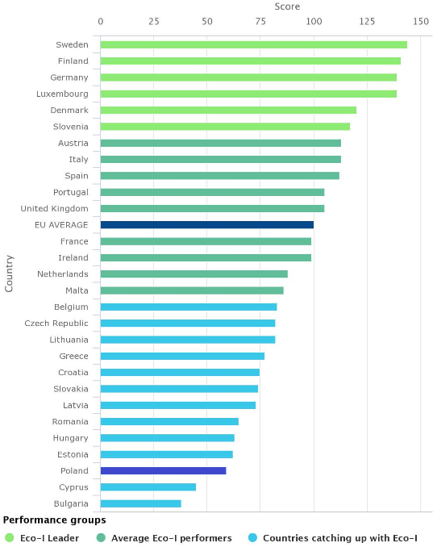

*Source: https://ec.europa.eu/ (accessed: 17.01.2019).*

In the Eco-innovation Scoreboard ranking, Poland has been ranked among the countries with the lowest eco-innovation index, significantly below the EU average, since 2010. Although, compared to 2012, Poland's overall ranking increased from second last position to the 23rd place, the low values for 4 out of 5 indicators taken into account in the assessment significantly reduce Poland's position in the EU ranking. Only in the case of one indicator – social and economic effects of introducing eco-innovations, in 2016 Poland performed best in comparison to other EU countries. This indicator refers to the development of the so-called eco-industry and the increase in employment in this sector. It is worth noting that in the same category, in 2012 Poland was 10th from the end.

Poland is still not allocating enough resources on R&D&I in eco-innovative technologies. While there is an increase in funding for eco-innovation projects in their early stages of development, as evidenced by the number of programmes under which it is possible to undertake R&D&I in eco-innovation, these resources are scattered. The programmes within which they are available have different strategic objectives and are supervised by different operators (NCBiR programmes: GOSPOSTRATEG, BIOSTRATEG, Advanced energy generation technologies E-KUMULATOR, NFOŚiGW programmes: Sokół, GEKON, SGOP competitions dedicated to innovation: Fast track, Market research, etc.). These programmes lack a uniform approach to defining environmental technologies and eco-innovations and to formulating measurable environmental parameters that must be met by the solutions developed in R&D&I projects, e.g. in the case of water efficient processing technologies – reduction of water consumption by at least 30%. This makes it impossible to monitor the results of translating R&D&I expenditure into concrete market and environmental results and to obtain information about developed and available technologies more quickly.

The technological offer in the field of eco-innovation presented by Polish technology transfer centres operating at universities or at the regional level contains, admittedly, proposals for solutions that show potential as environmental technologies, but the manner of describing solutions, lack of specific information about technical and utility parameters and benefits obtained from implementation limits both the interest of companies in these solutions and the probability of commercialisation.

As a result, there is no institutionally supervised national system of information on environmental technologies available on the market, ready for commercialisation or still in the research phase. This system should be a reference, contain a credible technological offer of new solutions, e.g. verified within the ETV, enable technology benchmarking based on technical and performance parameters in accordance with the needs of purchasers and selected environmental aspects (emissions, waste generation, noise, etc.).

At present, the designers of large installations are mainly following proven conventional solutions. The market offers of innovative technologies, especially in the field of water and waste water management and waste management, is dominated by technologies offered by foreign suppliers with an established position, which makes it difficult for Polish companies to compete on the market.

Despite the fact that eco-innovations in the EU and in the world are one of the most dynamically developing markets, ahead of even the ICT or pharmaceutical markets, the Polish capital market shows moderate interest in investing in new environmental technologies. Out of 32 companies operating in 2016, 12 declare interest in eco-innovation areas such as: energy, innovative industrial processes, innovative clean-tech materials and environmental engineering. It is worth noting, however, that in the 2017 edition of the BRIdge Alfa[155] competition, one fund qualified for financing, with capital support dedicated exclusively to green technologies.

Eco-innovations are quite widely represented in both national and regional smart specialisations. However, this does not translate directly into research and implementation priorities of R&D&I programmes, which are not systematically connected with the economy's demand for eco-innovations or the search for innovative solutions for priority problems requiring a quick and effective response, e.g. in the field of air protection, adaptation to climate change or implementation of circular economy.

Another important issue is the insufficient actions taken by companies to improve resource efficiency. Poland shows a dynamic economic growth, but it does not go hand in hand with a reduction in resources and energy intensity. In 2015, the domestic consumption of raw materials in Poland amounted to 16.9 tonnes compared to the EU average of 14.6 tonnes. According to EIO (Eco-innovation Observatory) data, in 2016 in Poland only 10% of companies implemented innovations resulting in ecological benefits for the company (EU average 53%) and 12% of companies introduced innovations to the market resulting in ecological benefits for the end user (EU average 50%).

The economy sector makes limited use of available funds, mainly structural funds for the implementation of innovative ecological solutions. The assessment criteria do not sufficiently promote eco-innovative solutions and refer to the environmental aspect of technology, focusing exclusively on the assessment of the fulfilment of horizontal requirements for sustainable development referred to in Article 8 of the Regulation of the European Parliament and of the Council (EU) laying down common provisions on the ERDF, ESF, CF, EAFRD and EMFF[156], e.g. in projects under Measure 3.2.1 SGOP "Research for the market" the criterion of innovation is considered exclusively as a new or significantly improved product or service and the improvement may concern technical characteristics, components, materials, embedded software and other functional characteristics of the product or service. However, the project selection criterion concerning the impact of this innovation on the environment is not decisive. For meeting these requirements, the application receives only 1 point.

*Fig. 9.2. Activities of companies undertaken in Poland to improve resource management (%).*

*Source: own elaboration based on: Flash Eurobarometer 426, SMEs, Resource Efficiency and Green Markets, September 2015.*

Polish companies do not perceive investing in eco-innovations as a way of building a competitive advantage. The level of business awareness of the environmental and economic benefits of implementing eco-innovations is also low. At the same time, data from Eurobarometer survey[157] conducted in 2015, presented in Fig. 9.2., concerning the effectiveness of resource management in enterprises in Poland, show that businesses are chiefly interested in taking action to reduce energy and material intensity, and then water consumption and waste generation, as this translates directly into their operating costs. These trends are in line with those of companies in the EU.

The aforementioned needs of companies indicate the market demand for eco-innovative technologies. However, there is a lack of expert advice for SMEs, e.g. on the use of business opportunities offered by eco-innovation, technological advice and assistance to eco-innovative companies to compete in global markets. In Poland there is a network of accredited Business Environment Institutions (BSI), but they do not have specialist knowledge, e.g. in the field of building export potential of eco-innovative technologies.

In the case of large enterprises (over 250 employees) a similar trend is confirmed by data from the Central Statistical Office concerning innovative activities undertaken by enterprises in the years 2012-2014, presented in the EIO report for Poland for 2017. They show that production plants implemented solutions mainly in the scope of waste management, water and waste water management, reduction of raw material consumption towards recovery of these resources for own needs or resale, while the services sector invested in energy-saving technologies and reducing CO2 emissions.

Another serious limitation are too high expenditures on eco-innovations with simultaneous lack of access to financing mechanisms enabling to obtain funds for investments in eco-innovations on preferential terms. Although instruments for companies to implement innovations are developing, there is still no system of incentives to prefer investments in eco-innovative solutions, bringing measurable benefits for the environment. Entrepreneurs are afraid of an uncertain return on investment in eco-innovation or too long a payback period. Potential investors and financial institutions apply the same criteria for eco-innovation as for other investments, often without taking into account the added value of reducing environmental burdens, which is marginal in investment decisions. In addition, there is still no system of economic and fiscal incentives, e.g. in the form of tax breaks and green vouchers, which would stimulate greater interest in eco-innovation on the part of *companies.*

*Tab. 9.1. The level of green public procurement in Poland.*

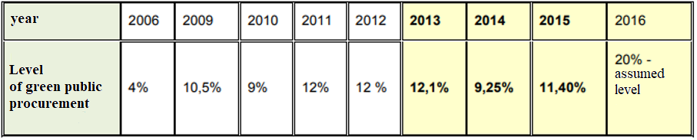

*Source:* *Public Procurement Office, National Action Plan Regarding Sustainable Public Procurement for 2017-2020, Warszawa, 2017, p. 35.*

The public finance sector is one of the most effective instruments for shaping the demand for eco-innovations. The value of the public procurement market in Poland in 2016 amounted to PLN 107.4 billion, constituting about 5.80% of the gross domestic product (GDP) in 2016[158] and it is showing an upward trend. The Act on Public Procurement Law (OJ L of 2018, item 1986, as amended) amended in 2016 provides for the promotion of the real application of non-economic objectives of public procurement, such as environmental protection, social integration or support for innovation. However, the percentage of green public procurement in Poland, although increasing, is still insufficient. In 2015, it amounted to 11.40% (i.e. PLN 13.26 billion).

The purchasing policy of the state – one of the strategic projects of *the Strategy for Responsible Development* – is to favour green public procurement. It defines the state's priority actions in the area of public procurement, indicating, among other things, the principle of preference for innovative and ecological solutions. However, this requires a change in the systemic approach to public procurement, in particular with regard to the preparation of tenders and the assessment of tenders, with particular attention to both environmental criteria and the environmental management requirements for the contractors. Despite the increasing level of environmental awareness, businesses and investors, particularly in the public finance sector, show a conservative approach to the implementation of eco-innovation. Some support may be provided by the Public Procurement Office's publication in 2017 of the guide "Sustainable Public Procurement. Social and Environmental Aspects in the Procurement Procedure in the Light of the Amendment of the Public Procurement Law". However, the guidelines contained in this document are not binding for the businesses. The number of good practice examples is limited to construction, transport and street lighting. A more widespread use of green public procurement would attract more interest from companies in the implementation of management schemes, such as the EU Eco-Management and Audit Scheme (EMAS) or other environmental management standards based on relevant European or international standards developed by accredited bodies (e.g. ISO 14000 series). The same applies to the inclusion of environmental criteria in the description of the subject-matter of the contract, which offers relatively the greatest potential for making the procurement green. The lack of knowledge of the entities compiling public procurement documentation regarding the performance/efficiency levels of innovative technologies, together with the lack of a credible market offer for eco-innovation enabling technology to be compared on an equal footing with specific user needs, results in the underutilisation of the detailed technical parameters determining the environmental impact of the technology or the environmental benefits sought as environmental criteria in public procurement. As a result, public procurement primarily concerns conventional solutions. Companies in Poland are not interested in obtaining EMAS certificates because they do not reinforce their market position. The same is true of the limited interest of companies in obtaining an ETV Certificate, as it does not result in a higher assessment when awarding a public contract.

The potential of cities to stimulate and use eco-innovation is not fully exploited. The Smart City concept, the greening of cities or the creation of adaptable cities, i.e. open to various effective models of problem solving and provision of public services so as to ensure the highest quality of life for the inhabitants at the lowest possible cost, create new opportunities for eco-innovative processes, products and services or innovations inspired by nature. In addition to issues related to transport systems, lighting, energy efficiency of buildings, the adaptation of cities to climate change fosters the implementation of innovations that improve urban ecosystem services, e.g. rainwater retention, standing water purification, carbon sequestration, etc. Thanks to funds from the K2020 EU Research Programme, Poznań and Wrocław participate in projects developing and implementing such solutions.

Poland engages in activities supporting research, development, implementation and promotion of eco-innovation. Industry organisations associating both SMEs and public finance entities organise a number of professional conferences dedicated to particular sectors, where innovative solutions are presented. The promotion of eco-innovation is also provided in trade publications and portals. Companies have the opportunity to get acquainted with the specialist technological offer presented during the trade fairs, which take place in Poland several times a year.

Other examples of activities undertaken in this period include implementation of the *Strategy for Innovation and Efficiency of the Economy*, undertaking initiatives to such as "GEKON – Generator of Environmental Concepts" (joint initiative of NFOŚiGW and NCBiR), E-kumulator, GOSPOSTRATEG and BIOSTRATEG (NCBiR) "Sokół – implementation of innovative environmental technologies" (initiative of NFOŚiGW).

Since 2011, the Ministry of the Environment has been implementing the *Pilot Programme for Environmental Technologies Verification (ETV) of the European Union –* the ETVSystem as an implementation of the European Action Plan for Eco-innovation[159] and the Environmental Action Plan for SMEs[160]. A support instrument prepared jointly by the Ministry of the Environment and the National Fund for Environmental Protection and Water Management (NFOŚiGW) was launched under the name "Popularisation of technologies verified within the ETV Environmental Technologies Verification System". There are 4 accredited verification units in Poland, which enable verification of the effects of technology in all three areas of the EU ETV pilot programme: water and waste water in the municipal and industrial sectors, water quality monitoring, energy technologies, including RES technologies and energy efficiency in the construction industry, use of energy from waste and materials, and recycling including, among others, waste management technologies, innovative bio and recycled materials, etc. All the above areas are important from the point of view of Poland's priorities in the area of improving the efficiency of resource use or implementing a circular economy, and thus they should result in the interest of the economy in the implementation of innovations in this area. ETV as a system providing impartial and reliable information on the operation of the technology and the environmental effects obtained through its implementation should play an important role in increasing the commercialisation and export potential of Polish technologies, creating the basis for the development of a systemically attractive technological offer. However, despite the creation of a suitable tool for verification supported by a financial instrument, the interest of creators and suppliers of new environmental technologies in verification is low. First of all, there is a lack of awareness and interest of buyers and users of solutions in the opportunities provided by ETV in terms of reducing technological and investment risk and selecting solutions best suited to the needs of the buyer. This is particularly true for the public finance sector enterprises (possibility to use ETV in tenders as a confirmation of compliance with the requirements set out in the ToR). Furthermore, ETV is not sufficiently widespread as part of a marketing strategy to increase the likelihood of successful commercialisation of a technology or to increase its export potential. ETV is not used by scientific-industrial consortia, e.g. for demonstration projects or projects with implementation obligations, nor is there any guidance on the eligibility of verification costs in various competitions advertised, e.g. as part of the SGOP. In addition, a new standard was adopted and published in Poland in July – ISO-PN 14034: 2016 Environmental management: Verification of environmental technologies. This standard provides a structured approach to assessing eco-innovative technologies and defines environmental technologies. Verifications carried out in Poland are based on this standard. Its adoption as a national standard is a milestone in systematising the approach to eco-innovation and building the offer of Polish eco-innovations based on ETVs that can effectively compete on global markets.

Another example of activities supporting the promotion of eco-innovation is the implementation of subsequent editions of the *GreenEvo – Technology Accelerator* *–* an original programme of the Ministry of the Environment. As in the case of ETV, GreenEvo aims to support Polish entrepreneurs in promoting their eco-innovative solutions on the domestic and foreign markets. However, it should be noted that there is no connection between ETV and GreenEvo, which weakens the potential of both projects.

Measures aimed at improving the implementation of eco-innovation in Poland also include the GreenInn project – creating preferences for green technologies in applications in programmes, including the creation of industry-specific accelerators, which will promote solutions on the global market. This project is being implemented by the Ministry of Entrepreneurship and Technology.

An increasing number of national key clusters are focused on eco-innovative projects (e.g. Waste Management and Recycling Cluster, West Pomeranian Chemical Cluster "Green Chemistry", Sustainable Infrastructure Cluster, Bydgoszcz Industrial Cluster).

However, these measures are implemented in isolation, there is no synergy between priorities and measures undertaken in other areas, e.g. research and development of innovations, management of natural resources, waste management, water and waste water management, adaptation to climate change, air quality protection, preservation of biodiversity, green public procurement, etc. This makes it difficult to build a coherent, systemic approach to eco-innovation.

## Eco-management and audit scheme (EMAS)

EMAS[161] is a Community environmental management system based on the ISO 14001 standard and its formal requirements are laid down in Regulation (EC) No 1221/2009[162]. It is the only environmental management system that has an official and reliable (managed by the European Commission services), publicly available register[163].

EMAS is an important environmental protection instrument that aims to stimulate positively business forms and methods that ensure systematic reduction of environmental impacts by introducing a unified system of self-assessment and self-control of environmental impacts of individuals and by ensuring that reliable information on these impacts is made available to the public[164]. It assumes active involvement of employees in the process of improving the organization's relations with the environment, as well as informing the public about the effects of these activities in the environmental declaration validated annually by an independent environmental verifier.

Organisations can join EMAS regardless of their size, activity or geographical location (registration from outside the Community is possible). It may be a company, corporation, firm, enterprise, authority or institution, public or private. In addition to micro, small, medium and large enterprises, the Community EMAS Register is also open to hospitals, schools and universities, religious associations and public administration bodies. The European Commission promotes best practices in environmental management in its own sectoral reference documents for selected priority sectors[165].

By implementing the requirements of EMAS, organisations optimise the consumption of resources and energy and confirm compliance with the law in the field of environmental protection. They undertake voluntary commitments in the field of environmental protection, often going beyond or even outside the scope of legislation. Thus, they create their own ***green image*** confirmed by a certificate granted in Poland by the General Director for Environmental Protection.

In Poland, the first national EMAS organisation was registered in 2006. Since then, their number has been constantly increasing. In 2015, 48 organisations had EMAS certification (an increase of 6.7% compared to the previous year) and 122 sites of these organisations, while in April 2018 there were already 69 organisations and 369 sites. This places Poland on the 6th place in the ranking of EU Member States just after the Federal Republic of Germany (1st place), Italy (2nd place), Spain (3rd place), Cyprus (4th place) and Belgium (5th place). The growth of EMAS-registered organisations is the result of the increasing environmental awareness of companies, which makes EMAS a scheme with the highest environmental management standard[166].

# Climate change – mitigation and adaptation measures[167]

Globally visible climate change is one of the greatest environmental, social and economic threats. The increase in average Earth air temperature, observed especially since the last decade of the 20th century, contributes to the increase in the intensity and frequency of many climatic and related phenomena which are relevant to economic and social development. These include extreme natural events, such as tornadoes, hail, heat waves and frost waves, torrential rains, storms and prolonged droughts, as well as floods, depletion of water resources, soil erosion and coastal erosion. As warming progresses, it is expected that the effects of climate change will be felt even more acutely in the future[168]. Further warming will result in climate migration, which will also affect Poland.

In the absence of the possibility to avoid all consequences of climate change, even if an ambitious policy to limit global greenhouse gas emission growth was successfully implemented, it was deemed necessary for the international community to take action to adapt to unavoidable climate change. Equivalent international treatment of mitigation and adaptation is reflected in the provisions of the global agreement, referred to as the Paris Agreement, adopted by the Parties to the Climate Convention in December 2015 in Paris.

## Mitigation measures

According to the latest reports of the *Intergovernmental Panel on Climate Change* (IPCC), it can be claimed with near-certainty that the cause of the observed global warming is mainly human activity since the mid-18th century. The effect of anthropogenic impact on the environment is, on the one hand, an increase in the concentration of greenhouse gases in the atmosphere, which leads to warming of the Earth's surface, and on the other hand, limiting the potential of the biosphere to absorb greenhouse gases from the atmosphere. Changes in atmospheric concentrations of greenhouse gases and aerosols, land cover and solar radiation affect the energy balance of the entire climate system. Concentrations of the main greenhouse gases in the atmosphere have reached levels never recorded in the last 800,000 years. The concentrations of carbon dioxide (CO2), methane (CH4) and nitrous oxide (N2O) exceed the natural range of concentrations of these gases in the atmosphere occurring before the industrial era by 40%, 150% and 20%, respectively. The main sources of greenhouse gas emissions are fossil fuel combustion (CO2, CH4), changing land use (CO2) and agricultural activity (CH4, N2O)[169].

*Fig. 10.1. Carbon dioxide emissions in Poland (without category 4) in 2016 by category*.

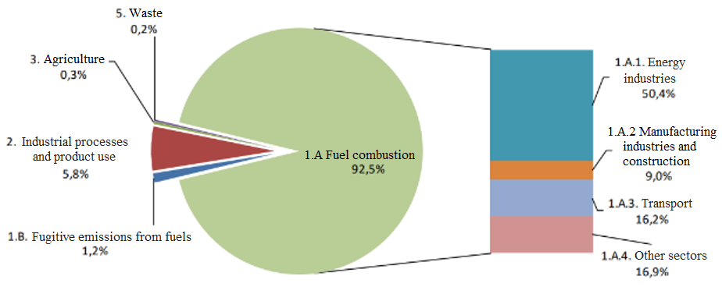

*Source: IOŚ-PIB/KOBIZE, Poland's National Inventory Report 2018. Greenhouse Gas Inventory for 1988-2016 Synthetic Report, Warszawa, 2018, p. 9.*

The main greenhouse gas emitted in Poland isCO2 (over 80% of emissions). The majority of emissions of this gas are caused by fuel combustion (nearly 93%), both in stationary sources (e.g. power plants, CHP plants) and mobile sources (transport). The remaining amount, about 6%, is related to industrial processes[170].

*Fig. 10.2. Historical (1988-2015) and projected (2020-2030) greenhouse gas emissions in Poland [ktCO2e].*



*Source: own elaboration based on: National Centre for Emissions Balancing and Management.*

In 2015, the level of greenhouse gas emissions (excluding LULUCF*[171]*) in Poland was 32% lower than in 1988. According to preliminary data for 2016, emissions increased slightly (by 1%) compared to the previous year, with domestic emissions not exceeding 400 million tonnes ofCO2e since 2012.

According to the national greenhouse gas emission projections prepared in 2015 for the *Second Biennial Report to the Conference of the Parties to the United Nations Framework Convention on Climate Change*, it is estimated that in 2030 total emissions in Poland will be 23% lower than in 1990 and 37% lower than in 1988.

*Fig. 10.3. Changes in GDP, greenhouse gas emissions and emission intensity ratio in the economy (ratio of emissions to GDP) in Poland in the period 1990-2015 (%).*

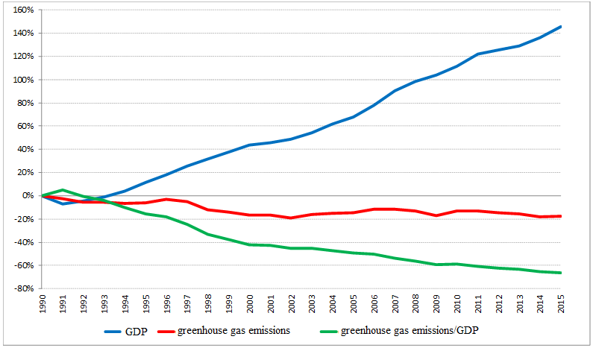

*Source: own elaboration based on data from the National Centre for Emission Balancing and Management.*

In Poland, there is still a phenomenon known as *decoupling,* i.e. the distinction between economic growth and its environmental costs, both due to the increase in pollutant emissions and other pressures on the environment. Between 1990 and 2015, total gross domestic product increased by 145%, while total emissions (excluding LULUCF) decreased by 18%. Between 1990 and 2015, the intensity of greenhouse gas emissions in the economy, defined as the ratio of emissions to GDP, decreased by more than 66%. Faced with the adverse and increasing impacts of climate change, all countries in the world have taken action and cooperated internationally to reduce greenhouse gas emissions in order to reduce the risks posed by climate change by adoption of the *United Nations Framework Convention on Climate Change* (UNFCCC*,* hereinafter referred to as the Convention) in 1992, the Kyoto Protocol (KP) in 1997, under which some developed countries and economies in transition adopted reduction targets for the period 2008-2012 (the first commitment period)[172] and the Doha Amendment to the Kyoto Protocol in 2012, under which further reduction targets for 2013-2020 (the second commitment period) were adopted.

The objective of quantified GHG emission reduction commitments was to stimulate countries to implement measures such as improving energy efficiency, protecting and increasing the efficiency of natural greenhouse gas reservoirs and "sinks” (e.g. forest areas), promoting sustainable forms of farming, increasing the use of new and renewable energy sources, implementingCO2 storage technologies and other advanced and innovative environmentally friendly technologies, and many other measures to combat climate change[173].

*Fig. 10.4. The trend of aggregated greenhouse gas emissions between 1988 and 2015, together with the national reduction target for the first commitment period of the Kyoto Protocol (KP) between 1988 and 2015 [ktCO2e].*

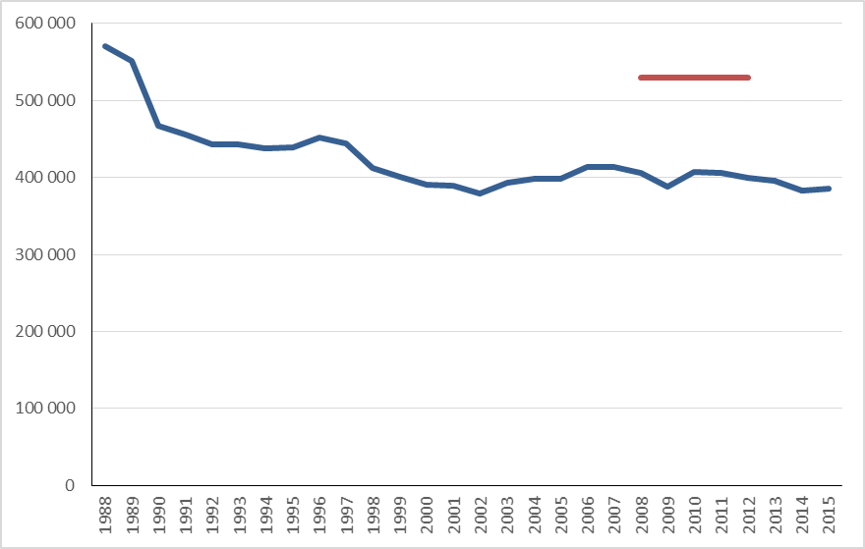

reduction target of the first commitment period of the KP for Poland

*Source: own elaboration based on data from the National Centre for Emission Balancing and Management.*

By joining the international efforts to combat climate change, Poland ratified the Convention in 1994 and the Kyoto Protocol in 2002 [and the Doha amendment in 2018]. Thus, our country has assumed the obligation to reduce its greenhouse gas emissions in 2008-2012 by 6% compared to the base year (1988 for the main gases: CO2, CH4 and N2O and 1995 for fluorinated gases). In fact, Poland reduced its emissions in the first commitment period of the Kyoto Protocol by 29%.

However, in the absence of the possibility of preventing global climate change by reducing emissions solely by Kyoto Protocol countries, it was already clear in the middle of the first decade of the 21st century that there was a need to negotiate a new agreement on the efforts of all countries to halt this phenomenon. The Paris Agreement, adopted in 2015 by 195 countries, including the Member States of the European Union, aimed at keeping a global average temperature rise below 2°C compared to pre-industrial levels, has become such a document. In the Paris Agreement the concept of climate neutrality, understood as the achievement of balance between greenhouse gas emissions and their absorption, as well as technological neutrality, which allows the Parties to decide independently on the manner of achieving the objective of the Agreement, as supported by Poland, has been taken into account. The Parties to the Agreement shall implement its objectives by implementing the *Nationally Determined Contributions* submitted by them to the Secretariat of the Convention*.* At the same time, *non-state actors,* especially in the period prior to 2020, have been identified as playing a major role in mitigating climate change. The actions taken by these actors are intended to support the efforts of the global community to close the gap between the cumulative effects of the activities of the Parties to the Convention and the level of reduction necessary to achieve the objectives of both the Convention and the Paris Agreement. Poland, being an EU Member State, did not submit an independent contribution to the Agreement, but is a party implementing together with other Member States the contribution submitted by the European Union.

The EU's climate change policy is based on the Emissions Trading Scheme (EU ETS) and emission reductions in areas not covered by the EU ETS – the so-called non-ETS. The EU ETS covers mainly the industrial and energy sectors, while non-ETS covers transport, agriculture, buildings, waste and industrial emissions outside the scope of the EU ETS. The share of domestic emissions in Poland from the EU ETS and non-ETS is roughly comparable, as in the period 2005-2015 the EU ETS and non-ETS emissions each accounted for about 50% of total domestic emissions. In this period, the volume of emissions from the EU ETS decreased in Poland by 3%, and from non-ETS by 6%. It should be noted that emissions have decreased despite an increase in the number of installations in the period covered by the EU ETS. Additional gases (NO2 and PFCs in the primary aluminium production sector) have also been taken into account.

Unlike the EU ETS, which is directly related to emissions from individual installations, non-ETS emissions are determined at the level of EU Member States. The legal basis for this is the so-called Effort Sharing Decision (ESD)[174].

*Fig. 10.5. Difference in emissions in the non-ETS sectors in Poland in 2013-2015 and projected for 2016-2020 in relation to the annual emission limits granted. Negative values denote the national surplus in achieving the reduction target [ktCO2e].*

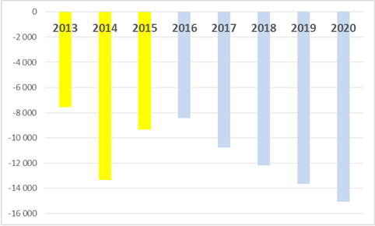

Source: own elaboration based on data from the National Centre for Emission Balancing and Management.

The emission volume allocated to Poland in the period 2013-2020 amounts to +14% in relation to 2005, which means that the increase of non-ETS emission cannot exceed this limit, which becomes the national reduction target. All EU Member States have, in accordance with their reduction targets, received annual emission quotas allocated to them in the non-ETS sectors. These relate to domestic emissions – reporting and accounting is the responsibility of the government. The results of the current settlement of non-ETS emissions for 2013-2015 and the national greenhouse gas emission forecasts prepared in 2015 for the *Second Biennial Report to the Conference of the Parties to the United Nations Framework Convention on Climate Change* indicate that Poland will achieve the aforementioned reduction target with a large surplus in relation to the entire period of 2013-2020.

At present, European policy on combating climate change focuses exclusively on reducing greenhouse gas emissions, whereas a broader approach to this issue is needed, which also includes the sequestration ofCO2 – in particular by forests. The implementation of the EU climate and energy policy is to be supported by, among others, the legislative package on the non-ETS sector and the inclusion of the LULUCF sector in the implementation of the EU's energy and climate policy objectives. Only such an approach can enable effective, quick and cost-effective limitation of the increase inCO2 concentrations in the atmosphere and achieving international objectives. From 2020, the EU shall also include LULUCF emissions mitigation in a common approach, ensuring that this is combined with efforts in other non-ETS sectors. Poland has great potential in reducingCO2 concentration in the atmosphere by using the potential of forests (absorption of 30.6 million tonnes ofCO2 annually from forest land) and implementing development projects such as the pilot project of Carbon Forests.

## Climate change and its effects

The concept of climate change refers to those climate change that persist over a longer period (usually decades or longer) and can be identified as changes in average values and/or in the variability of its elements. This applies to all climate change over time, whether resulting from natural variability or human activity[175].

*Fig. 10.6. Projected change in the average annual air temperature averaged over the area of Poland in the period 2006-2055.*

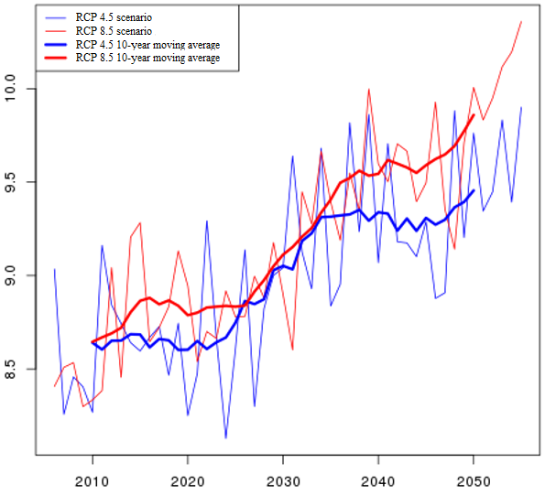

*Source: Institute of Environmental Protection – National Research Institute, carried out as part of the project:* Knowledge base on climate change and adaptation to its impacts and its dissemination channels in the context of enhancing the resilience of the economy, the environment and society to climate change and preventing and minimising the impact of exceptional threats.

Warming up of the climate is evident, particularly since 1950, many of the observed changes have occurred on a scale unprecedented for decades or even millennia. Global warming is manifested by the rise in global average air and ocean temperatures, the widespread melting of snow and ice and the rise in global average sea levels. The last 30 years in the series of instrumental measurements turned out to be a particularly warm period[176].

*Fig. 10.7. Difference in number of days with average 24-hour temperature above 10°C (Tdies>10°C) predicted for the period 2021-2050 compared to the reference period 1981-2010, for RCP4.5 (left) and RCP8.5 (right). Forecast values were calculated on the basis of a bundle of climate models from the EURO-CORDEX repository in 0.11° resolution, corrected with the use of E-OBS temperature fields. E-OBS repository was used as reference observation data.*

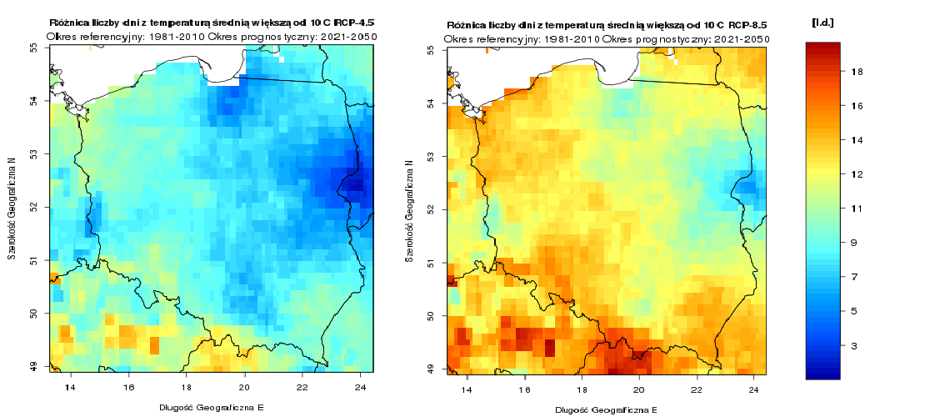

*Source: Institute of Environmental Protection – National Research Institute, carried out as part of the project:* Knowledge base on climate change and adaptation to its impacts and its dissemination channels in the context of enhancing the resilience of the economy, the environment and society to climate change and preventing and minimising the impact of exceptional threats.

According to researchers in the Copernicus programme, 2016 was the warmest year in the history of measurements. Observations by researchers from the US National Ocean and Atmosphere Administration (NOAA) and NASA showed that in 2016 the air temperature was 0.07 degrees Celsius higher than in the previous year. The temperature rose by almost one degree compared to the average of the entire 20th century. This has also been confirmed by the World Meteorological Organisation (WMO), which analyses data from various sources. The reason for this was an increase in carbon dioxide emissions and an exceptionally strong El Niño, a weather phenomenon in which the temperature of the water in the equatorial zone is maintained at high levels. The hottest month in the history of measurements was July 2016. Scientists note that the exceptional situation is that for the third time in a row, we have recorded the hottest year in history. During the entire period of temperature measurements, i.e. from the end of the 19th century, out of 16 hottest years, 15 occurred after 2001.

With warming, global sea levels have also risen. The area of snow cover decreased in both hemispheres, especially in spring and summer, and snow cover duration significantly decreased as well. On a continental and regional scale, other elements of the climate, such as precipitation levels and distribution, are also changing. A long-term trend of changes in precipitation levels has been observed in many large areas, although these changes are very spatially and temporally diversified. Global warming entails an increased probability of extreme weather events. Further warming could cause losses of billions of euros per year and affect access to drinking water and crop yields in the most vulnerable countries.

In Poland, climate change is also observed, which is manifested primarily by: an increase in the average annual air temperature, a change in the structure of precipitation and an increase in the frequency of occurrence of extreme phenomena. In all seasons of the year an increase in air temperature is observed, but it is much stronger in winter. A change in the precipitation structure is also observed. A common phenomenon that is evident in most parts of the country is the trend towards higher precipitation in spring and autumn and a decreasing contribution of summer precipitation to total annual values.

*Fig. 10.8. Projected annual average temperature at 2 metres, averaged over the period 2011-2020 (top) and 2041-2050 (bottom), based on a bundle of climate models from the EURO-CORDEX repository, corrected using E-OBS temperature fields, for RCP4.5 (left) and RCP8.5 (right), at 0.11o resolution.*

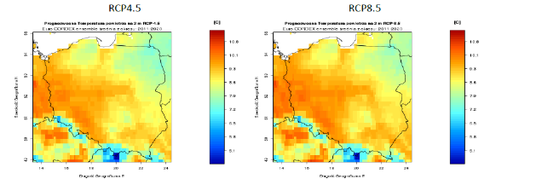

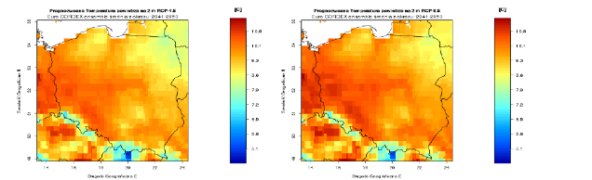

*Source: Institute of Environmental Protection – National Research Institute, carried out as part of the project:* Knowledge base on climate change and adaptation to its impacts and its dissemination channels in the context of enhancing the resilience of the economy, the environment and society to climate change and preventing and minimising the impact of exceptional threats.

A significant and often underestimated problem is the occurrence of droughts in Poland. Droughts can be much more dangerous than flooding, as their effects can last for many years. According to the date from the IUNG Institute of Soil Science and Plant Cultivation, the last year in which no drought was recorded in Poland was 1980. The droughts are "massive", as in 2006, 2008, 2015, 2016. Between these catastrophic years, smaller droughts are observed. Small retention, such as planting forests or creating water ponds, which counteract "desertification" and groundwater depletion are important in counteracting the effects of drought. The hydrotechnical infrastructure developed in Poland is more focused on the prevention of floods, not necessarily droughts. In order to counteract droughts, it is not only dry tanks or polders or multifunctional wet reservoirs (water retention reservoirs), from which water can be supplied during drought, e.g. irrigation and drainage channels, that are important. Water provision for social and living purposes also plays an important role.

Flooding is one of the main natural hazards occurring in Poland, which, in certain circumstances, may take the form of a disaster. Long-term climate change projections point to an increase in the frequency and scale of such phenomena. There are a number of factors affecting the evolution of flood risk. These include changes in the frequency, intensity and timing of precipitation and the reduction of snow cover associated with warming as well as changes in land use, the evolution of flood protection systems and an increase in the potential for flood losses.

The largest floods in our country include the "Millennium Flood", which affected southern and western Poland and neighbouring countries in July 1997. Water has caused significant damage to residential buildings and road infrastructure. In Poland 56 people died, and the material losses were estimated at approx. PLN 12 billion. The flood damage started a nationwide discussion about the danger of building houses in floodplains and the harmful effects of river engineering.

*Fig. 10.9. Difference in the number of days of precipitation (Pr > 1mm/day) projected for the period 2021-2050 in relation to the reference period 2008-2018 for RCP4.5 and RCP8.5. Projected values were calculated on the basis of a bundle of climate models from the EURO-CORDEX repository at a resolution of 0.11o, corrected with the use of ERA5 reanalysis. ERA5 reanalysis was used as reference observational data.*

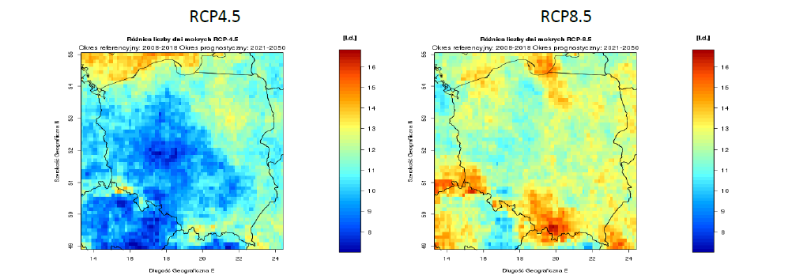

Source: Institute of Environmental Protection – National Research Institute, carried out as part of the project: Knowledge base on climate change and adaptation to its impacts and its dissemination channels in the context of enhancing the resilience of the economy, the environment and society to climate change and preventing and minimising the impact of exceptional threats.

*Fig. 10.10. Difference in the number of days without precipitation (Pr<1mm/day) projected for the period 2021-2050 compared to the reference period 2008-2018 for RCP4.5 and RCP8.5. Projected values were calculated on the basis of a bundle of climate models from the EURO-CORDEX repository at a resolution of 0.11o, corrected with the use of ERA5 reanalysis. ERA5 reanalysis was used as reference observational data.*

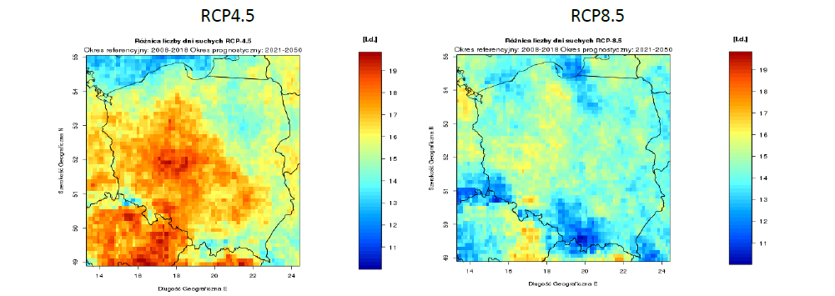

Source: Institute of Environmental Protection – National Research Institute, carried out as part of the project: Knowledge base on climate change and adaptation to its impacts and its dissemination channels in the context of enhancing the resilience of the economy, the environment and society to climate change and preventing and minimising the impact of exceptional threats.

These events were followed by the floods in Poland in May and June 2010, where 811 municipalities suffered losses. The flood destroyed 18,000 residential buildings, damaged more than 10,000 km of roads and many other elements of infrastructure. As a result of the flood, over 105 thousand farms were affected. The voivodships which were most affected by the floods in 2010 are: Małopolskie, Podkarpackie, Śląskie, Opolskie and Lubelskie Voivodships. The losses caused by the flood in 2010 amounted to about PLN 12.2 billion (including losses in agriculture). This figure exceeded 0.6% of GDP in 2009, which allowed submitting a request to the European Commission for financing for the damage caused by the floods in 2010.

*Fig. 10.11. Projected number of hot days per year (Tmax>30°C), averaged over the period 2011-2020 (top) and 2041-2050 (bottom), based on a bundle of climate models from the EURO-CORDEX repository, adjusted using E-OBS temperature fields, for RCP 4.5 and RCP 8.5, at 0.11o resolution.*

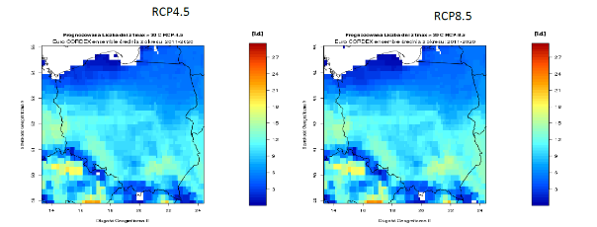

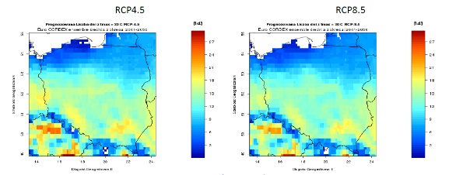

*Source: Institute of Environmental Protection – National Research Institute, carried out as part of the project:* Knowledge base on climate change and adaptation to its impacts and its dissemination channels in the context of enhancing the resilience of the economy, the environment and society to climate change and preventing and minimising the impact of exceptional threats.

Among the natural phenomena unfavourable and burdensome for the population, the environment and economy, the occurrence, especially since the 1990s, of severe heat waves[177] and hot days[178], most frequently occurring in the south-western part of Poland should be mentioned. Also problematic are the increased wind speeds, especially in summer, as well as hurricane wind speeds combined with violent storms, occurring in the so-called squall line. In Poland, reliable hurricane measurements and classifications have been carried out since 2006. Just over 10 years of reliable measurements is not enough to assess whether the phenomenon is increasing or decreasing. It is necessary to have a well-developed precise system for the detection of dangerous storms. The development of an early and rapid alert system in the form of meteorological alerts, covering only a given part of Poland with a strong storm and alerting the residents in areas at risk, may increase public confidence in all meteorological messages and in particular – the alerts.

An increase in storm-related swelling (increase in the number of storms and in the average sea level) in the southern Baltic Sea will be a significant threat to the functioning of the coastal zone, apart from the general increase in the sea level. The predicted changes indicate that the risk of these phenomena is increasing[179]. The swellings cause damage to the coastal zone, transform the undercoast and submerged bar zone, cause damage to beaches, dunes, cliff coasts and hamper maritime economy activities. The greatest risk of storm-related swelling shall remain at a constant level and shall concern Świnoujście. In the central coastal area (Ustka), there is a clearly increasing trend in the annual rate of swellings. The lowest risk is in Hel, where in the course of the long-term annual index we can see only a slightly growing trend and quite low values.

Sea ice formation, as one of the significant parameters in climate change research, also affects the business and economic development of ports, fisheries and maritime trade, through the threats posed by sea ice. A steady rise in sea levels and increased storm activity, especially in spring and winter, shall affect the destruction of beaches and cliffs and may threaten tourism infrastructure (marinas, harbours, beach infrastructure, etc.).

Among the threats caused by climate change, changes in the average sea level are important from the ecological and economic point of view in the Polish Coast region. Scenarios of changes in meteorological conditions[180] indicate that the average annual sea level in the period 2011-2030 shall increase by about 4-5 cm in relation to the values from the reference period 1971-1990. Scenarios developed for the period 2081-2100 show that the average annual sea level shall increase further. The smallest increase is expected for the B1 emission scenario and is approx. 20 cm. In the case of the A1B emission scenario, the expected increase in the average sea level is about 25 cm, and in the case of A2 – about 28 cm.

"In the period 2011-2030 the number of ice days on the Polish coast is expected to decrease"[181]. Projected land loss, calculated on the basis of the findings developed in the system of morphodynamic regions, indicates an increasing erosion of the shore depending on the rate of sea level rise.

Even at a minimum rate of sea level rise, the expected loss of land, assuming the rate of change of the last century, shall be about 6.4 ha/year. The predicted further increase of the sea level even in the minimum variant (30 cm/100 years) shall result in an increase of the length of eroded sections, an increase of the rate of destruction and greater loss of coastal sediments. An increase in the threat to the coast and nearby land should change the existing approach to coastal protection in order to preserve those elements of the coastal system or infrastructure of the coast and nearby land areas which shall be prioritised for protection in the overall quality classification of the zone.

A strong wind in the Baltic coastal zone blowing from the northern sector may be the cause of storm floods, the so-called "backwater". A storm wind blowing towards the shore hinders the outflow of rivers into the sea, causing water build-up in the estuary sections. Storm swellings are most often observed in autumn and winter. Whirlwinds also occur on the Polish Baltic coast. In recent years, the phenomenon has been observed on 10 August 2002 near Jastarnia (waterspout), 31 July 2005 near Jastrzębia Góra, 1 and 2 September 2010 in Kołobrzeg.

The Protection Program until 2023 provides for the protection of seashores over the length of 211.86 km, i.e. 42% of their total length. The assessment of the level of coastal safety shows, however, that 238.4 km of the coast, i.e. 48% of the total length must be protected in order to ensure that the coast can withstand a 100-year storm. The establishment and respect of a *seatback* zone seems to be the most important element in the protection of both property and the shore. In order to specify the safety standards of the coastal zone it is necessary to determine the resistance of the shore to hydrodynamic factors and then the limits of safe management in the coastal zone. This is one of the basic tasks of protecting the seashores until 2050. This does not apply to those stretches of coastline for which total maintenance of the natural or artificial coastline is planned.

The analysis of data concerning the amount of losses, on the basis of data collected within the framework of the KLIMADA project from tens of institutions (ministries and subordinate units, local government units) and expert opinions carried out within the framework of the KLIMADA project[182], showed that during the last 16 years, the phenomena causing the highest damage in Poland were mainly floods and adverse atmospheric phenomena in agriculture. The problem of flooding affected all sectors of the economy and, in addition to agriculture, was also damaging and costly for infrastructure in urban areas. On the other hand, drought (2015) and frost have also caused negative effects in agriculture. Storms have also proved to be a major and costly problem, causing not only material damage, but also a threat to human health and life.

The total value of direct losses caused by extreme weather and climate events in the years 2001-2016 was estimated at over PLN 78 billion, including losses of PLN 20.5 billion in the years 2012-2016 (at 2015 prices).

*Fig. 10.12. Estimation of losses caused by extreme weather and climate events in the years 2001-2016 (defined by the investment price index of 2015 in billion PLN).*

*Source: Siwiec E., Institute of Environmental Protection – National Research Institute (2017).*

Every year, extreme events cause losses ranging from PLN 2 to 5 billion. Once every few years, above-average damage occurs. During the analysis period, floods in 2001 and 2010 and extreme events, including drought in agriculture in 2006 and 2015, caused severe impacts.

According to the assumption that indirect losses compare to about 60% of direct losses[183], it can be assumed that the total losses caused by extreme events in Poland in the last 16 years amounted to approx. PLN 126 billion.

*Fig. 10.13. Losses from extreme weather and climate events in 2012-2016 by sector, following 2015 prices in billion PLN.*

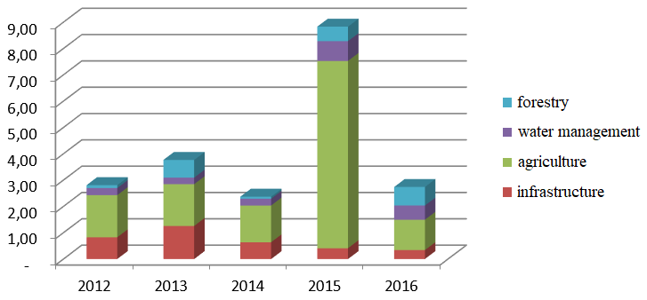

*Source: Siwiec E., Institute of Environmental Protection – National Research Institute (2017).*

In the years 2012-2016, there were no significant flood damages on a national scale. The highest direct losses were recorded in 2015 in the agricultural sector and amounted to approximately PLN 12.5 billion (mainly related to drought). Losses in infrastructure were estimated at about PLN 3.5 billion, while in forestry and water management each, losses of PLN 2 billion were recorded.

By 2030, climate change will have a twofold impact, both positive and negative, on the economy and society. A positive effect shall be, for example, an increase in the average air temperature in the form of extending the vegetation period, shortening the heating period and extending the tourist season. Unfortunately, the predicted negative consequences of climate change are predominant.

*Fig. 10.14. Difference in the number of days with a daily precipitation sum greater than 20mm/d projected for the period 2021-2050 in relation to the reference period 2008-2018 for RCP4.5 (left) and RCP8.5 (right). Projected values were calculated on the basis of a bundle of climate models from the EURO-CORDEX repository at a resolution of 0.11o, corrected with the use of ERA5 reanalysis. ERA5 reanalysis was used as reference observational data.*

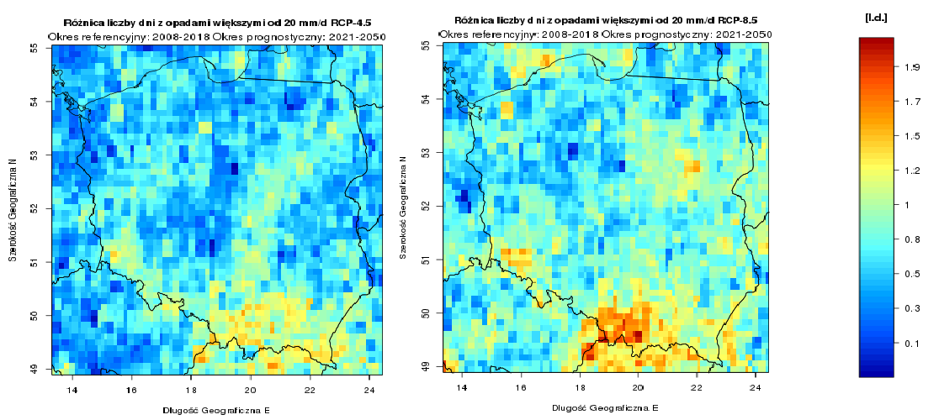

*Source: Institute of Environmental Protection – National Research Institute, carried out as part of the project:* Knowledge base on climate change and adaptation to its impacts and its dissemination channels in the context of enhancing the resilience of the economy, the environment and society to climate change and preventing and minimising the impact of exceptional threats.

Adverse changes in hydrological conditions are directly linked to climate change. Although the predicted annual precipitation values do not change significantly, they become more random and uneven in nature. The result shall be longer rain-free periods, interrupted by sudden torrential rainfall. The projected reduction of groundwater levels shall have a negative impact on biodiversity and forms of nature conservation, in particular on water bodies and wetlands. The negative impact of climate change will also be observed in the winter season, when the period of snow cover and its thickness will decrease and the evaporation process will intensify, which will result in a decrease in the country's water resources.

At the same time, the effect of climate change will be to increase the frequency of occurrence of extreme weather phenomena and disasters with a significant impact on sensitive areas and the economy of the country. The greatest hazard will be posed by torrential rainfall, causing flood, often accompanied by landslides, mainly in mountainous and upland areas. The occurrence of strong winds and even incidentally accompanying tornadoes and atmospheric discharges will increase. This will have a significant impact on, among others, the construction, power and transport infrastructure.

## 

## Adaptation measures

Climate policy does not only consist in limiting greenhouse gas emissions, but also adapting our societies, the environment and the economy to new climate conditions. In Poland, a number of measures have been implemented to improve the resilience of the economy and society to climate change and to reduce the related losses. A *Strategic Adaptation Plan for Sectors Vulnerable to Climate Change until 2020 with an Outlook to 2030* (SPA 2020) has been developed and adopted with a view to ensuring conditions for sustainable socio-economic development in view of the risks posed by climate change.

Policies focusing on the management and protection of water, land and biological resources to maintain and restore healthy and functioning ecosystems capable of adapting to climate change are one way of tackling the impacts of climate change. These strategies can also contribute to disaster prevention, as stated in the recent European Commission Communication[184]. Evidence suggests that using the nature's capacity to mitigate and control impacts in urban and rural areas can provide more effective means of adaptation than relying solely on physical infrastructure. Green infrastructure[185] can be an important contribution to the effective implementation of all policies where some or all of the desired objectives can be achieved in entirety or in part by nature-based solutions. It can play a key role in the adaptation process, as it provides resources important from social and economic points of view in extreme climate conditions. For example, it contributes to improving soil carbon and water storage capacity and water retention in natural systems, thereby mitigating the effects of drought and preventing floods, soil erosion and desertification.

In the context of projected climate change, rainwater management is becoming an increasingly serious problem, in particular with regard to urbanised areas and areas functionally linked to them.

Climate change combined with urbanisation through changes in land use patterns and practices shall lead to an increase in the frequency and intensity of precipitation in the coming years, including an increase in the frequency of torrential rains, which in turn shall result in urban floods, including flash floods, and other types of flooding, in a significant number of cases related to the insufficiency of urban drainage systems. In order to limit the occurrence of the discussed effects of heavy rainfall, often causing significant losses in urban infrastructure and the risk of loss of health or life of city dwellers, it is necessary to take adaptation measures. Such activities should include construction of sustainable rainwater management systems, reduction of soil sealing, construction of retention reservoirs as well as shaping and strengthening the role of the blue and green infrastructure in rainwater retention (small retention). Adaptation measures in the discussed scope should lead to limiting the amount of rainwater run-off and increased retention, as well as increasing the retention of rainwater in open areas. Consideration should be given to both the flood protection function of such measures and the functions related to drought control and the creation of favourable microclimatic conditions around open retention reservoirs. Local authorities should promote small retention at different scales (from backyards to urban forests) and the use of excess rainwater and ensure that the city structure creates a mosaic of open and developed areas, avoiding large, uniform impermeable spaces.

Preventive action brings clear economic, environmental and social benefits by addressing potential impacts and minimising threats to ecosystems, human health, the economy and infrastructure. Available sources suggest that in the medium to long term, the costs of measures undertaken to combat climate change (including mitigation and adaptation measures) shall be significantly lower than the costs of inaction[186].

The development and maintenance of green and blue infrastructure, especially in cities, plays an important role in the planned and implemented actions related to adaptation to climate change. The application of solutions based on urban greenery, apart from a positive adaptation effect, performs a number of other functions, related to health, aesthetics, biodiversity, impact on urban microclimate, absorbing pollution, etc. Therefore, the design, application and maintenance of green and blue infrastructure solutions is crucial for building the resilience of cities to climate change and is an integral part of the implementation of climate change adaptation. The management of “blue-green” infrastructure should combine environmental and recreational functions (integration into small infrastructure, walking and cycling routes, town squares, etc.).

# Environmental education and access to information about the environment

## Sustainable consumption patterns and environmental education

Many negative environmental changes are caused by the increasing use of natural resources necessary to meet the needs of existing production and consumption patterns. In order to reverse or even stop these trends, profound changes are necessary in both production and consumption patterns at the level of administration, households and individuals.

Environmental education is a horizontal issue concerning all areas of environmental protection and water management. The sustainable development of the country requires not only investments in modern, environmentally friendly technologies and rational management of natural resources, but also a high level of environmental awareness of the society. This means that environmental education, while guaranteeing the transfer of up-to-date knowledge and content, must be constantly adapted to the changing environment and the demand for supplementing knowledge and development of competences. Environmental education conducted in an orderly and systematic manner may have a significant positive impact on economic development with respect to the constitutional principle of sustainable development, and thus on the quality of life. Involvement, mutual coordination and cooperation of public institutions, NGOs as well as business and academia determine whether environmental education is effective and brings results (see *Environmental Education Strategy of the National Fund for Environmental Protection and Water Management for 2013-2016 with the perspective to 2020*).

As such, environmental awareness growth is an objective of environmental policy and contributes to the achievement of other objectives. Pollution of the environment in Poland results not only from  
infrastructural problems, but also from insufficient environmental awareness and environmentally unfriendly behaviours of Poles, as shown by the results of *Tracking studies of environmental awareness and behaviour of Poland’s inhabitants[187]*, conducted by the Ministry of the Environment.

The research shows unequivocally that the majority of Poles gives priority to economics over care for the natural environment. Most people are not ready to spend more money on environmentally friendly solutions, e.g. clean energy. The driving force behind saving energy or water is therefore more a concern for the home budget than a conscious environmentally friendly attitude.

*Fig. 11.1. Distribution of answers to the question: In which area do you think our country has most problems to solve? (%)*

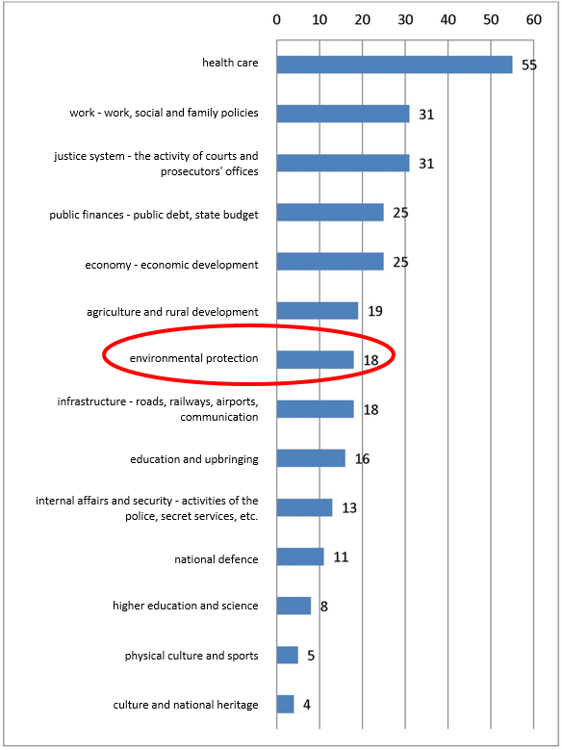

*Source:* own elaboration based on data from*: Tracking study of the awareness of environmentally friendly behaviours of Poland’s inhabitants. Study report. 2018, p. 18.*

Consequently, from the very beginning of the measurements[188], from among the various fields that the state deals with, the majority of Poles consider health protection and labour problems as the most challenging issues. There are no environmental problems on the list of the most "urgent" areas, as these are indicated by only 18% of the respondents. However, it is noteworthy that this percentage has increased compared to the previous survey (in 2014 only 8% of the respondents indicated environmental protection).

*Fig. 11.2. Distribution of answers to the request: Please select three most important, in your opinion, environmental problems in Poland (%)*

|  |
| --- |
| air pollution |
| waste problem |
| climate change |
| water pollution |
| natural disasters |
| disasters caused by the man |
| low water resources |
| disappearance of animal and plant species |
| depletion of natural resources |
| increased noise levels |

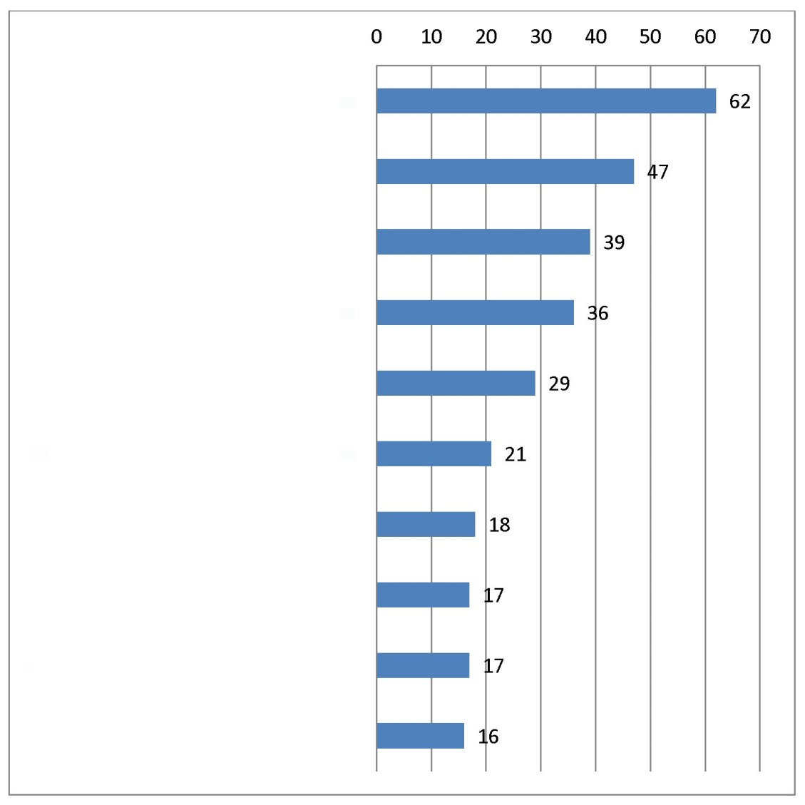

Source: own elaboration based on data from: *Tracking study of the awareness of environmentally friendly behaviours of Poland’s inhabitants. Study report. 2018.*, p. 23.

However, when asked directly about the most important environmental problems in Poland, the respondents consider air pollution as most important (62% of the respondents indicated this problem), with waste problem being the second (47%), and climate change the third (39%).

According to the respondents, air pollution is a significant environmental problem in Poland.

*Fig. 11.3. Distribution of answers to the request: Please rank the following reasons for poor air quality in Poland in the order FROM the most important for you TO the least important – the most important (average score)*

2018

emissions from large combustion plants, factories, etc.

emissions from individual sources, i.e. household furnaces

emissions from road transport

emissions from the countries neighbouring Poland

2013

2014

2018

3 lines of illegible text

* The respondents' answers were scored from 4 for the most important reason to 1 for the least important reason. The average was calculated from the indications of all respondents. The higher the score, the more significant the reason.

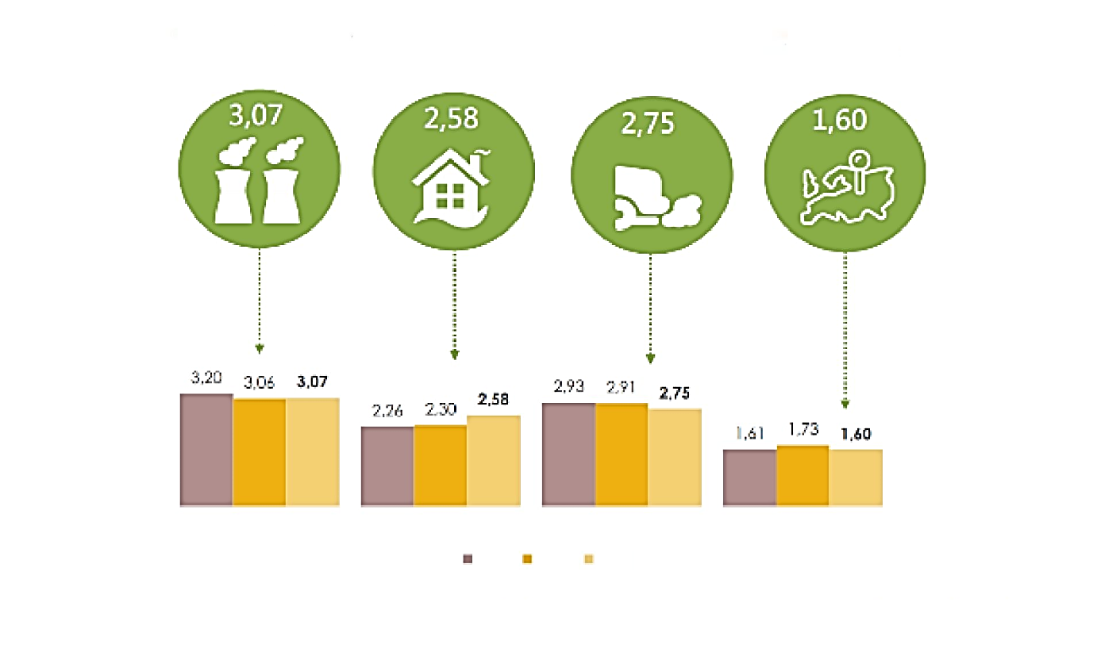

*Source: Tracking study of the awareness of environmentally friendly behaviours of Poland’s inhabitants. Study report. 2018., p. 47.*

According to the respondents, the reason for poor air quality are mainly emissions from large combustion plants, factories, etc. (average score 3.07) and emissions from individual sources, i.e. household furnaces (average score 2.58).

*Fig. 11.4. Distribution of answers to the request: Please indicate which measures, in your opinion, should be applied in order to improve air quality in Poland? (%)*

|  |  |
| --- | --- |
| replacement of old coal-fired furnaces with low-emission ones | image1 |
| use of renewable energy sources | image2 |
| connection of individual households to the heating network | image3 |
| thermal modernization of buildings | image4 |
| introduction of restricted traffic zones for motor vehicles in city centres - the so-called low emission zones | image5 |
| introduction of bicycle systems (bicycle rental) | image6 |
| difficult to say | image7 |
| separation of bus lanes | image8 |
| other, which? | image9 |

*Source: Tracking study of the awareness of environmentally friendly behaviours of Poland’s inhabitants. Study report. 2018., p. 51.*

In order to improve air quality in Poland, according to the respondents, old coal-fired furnaces should be replaced with low-emission furnaces (this answer was indicated by 61% of the respondents), and renewable energy sources should be used (53% of the answers).

The environmental awareness of Poles should be confronted with the actual actions taken to protect the environment. In 2018 the percentage of persons declaring regular waste segregation was only 62% (down from 68% in 2014). Despite the declared waste segregation, the level of recycling and preparation for reuse for paper, metal, plastics and glass was only 28% in 2016 in Poland[189]. Every fourth Pole (26.6%) threw waste into one basket, and almost every sixth Pole (17.2%) segregated waste sporadically.

*Fig. 11.5. Distribution of answers to questions related to waste segregation: Why in your household is waste not segregated or is it done sporadically?*

Hard to say

Household members don't know how to do that.

This entails additional cost.

No practical information on waste sorting

Household members don't have time for this

No suitable containers in the area

Household members don't feel like doing it

No confidence that waste will be reused

No room in the house

2012

2013

2014

2015

data as %

illegible

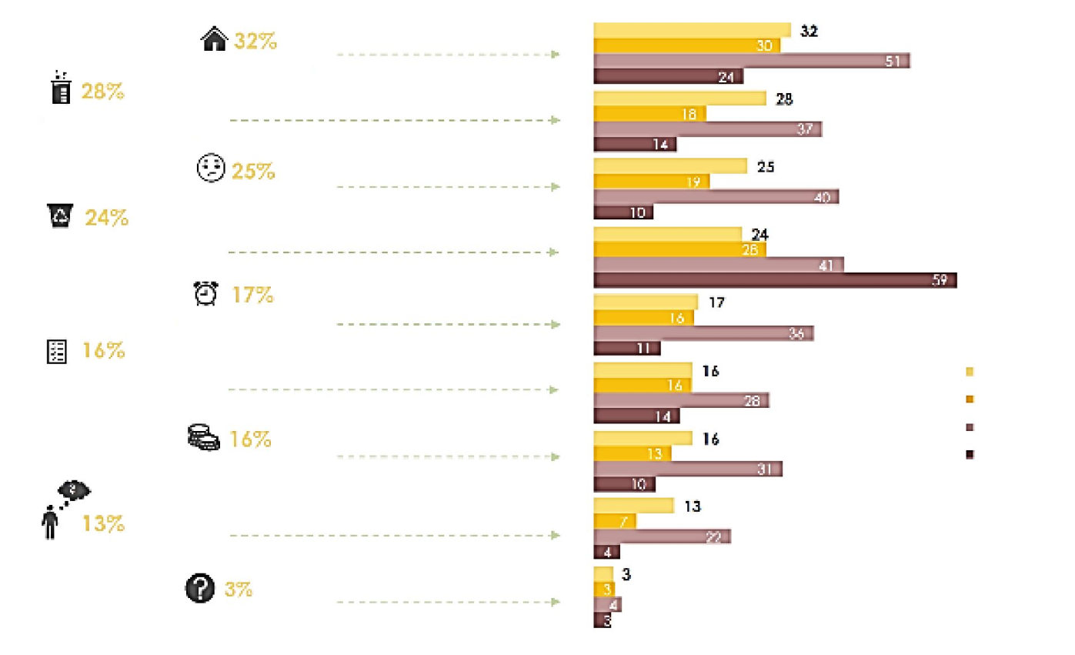

*Source:* Tracking study of the awareness of environmentally friendly behaviours of Poland’s inhabitants. Study report. 2018*, p. 59.*

Persons who did not declare waste segregation or do not do it regularly were asked what the reason for the missing segregation habit in their case is. The most common answer was the lack of space for waste segregation (32%). The lack of faith that waste will be reused was the reason why more than a quarter of the respondents (28%) did not separate their waste. The reluctance of household members is also of great importance (25%, increase by 6 percentage points compared to the 2014 survey), which shows how important in environmentally friendly attitudes is the internal motivation of people and the lack of adequate containers in the area (24%, decrease by 4 percentage points)[190].

*Fig. 11.6. Distribution of answers to the question: In your opinion, what is the most important factor that determines the condition of the environment? (%)*

|  |  |  |
| --- | --- | --- |
| image1 | activity of each of us | image2 |
| image3 | activity of local authorities in the field of environmental protection | image4 |
| image15 | good legislation and its enforcement | image5 |
| image16 | government's emphasis on environmental issues | image6 |
|  | recognition of environmental problems by the society as an important problem | image7 |
| image8 | financial situation of the state | image9 |
| image18 | how much is said about it in the mass media, how many information campaigns are conducted to improve people's awareness | image10 |
| image11 | corporate responsibility | image12 |
| image13 | difficult to say | image14 |

*Source: Tracking study of the awareness of environmentally friendly behaviours of Poland’s inhabitants. Study report. 2018., p. 35.*

The respondents were motivated to protect the natural environment mostly by care   
for human health and care for future generations – these factors were mentioned by 64% of Poles.

According to Poles, the state of the natural environment depends primarily on the activity of each citizen. Institutional factors (good law, government action, etc.) do count, but are on further positions. As a society, we attribute responsibility for the well-being of nature mostly to individuals rather than institutions. Such a conclusion is also confirmed by the answers to the question who should take care of shaping environmentally friendly attitudes and behaviours – the answer "each individual", next to the school and local and regional authorities, appears most often.

In the course of the 2017 survey concerning waste management[191], Poles were asked whether they have a habit of performing certain activities that can be considered as supporting environmental protection. The two most frequently undertaken environmentally friendly activities by Poles are the use of reusable bags (69%) and avoidance of waste generation by purchasing only necessary products (64%). More than half also declare that they repair broken devices before buying new ones and reuse unnecessary objects by giving them back or selling them (54.4% each). The least common practice was to avoid the use of non-returnable bottles, for example by drinking tap water, which was admitted by only 32% of the respondents.

As mentioned earlier, the majority of the respondents believe that environmental problems are not the most important challenge facing Poland. A consequence of this belief may be that there is no need to search for information about the natural environment and its protection. The results of the study indicate that the first source of information about the natural environment is television (mainly for the age group of 40+ recipients), and another preferred source is the Internet (especially for the age group of 15-39-year-old recipients).

Creating environmentally friendly behaviours results in the reduction of the negative impact of the man on the environment, which in the long run will contribute to the reduction of expenditures on the removal of threats and pollution of the environment. The promotion of environmental behaviour meets the requirements of the so-called activities at source, i.e. preventing negative impacts on the environment, and not just eliminating existing problems. The state of the environment depends both on good regulations and their enforcement as well as on the behaviours of individual inhabitants, therefore it is important to conduct effective environmental education and shape sustainable consumption patterns.

## Access to environmental information

Effective and efficient release of environmental information and its protection by public authorities is of multidimensional importance. It is essential for the proper functioning of civil society and building the national economy based on knowledge of the processes taking place in the natural environment and the impact of human activity on these processes. It provides a comprehensive analysis of the risks to human life and health arising from phenomena and changes in the natural environment. By providing reliable and verified data, access to environmental information supports effective, evidence-based environmental education.

The Aarhus Convention[192], the Directive on access to environmental information[193] and the INSPIRE Directive[194] and the national legislation implementing them together form the legal basis for the exchange of environmental information between state authorities and the society. They are also an integral part of the existing EU Government Action Plan for the public administration[195]. Effective implementation of the law on access to information on the environment and its protection is part of the implementation of the Sustainable Development Goals and the related UN strategy for the IT revolution.

Information shall be made available on request from interested parties and in an active manner. Electronic databases containing environmental information will be crucial in the near future. They should allow as wide direct access to up-to-date information via the Internet in real time as possible. They should also allow for the automatic exchange of information for other databases operated by stakeholders interested in their further use, transformation and dissemination. To this end, it is necessary to ensure the greatest possible interoperability between existing and future databases. It is also important to build access points which would aggregate many different databases in one place and thus enable the society to access them more easily.

The INSPIRE Directive sets standards for the exchange of specific spatial data between public authorities. It also requires the Member States to maintain a national geoportal through which spatial data are to be accessible. The thematic scope of the data covers not only those related to the environment, but also, inter alia, reference data[196], which are e.g. addresses, parcels of land or the administrative division of the state. The availability of environmental data (as defined in the INSPIRE Directive) and the data exchange policies ('open data') of each Member State are regularly reviewed[197]. Poland has achieved good results in implementing the INSPIRE Directive by allowing active access to environmental information, but there are areas for improvement. The applicable national rules define the entities entitled to receive data free of charge and the scope of the data to be made available. Poland does not envisage charging for the use of INSPIRE spatial data sets through discovery and viewing services. In accordance with the current deadlines, full implementation of the INSPIRE Directive should be completed by 2021.

Applications for mobile devices and web portals are an important tool for accessing environmental data. The forms of such access to environmental information are derived from the existence of public sources of information and data. Often, only the administration has the ability to develop and update databases, which are then used by applications for mobile devices or web portals. Databases can be built for a specific service or in a universal format that allows their use by different digital tools. The creator of the final product for the citizen is usually a private entity.

Until now, environmental data has been published in many different formats, including non-digital formats. Currently, the administration's efforts are focused on standardizing environmental data and making them available through network services. This is in line with the expectations of the market (digital toolmakers) and the society (digital tool users). During consultations on the amendment of the Act on Access to Public Information in 2015 comments were reported to ensure maximum interoperability of public data so that they can be used by entities outside the public administration. Actions are also being taken at the international level to ensure adequate data interoperability. The most ambitious initiative in this respect is the above-mentioned INSPIRE Directive and the creation of the EU-wide area-based geoportal (the vast majority of environmental information is area-based). The UN Economic Commission for Europe is also taking action to ensure as wide interoperability of data as possible. Present activities of public administrations will be continued and developed so that market participants can use public data in parallel for social and commercial purposes. Therefore, public administrations will increase the availability of public environmental data and ensure that they will be continuously updated, and that existing systems and databases will be interoperable.

# Instruments of the national environmental policy

## Entities involved in environmental management

The competence structure and organization of environmental protection bodies and institutions at the national level aim at systematic improvement of the condition of the environment and implementation of the principles of sustainable development. It is also crucial to meet growing national and EU requirements on environmental protection standards.

The system of organizations of environmental protection services, which has been developing for over the last dozen or so years, is currently a very extensive system, with complex and complicated competence relations, covering increasingly vast areas of problems. The Polish lawmaker adopted the so-called mixed concept of environmental protection services organization, imposing environmental protection competences on existing public administration bodies both governmental and self-government ones, which will perform environmental tasks alongside many other tasks. At the same time, it has set up specialized bodies dealing only with environmental issues. Competences in the application of environmental protection law were granted not only to central but also to local government administration bodies and bodies at practically all levels of the administrative division of the country (self-government authorities at the level of municipality, county and voivodship both of a legislative and executive nature).

The supreme body of public administration in the field of environmental protection is the minister in charge of the environment, which in the current organizational structure is the Minister of the Environment (MŚ). At the central level, there are also such government bodies supervised by the Ministry of the Environment, as the Chief Inspector for Environmental Protection (GIOŚ), the General Director for Environmental Protection (GDOŚ) and the President of the State Atomic Energy Agency.

At the local level, a distinction should be made between the combined administration and the non-combined administration. The field offices of the combined administration include the voivode and the Voivodship Inspector for Environmental Protection (WIOŚ), who has his own auxiliary staff in the form of the Voivodship Inspectorate for Environmental Protection, which is a separate budgetary unit. However, the Regional Directorate for Environmental Protection (RDOŚ) may be indicated among the non-combined administration bodies performing functions in the field of environmental protection.

The administrative grouping significantly influences the functioning of the State Environmental Monitoring, due to, among others, the fact that such a structure makes it more difficult to ensure efficient and cost-effective management of measurement and laboratory infrastructure, prioritization of tasks performed by individual units or specialization of laboratories over the administrative division. A problem of the Chief Inspectorate for Environmental Protection is also the gradual increase of duties and tasks to be performed without strengthening in financial and HR terms. The main challenges are to ensure the effectiveness of inspection activities in building a stable system of financing research and assessment of the condition of the environment as well as to fight against the so-called "grey zone" in waste management. The studies performed[198] show that the phenomenon of the "grey zone" in waste management is growing, and its range concerns 7.8 million tonnes of various types of waste and translates into a market share of approximately PLN 2.7 billion (excluding vehicles).

Among the self-government administration bodies performing tasks in the field of environmental protection there are no specialized bodies for environment protection. The bodies performing tasks in the field of environmental protection are general administration entities:

* at the voivodship level: voivodship council, voivodship board and voivodship marshal;
* at the county level: county council, county board, starosta (or president of the city in case of cities with county rights);
* at the municipality level: municipality council and mayor (or president of the city in case of cities with municipality rights).

It is worth noting that the Polish legislator also distinguishes, among environmental protection bodies, the nature protection bodies as specialized environmental protection authorities, which have matters related to nature protection within the scope of their competence and tasks. As a general rule, it has been assumed that the tasks in the field of nature protection may be performed by the environmental protection authorities specified in the act of 27 April 2001 on Environmental Protection Law (mayor, president of the city, starosta, voivodship marshal, voivode, minister in charge of environmental issues, General Director for Environmental Protection and Regional Director for Environmental Protection). From 1 January 2012 (pursuant to Article 91 of the Act of 16 April 2004 on nature protection (OJ of 2018, item 1614, as amended)[199], the structure of nature protection bodies also includes the director of a national park (currently a specialized administration authority). An important element of this organizational structure is also the obligation to cooperate in the field of nature protection with the nature conservation officer. The Ministry of the Environment performs nature conservation tasks with the assistance of the Chief Nature Conservation Officer[200] and RDOŚ – the regional nature conservation officer[201]. The nature conservation service also includes the director of a landscape park, the national park services and the landscape park services as well as the forest services.

The organization structure of environmental protection services in Poland also includes a very extensive catalogue of consultative and advisory bodies.

The discussed structure also includes organizational units supervised by the Ministry of the Environment. These are the National Fund for Environmental Protection and Water Management (NFOŚiGW) and the State Forest Holding State Forests (PGLLP) as well as the Forest Seed Production Bureau in Warsaw. The National Fund for Environmental Protection and Water Management is the largest separate public institution established to finance environmental protection in Poland. At the regional level, the tasks in this respect are performed by the voivodship environmental protection and water management funds (WFOŚiGW). These entities have legal personality and the possibility to decide independently on the directions of intervention within the limits of the applicable law, in particular the Act of 27 April 2001 on Environmental Protection Law.

PGLLP comprises organizational units, i.e.: General Directorate of State Forests, regional directorates of State Forests, forest districts and other organizational units without legal personality, which perform an auxiliary function[202]. Research institutes are also under the umbrella of the Ministry of the Environment, i.e. The Forest Research Institute, the Institute for Ecology of Industrial Areas and the Institute of Environmental Protection (which performs e.g. tasks of the KOBIZE). In addition, the Ministry of the Environment also runs forest schools.

The system of organization of environmental protection services in Poland also includes ecological institutions of quasi-police nature, appointed to monitor compliance with environmental protection regulations and to react quickly to detected violations. The scope of state natural guards includes:

* State Hunting Guard (acts within the scope of the Act of 13 October 1995 on Hunting Law (OJ L of 2018, item 2033, as amended)),
* two nature guards operating within the structures of state entities: Forest Guard (acts on the basis of the Act of 28 September 1991 on forests (OJ L of 2018, item 2129, as amended) and the Park Guard (operates on the basis of the u.o.p. in the structure of the National Park Services).

On 2 August 2017 the President of the Republic of Poland signed the new Water Law. The Act of 20 July 2017 on Water Law replaced the Act of 18 July 2001, which regulated water management, in particular the shaping and protection of water resources, the use of water and the ownership of water and land covered by water.

The system of legal and organizational structure of water management bodies, which has been in force for over a dozen years, has revealed numerous dysfunctions which have a significant impact on the difficult situation in the water management sector. The previous version of the Water Law Act provided for the functioning of the President of the National Water Management Authority as the central body of government administration competent in matters of water management, and in particular in matters of water management and water use, as well as directors of regional water management boards as governmental non-combined administration bodies competent in matters of water management in the water region. The scope of competence of the President of the National Water Management Authority was very broadly defined, while the scope of competence of the minister in charge of water management was so narrow that the real influence of the minister, and thus of the Council of Ministers, on water management was generally limited. This significantly hindered, for the minister in charge of water management, the possibility of effective and efficient intervention in cases requiring such intervention due to the implementation of the policy of the Council of Ministers in the area of water management and investment activity in water management. The director of the regional water management board performed tasks both on the administrative level (establishing local law, issuing permits under the Water Law) and on the level of management of State Treasury assets and conducted key investment processes in the area of water management. The combination in one body of two types of competences of a completely different nature adversely affected the effectiveness, efficiency and timeliness of actions undertaken in their scope.

Particular concern was raised by numerous problems with regard to the investment process in the water management system. The nature of investments in water management, which have a significant impact on the life, health and property of the population, justified the creation of such legal and organizational conditions in the area of water management to ensure that the investment process, both at the planning stage and at the stage of implementation, is conducted in a timely, reliable and effective manner. The previous legal and organizational structure of water management did not guarantee fulfilment of this postulate. It was also necessary to ensure real and effective water authority and influence of the minister in charge of water management and his subordinate bodies on all decisions concerning water management, including in particular water management planning, water protection and the system of water permits.

The scope of the currently implemented reform of water management aims at introducing instruments ensuring achievement of the Water Framework Directive[203] objective, i.e. full implementation of the catchment-based water management policy that meets the criteria of functionality, safety and sustainable development, economic efficiency, sustainability of ecosystems and social acceptance in accordance with the principle of sustainable water management, including economic use of water resources. Therefore, it is necessary to develop legal, organizational, financial and technical solutions in water management, which will ensure sustainable and balanced social and economic development of the country, taking account of the needs of economic water use and ensuring the availability of water resources of appropriate quality and quantity.

The new Water Law was created in response to the need to create an effective system of financing water management. It provides for payment for water services exceeding the scope of normal or universal water use. The establishment of such a regulation was a condition which Poland had to meet in order to use the funds from the European Union's operational programmes for 2014-2020.

The Act changed the system of water resources management in Poland. The authorities previously competent in this matter have been replaced by a new entity – Państwowe Gospodarstwo Wodne Wody Polskie ("Polish Waters"). Polish Waters are a state legal person (Article 9(14) of the Act of 27 August 2009 on Public Finances (OJ L of 2019, item 869)), which includes the following organizational units:

* The National Water Management Authority with its registered office in Warszawa,
* regional water management boards based in Białystok, Bydgoszcz, Gdańsk, Gliwice, Kraków, Lublin, Poznań, Rzeszów, Szczecin, Warszawa and Wrocław,
* 50 water catchment boards,
* 330 water surveillance bodies.

Polish Waters implement a catchment policy of water management at every level of the catchment area, water region and river basin. Moreover, Polish Waters exercise ownership rights in relation to public waters owned by the State Treasury, with the exception of inland waterways of special importance for transport, in respect of which ownership rights will be exercised by the minister in charge of inland navigation. According to the transitional provision, until the end of 2019 it will not be possible to change the tariffs for water charges.

Polish Waters conduct activities in the field of flood and drought protection and protection of the quality of our water resources, charge and collect fees for water services, issue administrative decisions (water consents). Polish Waters also serve as a regulatory authority to protect residents against unjustified increases in the prices of water and sewage services.

The President of Polish Waters or directors of regional water management boards approve tariffs for collective water supply and collective sewage disposal, give opinions on draft regulations for water supply and sewage disposal and settle disputes between water supply and sewage system companies and the recipients of their services.

One of the weakest pointsof the current legal and organizational system of environmental protection services in Poland is performance of the control function. The effectiveness of this function has a significant impact on ensuring effectiveness in the enforcement of the environmental law.

*Table 12.1. SWOT analysis for the System of Environmental Protection Services.*

|  |  |
| --- | --- |
| STRENGTHS | WEAKNESSES |
| * adoption of the so-called mixed concept for the organization of environmental protection services, i.e. the imposition of environmental protection competences both  on the existing public administration bodies as well as on the established bodies specializing in environmental protection; * functioning within the organization of environmental services of specialized bodies with specialist knowledge  from the field of legal sciences and administration, but also natural  and technical sciences and dealing only with environmental issues, which is important  in particular in view of the need to ensure the proper performance of the tasks for fulfilment of the obligations under the EU law; * development of a system of organization of environmental protection services over the last several years, large human resources potential  and technical background in the field of environmental protection; including the background of a network of accredited laboratories operating in provincial environmental protection inspectorates, performing measurements, research  and studies in connection with the performance of tasks aimed at verifying compliance with the protective obligations imposed by law on certain entities; * delegation of tasks  of executive nature to commune authorities as the basic unit of local government and the unit of public administration that is closest to the society; * functioning of the State Environmental Monitoring as a reliable and objective source of information on the state of the environment, which is necessary for the development, conduct and evaluation of the national environmental policy. | * entrusting self-government administration bodies of a general nature (especially commune bodies) with tasks that require a very high level of professional and profiled knowledge of legal sciences and administration as well as natural sciences and technical sciences to ensure substantive correctness of performing these tasks; * weakness of instruments of cooperation between general administration bodies  with the bodies specialized  in environmental protection; * making the possibility for the specialized body to carry out highly specialized environmental procedures conditional on the final decision of the general administrative body; * under-utilization of the potential of existing specialized bodies; frequent "dispersal" of this potential by assigning a number of tasks to such bodies covering a wide range of different cases (not always requiring particularly high expertise and profiled knowledge); * the lack of precise rules defining the tasks of each authority; * the multiplicity and complexity of organizational and competence links,  as well as personal links between bodies at different levels of administration; * lack of a properly shaped preventive function of inspection and control services for environmental protection; * lack of a modern human resources management system. |
| OPPORTUNITIES | THREATS |
| * possibility of using the possessed, large human resources potential, research facilities to create new structures in order to effectively perform public tasks  in the field of environmental protection, effective fulfilment of tasks by Poland in the field of environmental protection management and implementation of sustainable development objectives. | * inadequate assessment of the facts established by general administration bodies, low quality of environmental procedures and lack of substantive correctness of decisions issued; * prolongation of investment processes by several months,  and even years through repeated dismissal in appeal proceedings and transfer  to reconsideration of the same erroneous decisions in environmental cases and through subsequent verifications in administrative court proceedings; * the lack of a uniform interpretation of the conditions for the adoption of the same type of decision by different authorities; * the need for both public administration bodies and entrepreneurs who are direct addressees of environmental legal norms to operate in conditions of high uncertainty as to the correctness of applied environmental protection law provisions; * occurrence of numerous risks for an investor planning to implement projects (including even the final blocking of project implementation, generating additional, unnecessary costs, because they do not serve environmental protection, withdrawal of EU funds or stimulation of social conflicts); uncertainty among entities planning to implement the project; * inhibition of investment initiatives, lack of economic development of the state; * inability to effectively prevent environmental problems that may arise due to the activities of entities that are harmful to the environment; * conflicts of competence of various entities; competence disputes and the risk of a decision being taken in breach of the rules on competence, which is a premise for cancelling such a legal act; * lack of independence, weak institutional position of bodies (in particular the Environmental Protection Inspectorate)  and a real inability to take effective action, smaller effectiveness in law enforcement, inability to fully exploit the potential of expertise; * low effectiveness of the control function; * lack of financial resources for the implementation of environmental protection tasks; * low organizational, financial and substantive effectiveness of public tasks in the field of environmental protection; * incorrect transposition of EU legal standards by administration bodies; referrals to the EU Court of Justice. |

*Source: prep. by the author on the basis of: Analysis of the effectiveness of functioning of environmental protection services, in particular in the area of law enforcement, together with recommendations for systemic changes (2013)[204].*

Table No. 12.1 lists strengths, weaknesses, opportunities and threats to the current legal and organizational system, with particular emphasis on the causes of inefficiency in the area of environmental law enforcement.

## Environmental protection financing system

Multi-level system

The system of financing tasks from the area of environmental protection consists of institutions, economic instruments and regulations defining the rules of gathering and using financial resources in order to improve the quality of the natural environment or to preserve it in a non-deteriorated condition. The sources of financing are both public and private entities.

The largest separate public institution established to finance environmental protection   
in Poland is the National Fund for Environmental Protection and Water Management (NFOŚiGW), while at the regional level there are voivodship funds for environmental protection and water management (WFOŚiGW). These entities have legal personality and the possibility to decide independently on the directions of intervention within the limits of the applicable law, in particular the Act of 27 April 2001 on Environmental law. The activities of the National Fund for Environmental Protection and Water Management are supervised by the Minister of the Environment. An important entity financing environmental protection is the State Forest Enterprise (Państwowe Gospodarstwo Leśne Lasy Państwowe).

Environmental protection is a horizontal issue; therefore, its financing is also carried out with the participation of entities whose objectives include, e.g. economic development, support for rural areas, infrastructure development and science. Due to the size and number of projects implemented, the most important entities include the National Centre for Research and Development (research funding), the Polish Agency for Enterprise Development (business support) or the Agency for Restructuring and Modernisation of Agriculture (environmental support of agricultural producers and rural development). Measures related to projects taking account of environmental aspects are also implemented by entities responsible for the construction or modernization of road infrastructure (e.g. The General Directorate for National Roads and Motorways (GDDKiA)), railway infrastructure (e.g. PKP Polskie Linie Kolejowe) or power lines.

At the regional and local level, local government units are an important element of the system. The Marshal of the Voivodship, starosta, mayor, president of the city is obliged, among others, to provide access to basic infrastructure the proper functioning of which affects the state of the environment (e.g. sewerage systems). Voivodship governments are also responsible for the implementation of regional operational programs and the implementation of the voivodship contract.

Regardless of this, the key element of the system of financing environmental protection in Poland are households and enterprises.

It is estimated that there are over 14 million households in Poland. According to GUS (Statistics Poland) and EUROSTAT data, Polish households are much less affluent than households in Western Europe, they have a lower disposable income per capita. Such a state of affairs results in a specific structure of expenditures, dominated by the purchase of basic goods and services related to food, use of flats, energy carriers or purchases of clothing. Issues related to the adaptation of Polish law to EU requirements are of particular importance for the costs incurred by households for the use of their homes and for the purchase of energy carriers. Meanwhile, these entities cover almost half of all environmental protection expenditures in Poland[205]. Therefore, the introduction of additional environmental requirements should always take account of the impact of regulation on the burden on household budgets.

The group incurring significant costs for environmental protection in Poland is the business sector. According to the REGON register[206], the number of registered entities exceeds 4 million (most of them are registered natural persons conducting private businesses). The vast majority of enterprises (almost 99%) are micro and small companies, which finance their activity from their own resources. The consequence of the structure of the Polish economy with a significant share of agriculture and industry is a high share of costs incurred by enterprises for the purchase of energy and raw materialsused in the process of production or provision of services. On the other hand, the price of raw materials and energy depends to a large extent on the legal conditions concerning their acquisition, the possibility of using them using specific technologies and the current waste management method. Therefore, the introduction of changes tightening the norms and requirements concerning the use of the environment directly affects the size and direction of investments and current outlays of enterprises operating in Poland. Independent of the above, the financial cost of business for environmental protection is the recording and transmission of statistical data, including those related to the environment. According to research (also conducted by public administration), there are several thousand information obligations in Poland, which are recorded in several hundred legal acts. In the case of small enterprises, expenditure related to the management of the information needed to communicate to all relevant institutions can be a heavy burden on economic activity[207].

An important role in financing environmental protection is played by the banking sector, including Bank Gospodarstwa Krajowego and Bank Ochrony Środowiska S.A (BOŚ Bank). These banks participate, among others, in the efficient disbursement of assistance funds and the provision of preferential financial products to facilitate environmental investments.

The existing construction of the system of financing environmental protection leads to many challenges related, among others, to:

* limited possibility to coordinate a system managed by multiple independent entities,
* presence of not always justified differences in granting assistance for the same environmental projects in different parts of the country or depending on the entities carrying out assistance activities,
* implementation of large integrated projects, for which the financial engineering requires use of various sources,
* difficulties in recording and classifying the environmental effects achieved, which are developed within the framework of activities supported from various sources,
* the emergence, on the one hand, of a phenomenon of competition between different measures   
  in selected areas and, on the other hand, the risk of shortages for financing certain categories of projects,
* limited capacity of the system to quickly reorient the directions of assistance   
  in the event of an emergency.

System financed from multiple sources

The consequence of the deconcentration and decentralization of the system is a variety of the sources of funding. According to GUS data, total expenditures on environmental protection (expenditures on fixed assets and net current costs) amounted, in 2017, to about 1.5% of GDP, which corresponds to expenditures of about PLN 29 billion. About 66% of these costs were borne by households [208].

*Fig. 12.1. Expenditures on fixed assets for environmental protection (million PLN).*

Protection of ambient air and climate

Wastewater management and water protection

Waste management, protection of soil and groundwater and surface water

Other

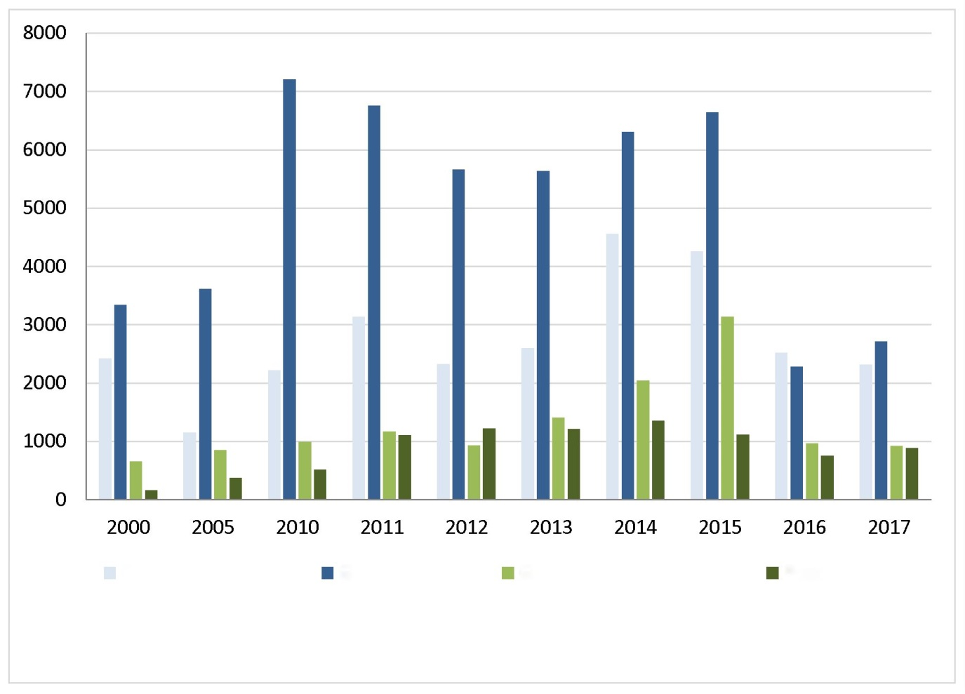

*Source:* own elaboration based on data from*: GUS (the Polish Central Statistical Office), Environmental protection 2018, Warszawa 2018, p. 183.*

GUS data indicate that in the years 2000-2015 there was an increase in expenditures on fixed assets serving the protection of the environment. The decrease in investment, which took place in 2016, resulted from the completion , in 2015, of many large, expensive investments, financed from the ending EU perspective for 2007-2013 and from the fact that in 2016 the funds under the new financial perspective 2014-2020 were not fully invested yet[209]. in 2017, the volume of these outlays amounted to approximately PLN 6.8 billion and was lower by almost a half as compared to 2015 (when these outlays amounted to PLN 15.2 billion).

The structure of financing of fixed assets serving environmental protection was dominated by own funds of municipalities and enterprises, which constituted 64% of all sources of financing. Another important source of financing were foreign funds (12%), environmental funds – loans, credits and subsidies (10%). The remaining outlays were financed with domestic loans and borrowings and other funds, including non-financial outlays and central budget funds. It should be remembered that about 70% of investment outlays were incurred by enterprises, 24% by municipalities, while budget units financed about 6% of all outlays[210].

In the case of public funds, the specificity of the Polish system of financing environmental protection consists in the directional, strictly defined spending of funds from fees and penalties related to the use of the environment. In this way, the "polluter pays" principle is implemented in Poland, and the funds obtained as a result are transferred to investments reducing environmental pollution. According to the Act of 27 April 2001 on Environmental Protection Law the financial and legal means of environmental protection include in particular: fee for using the environment; administrative fine; differentiated rates of taxes and other public levies serving the purposes of environmental protection. Revenues from fees for using the environment and fines for exceeding or breaching the conditions of using the environment are revenue of the National Fund for Environmental Protection and Water Management (NFOŚiGW), WFOŚiGW and revenue of the budgets of counties and municipalities. Additionally, tasks related to environmental protection are also co-financed from the state budget funds (e.g. tasks related to water management).

In this context, it should be noted that, as a consequence of the positive developments taking place   
in the Polish economy and the reduction in its negative impact on the environment, it is possible that the impact of environmental protection funds from penalties and environmental charges will be limited. In the situation of the existing uncertainty concerning the scope and amount of financing of environmental protection from foreign funds after 2020 – it seems important to take this possibility into account when programming the environmental protection financing policy in Poland. In doing so, it seems necessary to take account of the fact that the "polluter pays" principle cannot always lead to security of access for the society to critical ecosystem services (very often of the nature of public goods - e.g. ensuring adequate air quality in urban areas). This situation means that there is still a need for the state support for investment, including non-repayable forms of assistance.

The National Fund for Environmental Protection and Water Management finances or co-finances environmentally friendly undertakings from its own resources and the European funds at its disposal (or operated by them)[211]. In the years 2007-2016, from the so-called "ecological income", the National Fund for Environmental Protection and Water Management was provided with PLN 16.2 billion, while it spent (own funds) approximately PLN 22.9 billion in total. The National Fund for Environmental Protection and Water Management co-finances environmental protection and water management, using non-repayable and repayable forms of financial support.

The funds managed by 16 WFOŚiGW are an important source of financing for environmental protection. In the period 2007-2016, they spent approximately PLN 21.4 billion on environmental protection and water management. In the period 2007-2016, the statutory revenues of WFOŚiGW with regard to fees for economic use of the environment and penalties for non-compliance with pollution emission standards totalled PLN 6.5 billion.

The use of repayable forms of financing, in particular loans, by the National Fund for Environmental Protection and Water Management and WFOŚiGW, ensures partial revolving of the financial resources of these Funds, and is therefore one of the mechanisms to ensure continuity in the performance of their tasks and access by stakeholders to non-commercial and preferential sources of financing for environmental protection projects.

Foreign funds play a noticeable role in financing environmental protection (especially in the investment part). Under the Infrastructure and Environment Operational Programme (2014-2020), an amount (from the Cohesion Fund) of over EUR 3.5 billion was allocated for projects related to adaptation to climate change, waste management, water and sewage management, nature protection and environmental education and urban environment. Under the previous financial perspective (2007-2013), this amounted to approximately €4.8 billion. The most important measures financed under OP I&E 2007-2013 included: water and sewage management, waste management and land surface protection, resource management, protection against threats, nature protection and environmental education as well as support for enterprises.

Significant amounts of assistance are managed by bodies independent of the minister for the environment.

The Minister of Agriculture and Rural Development manages the Rural Development Programme (RDP) for 2007-2013 and 2014-2020. These programs are financed by the European Agricultural Fund for Rural Development (EAFRD) and the state budget. Under RDP (both in the years 2007-2013 and 2014-2020), co-financing is provided for measures aimed at improving the condition of the environment, e.g. by means of sustainable use of agricultural land, encouraging farmers to use environmentally friendly agricultural production methods and compensating farmers for costs incurred due to the location of their farm in a NATURA 2000 network area (e.g. in the framework of agri-environmental payments). In addition, farmers may apply for financial support for the afforestation of agricultural and non-agricultural land, measures to protect forests against fires and natural disasters.

In RDP 2007-2013, the amount (part of co-financing from the EAFRD) of EUR 4 238 958 902 was allocated to axis 2 (including measures implementing environmental objectives), which accounts for approximately 31.6% of the total budget.

In RDP 2014-2020 for priority P4 (restoring, preserving and enhancing ecosystems linked to agriculture and forestry) and priority P5 (supporting resource efficiency and the transition to a low-carbon and climate-resilient economy in the agricultural, food and forestry sectors), EUR 2,875,137,420 was allocated (part of EAFRD co-financing), which accounts for approximately 33.1% of the total budget.

Pro-environmental measures are also financed from the European Regional Development Fund under 16 Regional Operational Programs. A key role in management and implementation of ROPs is played by voivodship boards, which, as Managing Authorities of the programs (MA), are responsible for the preparation and implementation of ROPs. In the 2007-2013 perspective, for environmental protection and hazard prevention, an allocation of almost EUR 1.8 billion was earmarked. These funds were used for projects related, among others, to water and sewage management, management of municipal and industrial waste, promotion of biodiversity, nature protection, revalorization of industrial areas and reclamation of contaminated land, air protection and pollution control. In the 2014-2020 perspective, EUR 2.6 billion has been earmarked for investments in: improving flood safety and drought prevention, securing urban areas, developing early warning and threat forecasting systems, the waste management sector, construction and modernization of the sewage system and sewage treatment plants, protection of biodiversity. The ROPs also finance projects related to the so called low-carbon economy (the EU contribution exceeds €4.5 billion).

However, the minister in charge of energy supervises the financing of projects implemented under priority axis I of the Operational Programme Infrastructure and Environment 2014-2020. The EU contribution to activities related to the low-carbon economy under the first axis of the OPI&E 2014-2020 exceeds EUR 1.8 billion.

Upon accession to the EU, Poland also became a beneficiary of funds under the Norwegian Financial Mechanism (NMF) and the Financial Mechanism of the European Economic Area (FM EEA). From the funds allocated for the years 2004-2009 for the implementation of environmentally friendly investments, support amounting to approximately EUR 112 million was obtained, while for the years 2009-2014 another EUR 180 million was obtained. Under the new financial perspective (2014-2021), the total amount earmarked for Poland is over EUR 800 million.

Since 2008 Poland have also benefited from the LIFE Programme, which is the only financial instrument of the European Union focusing exclusively on co-financing projects in the field of environmental and climate protection. In the 2007-2013 perspective, under LIFE+ the allocation for Poland amounted to approximately EUR 88.3 million. In the financial perspective 2014-2020, the method of distribution of funds was changed: national allocations were determined only for the years 2014-2017 and only for the Sub-Programme for the Environment. The allocation earmarked for Poland amounts to EUR 51 million.

Poland is also a beneficiary of the Swiss-Polish Cooperation Program. In 2007-2017, financing covered activities related to the management of hazardous waste (asbestos), increasing energy efficiency and protecting biodiversity. The amount of co-financing exceeded 160 million Swiss francs.

Bank Ochrony Środowiska S.A. (BOŚ Bank) also plays an important role in the system of financing environmental protection in Poland, providing, among others, specialized banking services to support environmental protection and water management activities. Bank Ochrony Środowiska S.A. has experience in financing environmentally friendly tasks and participates in co-financing of investment projects implemented within the framework of programs supplied with foreign funds. For over 20 years, it has spent PLN 11 billion on financing environmental projects.

## Forms of nature conservation

The creation and functioning of forms of nature protection is an important element in the implementation of nature protection objectives in Poland. The forms of nature protection function on the basis of scientific foundations and many years of national nature protection practice. Each of the forms fulfils a different role in the Polish system of nature protection and serves different purposes, therefore it is characterized by a different protective regime and the scope of restrictions in use. In the Act of 16 April 2004 on nature protection, the following forms of nature protection are distinguished: national parks, nature reserves, landscape parks, protected landscape areas, Natura 2000 areas, natural monuments, documentation stands, ecological sites, natural and landscape complexes, species protection of plants, animals and mushrooms.

There is a Central Register of Forms of Nature Protection in Poland, which is operated by   
the General Director for Environmental Protection (pursuant to Article 113(1) of the Act of 16 April 2004 on nature conservation). The register constitutes the basis for forms of nature protection and is updated on a regular basis. In order to preserve the natural heritage of Poland, until the end of September 2017, according to GDOŚ data, 11,330,100 ha of the area of Poland were covered by national forms of area nature protection. From November 2008 to September 2017 regional directors for environmental protection created 79 reserves in total.

*Fig. 12.2. Protected areas in Poland.*

|  |
| --- |
| Monuments of Nature |
| Ecological Sites |
| Reserves |
| Landscape Parks |
| National Parks |
| Landscape Protection Areas |
| Nature and Landscape Complexes |

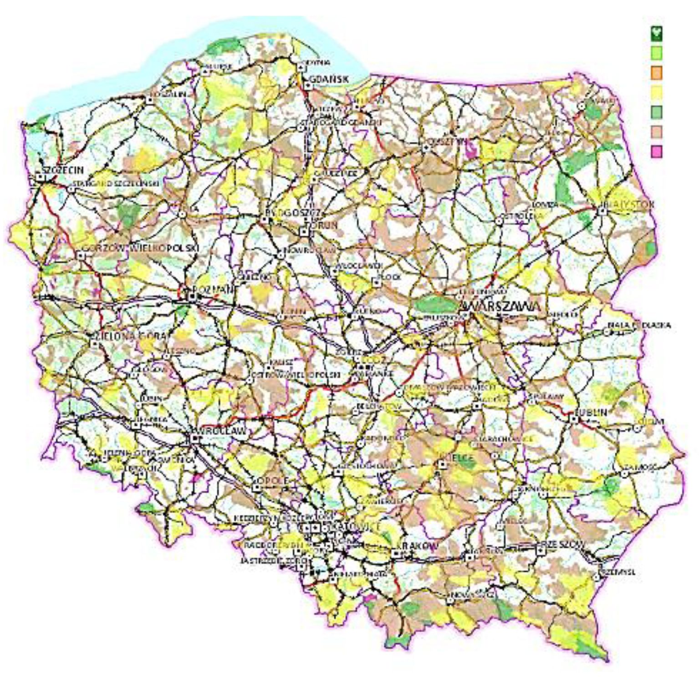

*Source: http://geoserwis.gdos.gov.pl/ (accessed 31.01.2019).*

Area-based forms of nature protection with low protection regimes dominate in Poland (e.g. areas of protected landscape, landscape parks). National parks and nature reserves occupy only 5% of the area of all objects and areas of special natural value in our country. There are 23 national parks in Poland. The oldest of them is the Białowieża National Park, established in 1932 (then called "National Park in Białowieża" – the current name was given in 1947), and the youngest one – "Warta Mouth" National Park (2001)[212]. In terms of the area, the largest one is the Biebrza National Park (nearly 60,000 ha), and the smallest one – Ojcowski National Park with an area of less than 2.2 thousand ha.

*Fig. 12.3. Objects and areas of special natural values legally protected in 2016*

protected landscape areas

69.3%

**ecological sites**

**0.5%**

**natural and landscape complexes**

**0.4%**

**national parks**

**3.1%**

**nature reserves**

**1.7%**

**landscape parks**

**25.0%**

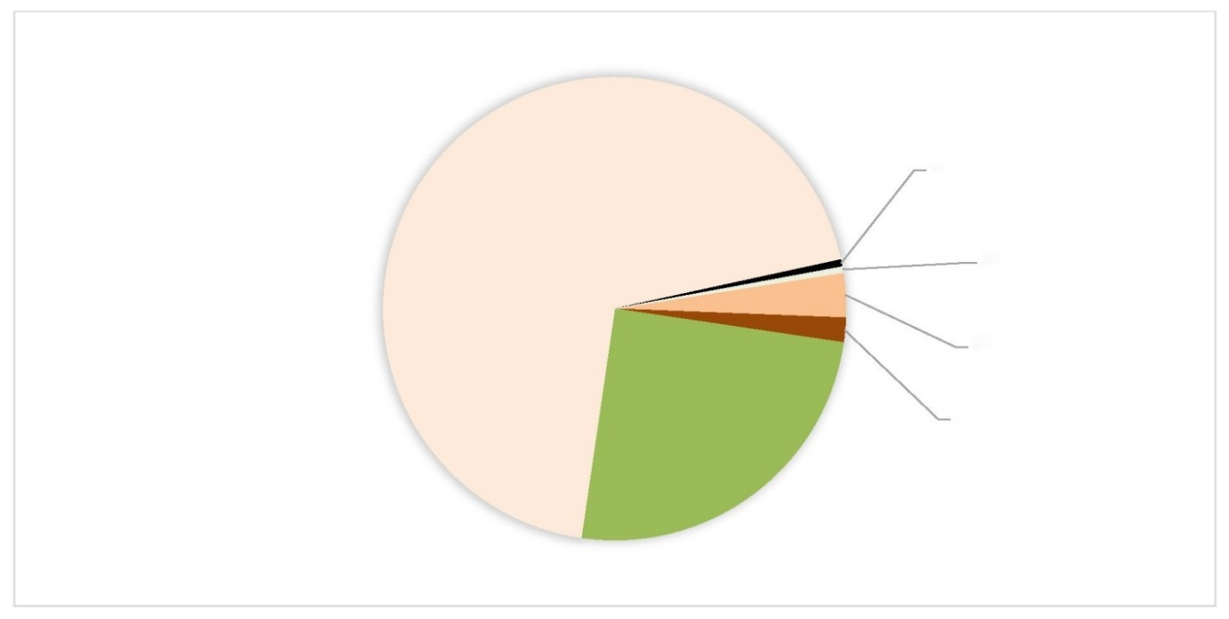

*Source:* own elaboration based on data from*: GUS (the Polish Central Statistical Office), Environmental protection 2017, p. 265.*

The highest form of nature protection in Poland is national park, which covers an area distinguished by its special natural, scientific, social, cultural and educational values, with an area not smaller than 1000 ha, where the entire nature and landscape values are protected. A national park is created in order to preserve biodiversity, resources, creations and components of inanimate nature and landscape values, to restore the proper state of resources and components of nature. The aim of the park is also to restore distorted natural habitats, plant, animal or mushroom habitats.

The area of national parks in Poland is small. Compared to other countries, we occupy 26th place in Europe. They account for only 1.1% of the country's surface area, compared to an average of 3.4% in Europe.

Species and natural habitat types that are valuable and located within the territory of the European Union (i.e. listed in the Annexes to the Habitats and Birds Directives) have been included for conservation purposes in the Natura 2000 network. This network is being established in accordance with the requirements of both the above-mentioned directives and consists of the so-called Bird Special Protection Areas (SPAs) and Sites of Community Importance (SCIs)/Special Protection Areas (SPAs). After the relevant regulations of the Minister of the Environment have been issued, the SCIs will eventually become the so-called special areas of habitat protection. As at the end of September 2017, 83 areas have been granted the SPA status.

Presently[213], the Natura 2000 network in Poland consists of 987 areas, including 145 "bird" areas with a total area of 55,599 km2 (17.3% of the country's total area) (of which 7209km2 lies at sea), and 849 "habitat" areas covering 38 510 km2 (11.8% of the country's total area) (of which 4346 km2 lies at sea[214])[215]. Seven areas with a total surface area of 3490 km2 has "common" status, i.e. created for the protection of birds as well as species and natural habitats. The network of Natura 2000 areas includes a large part of legally protected areas, including all national parks and some landscape parks.

Irrespective of the coexistence of Natura 2000 areas and other forms of nature protection established on the basis of national legislation, it should be noted that the system of protected areas in Poland is coherent and complementary. It is worth noting that the national forms of nature protection have different protection objectives and a separate protection regime than Natura 2000 areas, and other entities may be responsible for protection activities, supervision and their proper functioning. At the central level (national parks, nature reserves and Natura 2000 areas), statutory provisions prescribe the merging of management functions of these areas. For example, as a rule, the Regional Director for Environmental Protection, who also supervises nature reserves, is the supervisor of the Natura 2000 area located in a given voivodship. However, in accordance with Art. 32(5) of UOP (Nature Protection Act), if the Natura 2000 area includes, in whole or in part, a national park area, the director of the national park is responsible for supervising the Natura 2000 area within the boundaries of the national park. Coexistence of different forms of nature protection in a given area makes it necessary to develop appropriate (sometimes compromise-based) synergic measures aimed at achieving the protection objectives, which in general terms gives beneficial effects for nature and landscape.

*Fig. 12.4. Natura 2000 areas in Poland.*

Natura 2000 - bird areas

Natura 2000 - habitat areas

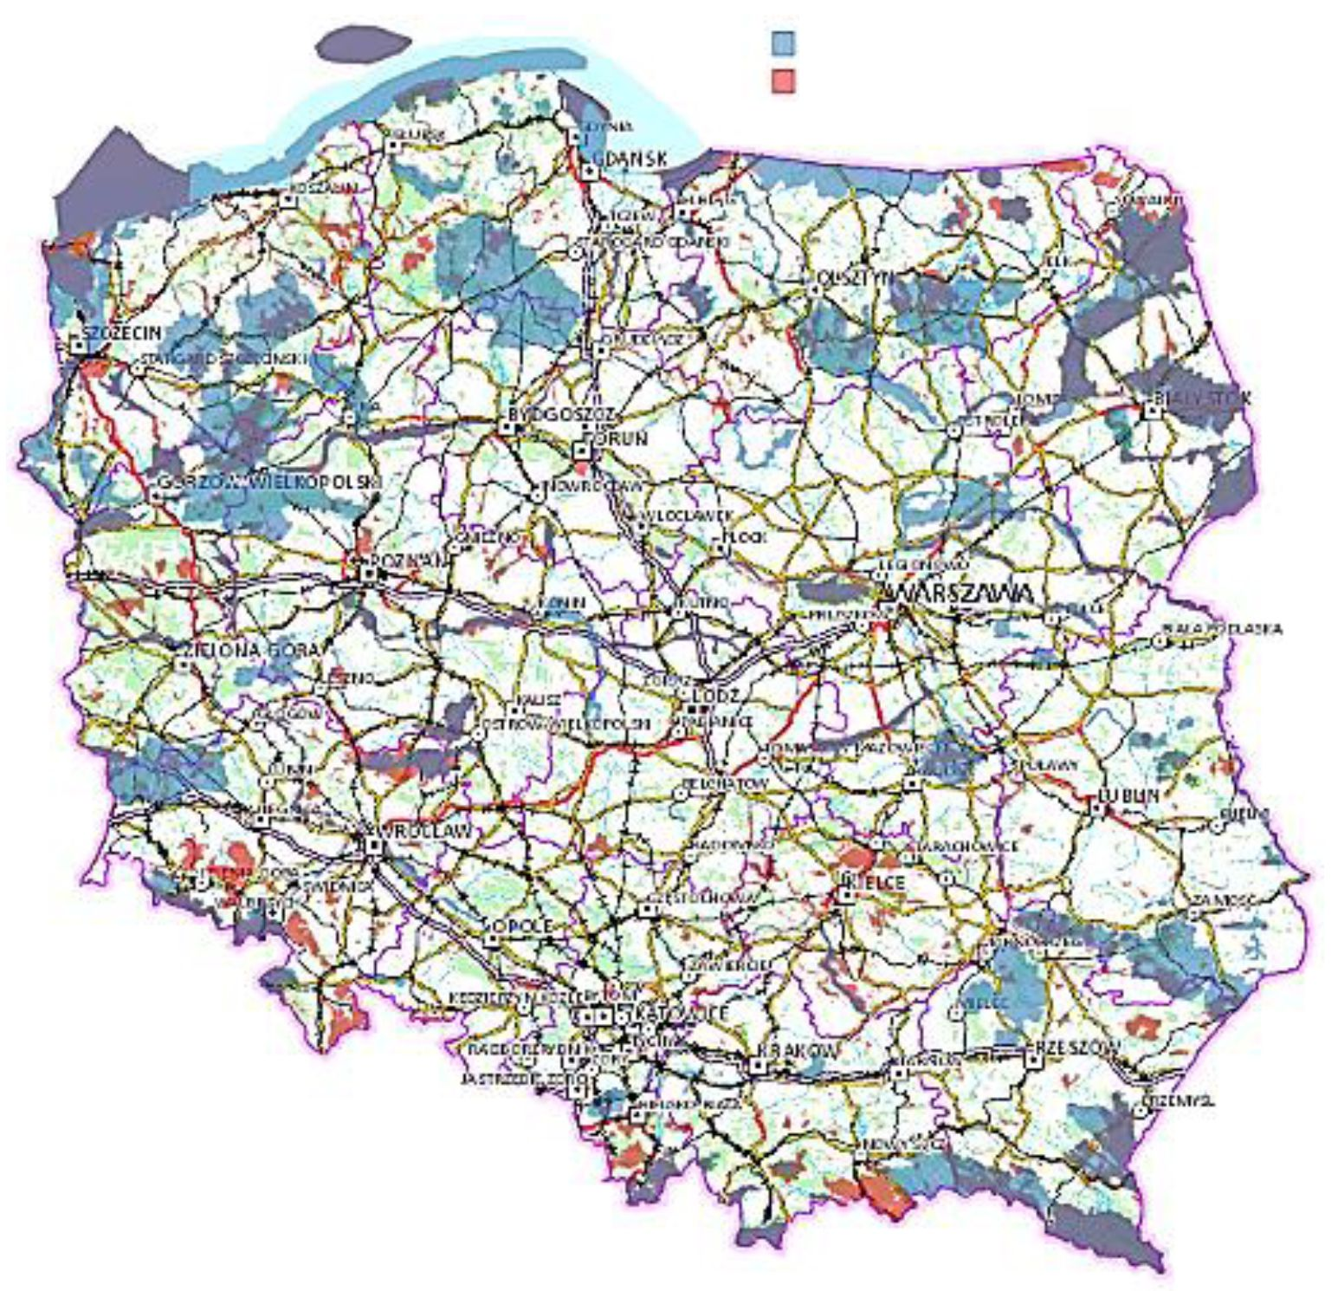

*Source: http://geoserwis.gdos.gov.pl/ (accessed on 01.02.2019).*

An example of such a synergic approach is the provision of Art. 20 par. 5 of the u.o.p, according to which the protection plans for a national park, nature reserve or landscape park in the part corresponding to the Natura 2000 area should take account of the scope of the plan of protection tasks for the Natura 2000 area, or the scope of the protection plan for the Natura 2000 area. According to the legislator, at the voivodship and local level, local governments may decide which objects to protect, which gives them a certain autonomy in terms of nature and landscape protection and constitutes an element of hierarchically balanced management. Not everything that is protected at the local level could and should be protected at the central level. Thanks to such a system and diversity of forms, it is possible to protect the full spectrum of diversity of natural forms and resources of the country.

The Polish areas of natural value were also granted other international and even world statuses. These are:

* Ramsar Areas – The Convention on Wetlands of International Importance, Especially as Waterfowl Habitat, known as the Ramsar Convention, was signed in Ramsar on 2 February 1971. To date, 168 states have ratified it and have designated 2186 wetlands of international importance. The aim of the Ramsar Convention is the protection and sustainable use of all wetlands through national and local action and international cooperation. These activities contribute to the achievement of sustainable development worldwide.
* In Poland there are 13 protected nature areas (in total over 145 thousand ha), including the areas of 7 national parks and 6 nature reserves included in the list of the Ramsar convention. Poland has been a Party to the Convention since 22 March 1978.
* UNESCO-MaB biosphere reserves (*Man and Biosphere*) – International Program "Man   
  and Biosphere" was initiated by UNESCO in 1971. The aim of the Program is to create balanced relations between humans and the biosphere, and the method of achieving this goal is to create an international Network of Biosphere Reserves. It currently comprises 669 such sites in 120 countries. 16 of them are cross-border reserves. The reserves aim to protect biodiversity and improve the ability to observe ecological changes across the planet. They also serve to stimulate public awareness of the links between ecological and cultural diversity.
* On the UNESCO World Biosphere Reserve List there are 10 Polish sites with a total area of 717 532 ha. These include, inter alia, 7 national parks and other protected areas, 3 of which have cross-border status (the "Eastern Carpathians" Biosphere Reserve, the "Karkonosze" Biosphere Reserve and the "Tatra Biosphere Reserve").
* HELCOM marine protected areas[216] – The basic document of the Helsinki Convention, determining the directions of work of its parties, is the Baltic Sea Action Plan (BSAP) signed by the representatives of the governments of the Baltic Sea countries in 2007 in Krakow. It consists of 4 basic segments, one of which is "Biodiversity and nature conservation". It states, inter alia, that the parties to the Convention commit themselves to designate a coherent network of Baltic Sea Protected Areas (BSPAs) by the end of 2009.
* Until then, 4 BSPA areas had been designated in Poland, covering two national parks (Wolin National Park and Słowiński National Park) and two landscape parks: Nadmorski and PK Mierzeja Wiślana (Vistula Spit). As from 31 December 2009 the Minister of the Environment nominated the remaining marine Natura 2000 sites as BSPA sites. Currently nine Natura 2000 sites with a total area of 7939 km2, covering the largest areas of marine waters, have the status of HELCOM Marine Protected Areas (HELCOM MPAs)[217].

A number of other activities were also implemented. Until 1 September 2017 the planning documents were established (i.e. plans of protection tasks (PZO), plans of protection of nature reserves containing the range of PZO and protection plans for national parks containing the range of PZO) for 525 Natura 2000 areas, which constitutes 53.2% of all areas. This includes the plans of protection tasks for 504 areas (51.1% of all areas). Planning documents have been established for 94 Special Protection Areas, 429 SCIs/Habitats Special Areas and 2 areas which are both "Birds" and "Habitats" areas. Draft protection plans for 7 national parks have also been developed. Until 2017 the General Director for Environmental Protection also approved 5 protection programs for: doublet, lesser spotted eagle, greater spotted eagle, Montagu's harrier and harbour porpoise.

In 2013 the Minister of the Environment developed and approved *the Priority Action Framework for the Natura 2000 Network for the Multiannual EU Financing Program 2014-2020* (PAF). It contains an analysis of the most urgent financial needs in the context of the conservation status of species and natural habitat types and a list of the most important actions necessary for the protection of these natural values.

## Environmental impact assessment system

Environmental impact assessment is, in Poland and worldwide, one of the basic tools for environmental protection and sustainable development, applied individually, i.e. in relation to specific plans, programs and projects.

As the name suggests, these assessments are used to determine the impact of the planned intervention on the environment. However, this is not the end of their role, as this concept covers much more important - although feasible after a thorough impact assessment - aspects: preventing, minimizing and compensating for adverse environmental impacts that are or would result from the intervention.

The national system of environmental impact assessments includes:

1. strategic environmental impact assessments;
2. proceedings concerning projects that may have a significant impact on the environment, including the assessment of the impact of projects on the environment;
3. proceedings concerning projects that may significantly affect the Natura 2000 area (other than those that may significantly affect the environment), including the assessment of the impact of projects on the Natura 2000 area.

Strategic environmental impact assessments

This procedure is applied to plans and programs implementation of which may result in the occurrence of significant environmental impacts. The aim of the procedure is to identify the possibility of such impacts as early as possible - at the planning stage, before the investment stage - in order to effectively prevent or, if not possible, limit them and minimize their effects. It is also important to ensure public participation in the preparation of these documents. The strategic environmental impact assessment also examines the possibility of environmental impacts of transboundary nature and, if necessary, proceedings are conducted with the participation of affected countries.

Directive 2001/42/EC is the European Union law on strategic environmental impact assessment[218]. It has been transposed into national regulations with the act of 3 October 2008 on the provision of information on the environment and its protection, public participation in environmental protection and environmental impact assessments[219].

In accordance with the provisions of the EIA Act, strategic environmental impact assessment is conducted for documents prepared or adopted by administrative bodies or other entities performing public functions. These documents include:

* the concept of spatial development of the country, studies of conditions and directions of spatial development of the commune, spatial development plans and regional development strategies,
* policies, strategies, plans or programs in the fields of industry, energy, transport, telecommunications, water management, waste management, forestry, agriculture, fisheries, tourism and land use, providing a framework for the subsequent implementation of projects likely to have a significant impact on the environment,
* other policies, strategies, plans and programs where their implementation is likely to have a significant impact on a Natura 2000 site, if they are not directly related with or do not result from the protection of a Natura 2000 site,
* documents other than those mentioned above, if they set the framework for the later implementation of projects likely to have a significant impact on the environment or if the implementation of their provisions may cause a significant impact on the environment.

A strategic environmental assessment must also be carried out in the event of amendments to already adopted documents.

The main stages of the procedure are: obtaining agreements and opinions required by law, developing an environmental impact assessment, conducting proceedings with the participation of the public and preparing a written summary, in which there is a justification for the choice of the adopted document with reference to the alternatives under consideration. It shall also contain information on how the following have been taken into account and to what extent they have been taken into account: findings of the environmental impact forecast; opinions of the competent bodies; comments and conclusions of the public; results of the investigation concerning cross-border environmental impact, if any, and proposals concerning the methods and frequency of monitoring the effects of the implementation of the provisions of the document. The body responsible for carrying out the strategic environmental impact assessment is the body preparing the draft document. The General Director for Environmental Protection is the body competent for issuing opinions on documents and agreeing the scope of the environmental impact assessment in the case of draft documents prepared and amended by the national or central government administration bodies and in the case when the planned implementation of a given document covers the area of more than two voivodships. The Regional Director for Environmental Protection is a competent body for issuing opinions on documents and agreeing the scope of the environmental impact assessment in the case of draft documents prepared at the regional level (maximum 2 voivodships) and lower levels. The Sanitary Inspection Authority, i.e., depending on the type of the draft document - the Chief Sanitary Inspector, the State Voivodship Sanitary Inspector or the State District Sanitary Inspector - is the authority competent for issuing opinions on documents and agreeing the scope of the forecast of environmental impact within the scope of the impact of the draft document's findings on human safety and health.The Director of the Maritime Office is the competent authority for issuing opinions on documents and agreeing the scope of the environmental impact assessment in the case of draft documents, the findings of which may have an impact on marine areas.

On average, several hundred strategic environmental impact assessment proceedings are carried out each year in each of the voivodships. Most of these proceedings are concerned with drafts and draft amendments to planning documents in the field of spatial management, prepared at the municipality level - studies of conditions and directions of spatial development and local spatial development plans. In addition, several dozen proceedings are conducted annually for documents prepared at the central level and/or covering the area of three or more voivodships, for which the General Director for Environmental Protection plays the role of an opinion-forming and agreeing body. Recently, a large part of these studies have been documents and amendments to documents created in connection   
with the programming of the EU financial perspective for 2014-2020 (e.g. Operational Program Infrastructure and Environment 2014-2020, Operational Program Eastern Poland 2014-2020, Operational Program Fisheries and Sea 2014-2020, Rural Development Program 2014-2020) and documents related to water management (e.g.: updates of water management plans, plans of counteracting the effects of drought).

Proceedings concerning projects likely to have a significant impact on the environment

Environmental impact assessment, as a tool for environmental protection, is usually identified with projects that may have a significant impact on the environment. The basis for assessment proceedings in the EU legislation is Directive 2011/92/EU of the European Parliament and of the Council[220], whereas in Poland this area is regulated by the aforementioned EIA Act. There are two categories of the mentioned projects, which, according to the Polish nomenclature, are projects:

* which may always have a significant impact on the environment,
* likely to have a significant potential impact on the environment.

The former of them, listed in Annex I of the EIA Directive (EU law) and §2 of the Regulation of the Council of Ministers of 9 November 2010 concerning projects that may significantly affect the environment (OJ of 2016, item 71) (national transposition), each time require an environmental impact assessment. This assessment covers in particular:

* verification of the report on the environmental impact of the project,
* obtaining opinions and agreements required by the act,
* ensuring the possibility of public participation in the proceedings.

With regard to projects in the second category, listed in Annex II to the EIA Directive and in §3 of the above-mentioned Regulation of the Council of Ministers, the need to assess the impact of the project on the environment is analysed individually for the projects with a defined scope and location. As a result of the impact analysis of these projects it is possible, among others on the basis of the project information sheet, for the authority to state that the project which may potentially have a significant impact on the environment:

* requires an environmental impact assessment of the project (in such a case the procedure is analogous to projects that may always have a significant impact on the environment),
* does not require an assessment of the environmental impact of the project,   
  and in the course of the procedure the conditions for the execution of the project were determined,
* does not require an environmental impact assessment or the determination of the conditions for the execution of the project.

These proceedings are conducted within the framework of administrative procedures, regulated by the Code of Administrative Procedure, aimed at issuing a decision on environmental conditions (this decision is issued only for projects that may have a significant impact on the environment, regardless of the need to carry out an environmental impact assessment of the project).

In the case of both groups of projects, when the environmental impact assessment was carried out, it is possible to apply the reassessment of the environmental impact. This procedure usually takes place within the framework of a procedure aiming at the issuance of the building permit and is not related to the need to obtain another decision on environmental conditions and is of corrective nature.

Regardless of the adopted procedure, activities related to the assessment of the environmental impact of the project are aimed at determining individual methods of effective environmental protection, even before the commencement of the project. They are of preventive nature and are a basic tool for sustainable development.

The bodies competent to issue decisions on environmental conditions are mainly Regional Directorate for Environmental Protection (RDOŚ), village heads, town mayors and city mayors. The important thing is that RDOŚ also participates in the proceedings conducted by authorities other than RDOŚ, expressing their opinion on the need to assess the environmental impact of the project and determine the conditions for the execution of the project.

Every year in Poland there are several thousand proceedings concerning the issuance of a decision on environmental conditions.

The following aspects are taken into account in the strategic environmental impact assessments and proceedings concerning projects that may have a significant impact on the environment:

* regulated by Council Directive 92/43/EEC of 21 May 1992 on the conservation of natural habitats and wild fauna and flora,
* regulated by Directive 2009/147/EC of the European Parliament and of the Council of 30 November 2009 on the conservation of wild birds,
* regulated by Directive 2000/60/EC of the European Parliament and of the Council of 23 October 2000 establishing a framework for community action in the field of water policy,
* related to climate change mitigation and adaptation.

It should be emphasized that in the case of assessments of draft documents and planned projects it is possible that impacts beyond the borders of Poland may occur. In such cases, a transboundary environmental impact assessment is carried out. The national legal basis for this procedure is defined in the EIA Act, and the international legal instrument, devoted to environmental impact assessment in a transboundary context for planned projects that may have a significant negative impact on the territory of another country, is the Espoo Convention (the Convention on Environmental Impact Assessment in a Transboundary Context drawn up in Espoo on 25 February 1991). As an attachment, the so-called Strategic Protocol (Protocol on Strategic Environmental Impact Assessment to the Convention on Environmental Impact Assessment in a Transboundary Context, drawn up in Kiev on 21 May 2003) has been signed, which applies in relation to draft strategic documents, i.e. plans, programs or policies. Poland is a party to both these legal instruments.

The aim of cross-border proceedings is to ensure the participation of an affected country in the proceedings, including to conduct proceedings with the participation of the public in that country. Comments made during the proceedings are taken into account in the formulation of the final content of the document/decision. In recent years, Poland has repeatedly participated in the cross-border procedure both as the party of origin and as an affected party. In the event that the effects of the implementation of draft strategic documents prepared by Poland could cause transboundary impacts on the territory of other countries, Poland, as the party of origin, effectively notified the affected parties and carried out a full procedure according to Article 7 of the SEA Directive and Article 10 of the Strategic Protocol. This assessment was carried out in most cases for planning documents, such as: spatial development plans at local and regional level and studies of conditions and directions of spatial development in communes. In addition, Poland conducted a cross-border SEA procedure for the Polish Nuclear Energy Program, notifying 10 countries, and then entering into a full cross-border consultation procedure with 7 countries. On the other hand, when Poland was a party to the transboundary SEA procedure, the proceedings were conducted primarily for planning documents concerning spatial management, including mainly for the implementation of specific projects, e.g. wind farms or nuclear power plants. In addition, this procedure was conducted for draft documents in the following sectors: energy (mainly documents related to wind and nuclear energy), transport, mining, flood protection, regional development, operational programs. The General Director for Environmental Protection is an environmental authority participating in cross-border proceedings within the strategic environmental impact assessment.

Proceedings concerning projects likely to have a significant impact on Natura 2000 sites

With regard to any intervention not mentioned in the above-mentioned Regulation of the Council of Ministers, it is necessary to consider its impact on Natura 2000 areas. This is due to the fact that, pursuant to Article 6(3) of the Habitats Directive, all projects - and not only those which may have a significant impact on the environment - require an analysis of the possibility of their impact on Natura 2000 areas.

Studies in this respect, with the participation of the RDOŚ, are conducted within the framework of proceedings aimed at issuing various investment permits, including decisions on development conditions and land use conditions and building permits.

The Polish system of environmental impact assessments, compliant with the requirements of the international law, is a well-functioning and positively evaluated structure. Together with the legal institutions of applications and decisions allowing for the implementation of projects, it is an important element of sustainable development.

## Integrated permits

Integrated permit is a formal and legal instrument introduced into the EU law with the so-called IPPC Directive[221] (*Integrated Pollution Prevention and Control*), now replaced by the IED Directive[222] (*Industrial Emissions Directive*).

The purpose of integrated permits is to eliminate or, where not possible, reduce the negative impact of industrial plants on the environment. This is done by issuing permits based on Best Available Techniques (BAT), which also include emission limit values that do not, under normal operating conditions, exceed the BAT-associated emission levels. BAT requirements are published in the form of Commission implementing decisions, so-called BAT conclusions. In addition to emission requirements, integrated permits regulate issues related to emission monitoring, waste management, use of energy and raw materials. Integrated permits are therefore an effective tool for improving environmental quality.

Installations which require obtaining an integrated permit, due to the scale and type of activity conducted in them, have been specified in the Regulation of the Minister of the Environment of 27 August 2014 on the types of installations which may cause significant pollution of particular natural elements or the environment as a whole (OJ L, item 1169). In Poland there are about 3500 installations requiring an integrated permit[223].

There are six categories of industrial activities for which an integrated permit is required:

* energy industry,
* production and processing of metals industry,
* mineral industry,
* chemical industry,
* waste management facilities,
* other activities (e.g. paper, textile and agri-food industries).

The integrated approach to the determination of environmental conditions in the permit consists in practice in replacing sectoral permits for the introduction of substances or energy into individual components of the environment with a single document, which allows to limit the transfer of pollution between individual components of the environment. Installations requiring an integrated permit must comply with the BAT environmental protection requirements developed at the European level under the so-called Sevilla Process involving the exchange of information between Member States, industry and NGOs on the pro-environmental techniques used in various industries.

The solutions identified in the BAT conclusions are, as a rule, proven on an industrial scale   
and available to the industry, but in some cases the adaptation of installations requiring an integrated permit to the requirements set out in the BAT conclusions will require the operator to implement cost-intensive technological solutions.

LIST OF TABLES AND FIGURES

Fig. 2.1. River basin districts in Poland, p. 6.

Fig. 2.2. Map of the status of documentation of available groundwater resources in Poland, p. 10

Tab. 2.1. Assessment of the state of river surface water bodies monitored in 2017, p. 11.

Fig. 2.3. Ecological state of the natural lake SBWs in 2017, p. 13.

Fig. 2.4. Ecological potential of heavily modified lake SWBs in 2017, p. 14.

Fig. 2.5. Assessment of the chemical state of lake SWBs monitored in 2017, p. 15.

Fig. 2.6. Assessment of the chemical state of all lake SWBs monitored in 2017, p. 16.

Fig. 2.7. Ecological state of the natural lake SBWs in 2017, p. 17.

Fig. 2.8. Assessment of the state of lake SWBs monitored in 2017, p. 18.

Fig. 2.9. Average concentrations of selected heavy metals, sum of polychlorinated biphenyls and polycyclic aromatic hydrocarbons (BaP, BbF, BkF, IndP, Bper) in sediments of benchmark lakes in Poland monitored in the years 2009, 2011, 2013, 2015, p. 18.

Fig. 2.10. Average concentrations of selected heavy metals, sums of polychlorinated biphenyls and polycyclic aromatic hydrocarbons (BaP, BbF, BkF, IndP, Bper) in sediments of Polish rivers at measurement points tested in the years 2009-2015, p. 21.

Fig. 2.11. Average assessment of the ecological state or potential of transitional and coastal waters in the years 2011-2016, p. 21.

Fig. 2.12. Average assessment of the chemical state of transitional and coastal waters based on 21 substances12 between 2011 and 2016 (%), p. 22.

Fig. 2.13. Assessment of the condition of the marine environment in 2016 in terms of eutrophication, p. 23.

Fig. 2.14. The state of the marine environment in 2016 with respect to POP contamination in fish intended for consumption, p. 24.

Fig. 2.15. Groundwater quality classes at operational monitoring points according to data from 2017, p. 26.

Fig. 2.16. Assessment of the state of groundwaters according to data from 2017, p. 27.

Fig. 2.17. Chemical state of GWBs, p. 28.

Fig. 2.18. Industrial and municipal sewage in need of treatment discharged into water or soil, p. 29.

Fig. 3.1 Emissions of SO2, NOx, NH3, NMVOCs and PM2.5 against the ceilings for 2020 set in the Directive on the reduction of national emissions of certain atmospheric pollutants, p. 33.

Fig. 3.2. Structure of emissions of the main pollutants in Poland in 2016 by sectors of the economy, p. 34.

Fig. 3.3. Structure of PM10 primary particulate matter emissions in Poland in 2016 by sectors of the economy, p. 35.

Fig. 3.4. Zone classes based on 24-hour concentrations of PM10 as a result of the assessment of air quality in 2017 (health criteria), p. 39.

Fig. 3.5. Number of days with exceeded values of the 24-hour limit value for PM10 in 2017 at measuring stations located in agglomerations, p. 40.

Fig. 3.6. National average exposure indicator for PM2.5 for the years 2010-2017, p. 42.

Fig. 3.7. Average exposure to PM2.5 for the years 2011-2017, p. 42.

Fig. 3.8. Classification of zones in Poland for benzo(a)pyrene on the basis of annual air quality assessment for 2017 (health protection), p. 44.

Fig. 3.9. Classification of zones in Poland for O3 on the basis of air quality assessment for 2017, p. 45.

Fig. 3.10. Average number of days with exceeded values of the 8-hour moving average of the target concentration of ozone (120 µg/m3) from the period 2015-2017 for the area of Poland, p. 47.

Fig. 4.1. Structure of land use, p. 50.

Fig. 4.2. Devastated and degraded lands (ha), p. 54.

Fig. 5.1. Percentage distribution of short-term road noise in the light of the 1993-2015 survey, p. 58.

Fig. 5.2. Percentage of long-term road traffic noise measurement points (expressed as the LAeqN index) for individual classes of exceeding permissible sound levels in 2012-2016, p. 59.

Fig. 5.3 Percentage of long-term road traffic noise measurement points (expressed as the LAeqD index) for individual classes of exceeding permissible sound levels in 2012-2016, p. 60.

Tab. 5.1. Population of cities with over 100,000 inhabitants exposed to road noise, expressed as the LN index on the basis of acoustic maps prepared in the second round of mapping (year 2017), p. 61.

Fig. 5.4 Average values of electromagnetic field strength in the environment obtained as part of the State Environmental Monitoring in 2017 (V/m), p. 63.

Fig. 5.5 Cs-137 activity in average annual total precipitation in Poland in 2008-2017 (Bq/m2), p. 66.

Fig. 5.6. Average annual concentrations of Cs-137 in the waters of the Vistula, Oder and lake basins in the years 2007-2016, p. 67.

Fig. 5.7. Concentrations of Cs-137 in the surface layer of soil in the years 1988-2016, p. 68.

Tab. 6.1. Number of species/habitat types listed in the Annexes of the Habitats Directive occurring in Poland, p. 73.

Fig. 6.1. Conservation status of species and natural habitats in biogeographical and marine regions of the Baltic Sea, p. 74.

Fig. 6.2. Rate of change in the population numbers of 160 species of nesting birds monitored under the MPP. Status as at 2017, p. 78.

Fig. 6.3. Changes in the Farmland Bird Index (FBI) and Forest Bird Index 34 (FBI34) between 2000 and 2017, p. 79.

Fig. 6.4. Map of forest distribution in Poland in 2018, p. 85.

Fig. 7.1. Industrial waste generated in Poland in the years 2010-2017, p. 92.

Fig. 7.2. Management of industrial waste in Poland in the years 2000-2017, p. 93.

Fig. 7.3. Municipal waste generated per capita in 2017 in the EU countries, p. 94.

Fig. 7.4. Annual levels of recovery and recycling of packaging waste in Poland in the years 2014-2017, p. 96.

Fig. 7.5. Waste electrical and electronic equipment collection rate in Poland in the years 2007-2016, p. 97.

Fig. 7.6. Annual collection rates of waste portable batteries and waste portable accumulators in Poland in the years 2010-2017, p. 98.

Fig. 8.1. Structure of domestic extraction of minerals in Poland in 2017, p. 101.

Fig. 9.1. Eco-innovation Index for the European Union countries in 2017, p. 104.

Fig. 9.2. Activities of companies undertaken in Poland to improve resource management, p. 107.

Tab. 9.1. Level of Green Public Procurement in Poland, p. 108.

Fig. 10.1. Carbon dioxide emissions in 2016, p. 114.

Fig. 10.2. Historical (1988-2015) and projected (2020-2030) greenhouse gas emissions in Poland, p. 115.

Fig. 10.3. Changes in GDP, greenhouse gas emissions and emission intensity index in the economy (ratio of emissions to GDP) in Poland in the years 1990-2015, p. 116.

Fig. 10.4. Trend of aggregated greenhouse gas emissions between 1988 and 2015, together with the national reduction target for the first commitment period of the Kyoto Protocol (KP) between 1988 and 2015, p. 117.

Fig. 10.5. Difference in emissions in non-ETS sectors in Poland in 2013-2015 and projected for 2016-2020 in relation to annual emission limits, p. 119.

Fig. 10.6. Projected change in the average annual air temperature averaged over Poland in the period 2006-2055, p. 120.

Fig. 10.7. Difference in number of days with average 24-hour temperature above 10°, p. 121.

Fig. 10.8. Projected annual average temperature at 2 metres, p. 122.

Fig. 10.9. Difference in the number of precipitation days (Pr>1mm/day), p. 123.

Fig. 10.10. Difference in the number of precipitation-free days (Pr<1mm/day), p. 124.

Fig. 10.11. Projected number of hot days per year (Tmax>30°C), p. 124.

Fig. 10.12. Estimation of losses caused by extreme weather and climate events in the years 2001-2016 (defined by the investment price index of 2015 in billion PLN), p. 128.

Fig. 10.13. Losses from extreme weather and climate events in 2012-2016 by sector, following 2015 prices in billion PLN, p. 129.

Fig. 10.14. Difference in the number of days with daily precipitation over 20mm/d, p. 129.

1. The chapter quotes extensive excerpts from the following studies: *State of the Environment in Poland Signals 2016* (GIOŚ 2017), ed. B. Albiniak and *State of the Environment in Poland. Report 2014*, (GIOŚ 2014).
2. Report "Water Resources Management in Poland 2018", prepared as a result of the implementation of the GNCP program named "Water Resources Management 2018", with presentation at the Cities for Climate Urban Summit on 5 December 2018 as part of the 24th session of the Conference of the Parties to the United Nations Framework Convention on Climate Change (COP24) in Katowice.
3. Statistics Poland, Environmental Protection 2018, Warszawa, 2018, p. 22.
4. Pursuant to the Act of 20 July 2017 – Water Law (OJ L of 2018, item 2268, as amended), Article 16(20) and the Act of 20 July 2018 amending the Water Law and certain other acts (OJ L of 2018, item 1722).
5. In 2017, an updated division of the hydrographic network of the country into water bodies was developed. According to this division, there are 3116 river SWBs, 1068 lake SWBs, 7 transitional SWBs and 4 coastal SWBs.
6. Pursuant to Article 16(3) and (6) of Directive 2000/60/EC of the European Parliament and of the Council of 23 October 2000 establishing a framework for community action in the field of water policy (priority substances are substances hazardous to the environment).
7. Based on data for 2016 and 2017.
8. Directive 2008/105/EC of the European Parliament and of the Council of 16 December 2008 on environmental quality standards in the field of water policy, amending and subsequently repealing Council Directives 82/176/EEC, 83/513/EEC, 84/156/EEC, 84/491/EEC, 86/280/EEC and amending Directive 2000/60/EC of the European Parliament and of the Council (OJ L 348 of 24.12.2008, p. 84, as amended).
9. Directive 2013/39/EU of the European Parliament and of the Council of 12 August 2013 amending Directives 2000/60/EC and 2008/105/EC as regards priority substances in the field of water policy (OJ L 226 of 24.08.2013, p. 1).
10. The Minamata Convention on mercury, signed in Kumamoto on 10 October 2013, is an international instrument of the United Nations Environment Programme (UNEP) at global level, which aims to protect human health and the environment from anthropogenic emissions and releases of mercury and mercury compounds. The provisions of the Convention regulate in a comprehensive manner the issues related to the extraction of mercury, trade in products containing mercury, emissions of mercury to the atmosphere and its release to water and soil, as well as the use of mercury in industrial products and processes. The Convention establishes coherent actions and mechanisms at international level to identify possible ways of mercury management in order to reduce its use and minimise its negative impact on the environment and human health. The activities undertaken in the Minamata Convention on mercury continued with the Regulation (EU) 2017/852 of the European Parliament and of the Council of 17 May 2017 on mercury and repealing Regulation No. 1102/2008, adopted by the European Union (OJ L 137 of 24.05.2017, p. 1), which completes the transposition of the provisions of the Convention into the current EU legislation.
11. Directive 2013/39/EU of the European Parliament and of the Council of 12 August 2013 amending Directives 2000/60/EC and 2008/105/EC as regards priority substances in the field of water policy.
12. Directive 2013/39/EU of the European Parliament and of the Council of 12 August 2013 amending Directives 2000/60/EC and 2008/105/EC as regards priority substances in the field of water policy.
13. Data available on the websites of the individual Voivodship Inspectorates for Environmental Protection. Separate branches were incorporated into the headquarters of the Voivodship Inspectorates for Environmental Protection. For WIOŚ in Opole, Kraków, Rzeszów, Katowice, Łódź, Wrocław and Szczecin there are no data regarding lake SBWs.
14. Ibid.
15. PMPL – Phytoplankton Metric for Polish Lakes.
16. ESMI – Ecological State Macrophyte Index. It is a method of water assessment that must take into account the taxonomic composition and abundance of macrophytes, and these aspects must be expressed in terms of indicators (metrics) that respond well to pressure (showing clear directional variability in pressure gradient).
17. Data available on the websites of the individual Voivodship Inspectorates for Environmental Protection. Separate branches were incorporated into the headquarters of the Voivodship Inspectorates for Environmental Protection. For WIOŚ in Opole, Kraków, Rzeszów, Katowice, Łódź, Wrocław and Szczecin there are no data regarding lake SBWs.
18. Ibid.
19. Ibid.
20. Ibid.
21. Benchmark monitoring network – a set of measurement and control points on surface water bodies selected as representative for Poland in order to monitor their quality. Monitoring in the benchmark points is carried out more frequently than in other locations.
22. Zieliński T., Sedimentology. Settlements of rivers and lakes. Published by Adam Mickiewicz University, Poznań, 2014.
23. cf. Robak-Bakierowska A., Kopiec J., Łużecki G., Łysiak-Pastuszak E. et al., *Ocena stanu środowiska morskiego polskiej strefy ekonomicznej Bałtyku na podstawie danych monitoringowych z roku 2012 na tle dziesięciolecia 2002-2011 (Assessment of the State of the Marine Environment of the Polish Exclusive Economic Zone on the Baltic Sea Based on the Monitoring Data of 2012 against the 2002–2011 Decade),* Biblioteka Monitoringu Środowiska, Warszawa, 2013.
24. HELCOM – Helsinki Commission, executive body of the Convention on the Protection of the Marine Environment of the Baltic Sea Area (Helsinki Convention).
25. HELCOM COMBINE – Cooperative Monitoring in the Baltic Marine Environment.
26. GIOŚ*, State of the Environment in Poland. Report 2018*, Biblioteka Monitoringu Środowiska (Environmental Monitoring Library), 2018, p. 142.
27. GIOŚ*, State of the Environment in Poland. Signals 2016*, p. 55.
28. GIOŚ, *Monitoring of Groundwater Quality*, http://mjwp.gios.gov.pl/ (accessed: 12.02.2019).
29. PIG-PIB, *Interpretation of the Results of Operational Monitoring, Assessment of Chemical State and Preparation of a Study on the Chemical State of Groundwater Bodies at Risk of Failure to Achieve Good State According to Data from 2017*, Warszawa, 2018, pp. 178-179.
30. Ibid., p. 180.
31. *Statistics Poland, Environmental Protection 2018, Warszawa, 2018, p. 60.*
32. Ibid., p. 62.
33. Council Directive 91/676/EEC of 12 December 1991 concerning the protection of waters against pollution caused by nitrates from agricultural sources (OJ L 375 of 31.12.1991, p. 1, as amended; Polish translation section 15, vol. 2, p. 68, as amended).
34. Directive 2000/60/EC of the European Parliament and of the Council of 23 October 2000 establishing a framework for Community action in the field of water policy (OJ L 327 of 22.12.2000, p. 1, as amended; Polish translation section 15, vol. 5, p. 275, as amended), hereinafter referred to as the "Water Framework Directive".
35. The chapter quotes extensive excerpts from the following studies: *State of the Environment in Poland Signals 2016* (GIOŚ 2017), ed. B. Albiniak and *State of the Environment in Poland, Report 2014* (GIOŚ 2014)*.*
36. PM10, PM2.5 – suspended particulate matter with a particle size of 10 micrometres or less and 2.5 micrometres or less, respectively.
37. Regulation of the Minister of the Environment of 24 August 2012 on the levels of certain substances in the air (OJ L item 1031).
38. GIOŚ*, State of the Environment in Poland. Signals 2016,* Warszawa, 2016, p. 23.
39. Directive 2016/2284 of the European Parliament and of the Council of 14 December 2016 on the reduction of national emissions of certain atmospheric pollutants, amending Directive 2003/35/EC and repealing Directive 2001/81/EC (OJ L 344 of 17.12.2016, p. 1).
40. Directive 2001/81/EC of the European Parliament and of the Council of 23 October 2001 on national emission ceilings for certain atmospheric pollutants (OJ L 309 of 27.11.2001, p. 22, as amended; Polish translation section 15, vol. 6, p. 320, as amended).
41. Directive 2016/2284 of the European Parliament and of the Council of 14 December 2016 on the reduction of national emissions of certain atmospheric pollutants, amending Directive 2003/35/EC and repealing Directive 2001/81/EC.
42. Directive 2015/2193 of the European Parliament and of the Council of 25 November 2015 on the limitation of emissions of certain pollutants into the air from medium-sized combustion plants (OJ L 313 of 28.11.2015, p. 1).
43. Directive 2010/75/EU of the European Parliament and of the Council of 24 November 2010 on industrial emissions (integrated pollution prevention and control) (OJ L 334 of 17.12.2010, p. 17, as amended).
44. It is thenameplate capacity *(rated power, nominal power*) of a device used to generate electricity, i.e. a generator, a photovoltaic cell or a fuel cell, specified by the manufacturer, expressed in watts [W] or in multiples of that unit (kW, MW) – as in : information of the President of the Energy Regulatory Office no. 44/2016 of 21 September 2016 on the application of the concept of "installed electrical capacity".
45. Directive (EU) 2016/802 of the European Parliament and of the Council of 11 May 2016 relating to a reduction in the sulphur content of certain liquid fuels (OJ L 132 of 21.05.2016, p. 58).
46. GIOŚ*, State of the Environment in Poland. Report 2018*, Biblioteka Monitoringu Środowiska (Environmental Monitoring Library), 2018, p. 91.
47. The classification of zones is carried out in accordance with the Regulation of the Minister of the Environment of 24 August 2012 on the levels of certain substances in the air and the Regulation of the Minister of the Environment of 2 August 2012 on zones in which air quality is assessed (OJ L item 914), where for Class A, the concentration levels do not exceed the permissible level, and for Class C the concentration levels are above the permissible level. For the averaging period of:

    24 hours – the limit value for PM10 in air is 50 μg/m3 and the threshold excess frequency is 35 times in a calendar year,

    calendar year – limit value for PM10 in air is 40 μg/m3.

    One station where the admissible level is exceeded is sufficient for the entire zone to be categorised as Class C.
48. Juda-Rezler K., Toczko B. (ed.), *Pyły drobne w atmosferze. Kompendium wiedzy o zanieczyszczeniu powietrza pyłem zawieszonym w Polsce (Particulate Matter in the Atmosphere. Suspended Dust Air Pollution in Poland – Compendium).* Biblioteka Monitoringu Środowiska (Environmental Monitoring Library), Chief Inspectorate for Environmental Protection, Warszawa 2018, p. 2016.
49. The classification of zones is carried out in accordance with the Regulation of the Minister of the Environment of 24 August 2012 on the levels of certain substances in the air, where for Class A, the concentration levels do not exceed the permissible level, and for Class C the concentration levels are above the permissible level. While, for the averaging period of one calendar year, the target level for benzo(a)pyrene in air shall be 1 ng/m3.
50. GIOŚ, *What is Ozone and How Does It Affect Life on Earth?* , http://powietrze.gios.gov.pl/ (accessed: 4.01.2019).
51. EEA*, Every Breath we Take. Improving Air Quality in Europe.* *Signals, European Environment Agency,* Copenhagen, 2013.
52. GIOŚ, *What is Ozone…*, ibid.
53. Ibid.
54. The chapter quotes extensive excerpts from the following studies: *State of the Environment in Poland Signals 2016* (GIOŚ 2017), ed. B. Albiniak and *State of the Environment in Poland.* *Report 2014*, (GIOŚ 2014).
55. Statistics Poland, *Environmental Protection 2018*, p. 35.
56. Report from Stage 3 of the contract: *Monitoring of Arable Soil Chemistry in Poland in the Years 2015-2017*, Institute of Soil Science and Plant Cultivation in Puławy – National Research Institute, Puławy, 2017, p. 39.
57. The chapter quotes extensive excerpts from the following studies: *State of the Environment in Poland Signals 2016* (GIOŚ 2017), ed. B. Albiniak and *State of the Environment in Poland, Report 2014* (GIOŚ 2014)*.*
58. Directive 2001/18/EC of the European Parliament and of the Council of 12 March 2001 on the deliberate release into the environment of genetically modified organisms and repealing Council Directive 90/220/EEC.
59. Pursuant to Article 3(5) of the Act of 27 April 2001 – Environmental Protection Law.
60. Chief Inspectorate for Environmental Protection, *Loud Music and the Activities of the Inspection for Environmental Protection in Warszawa*, http://www.gios.gov.pl/ (accessed: 07.01.2019).
61. World Health Organization – Joint Research Centre (WHO – JRC), 2011, *Burden of Disease from Environmental Noise,* http://www.euro.who.int/ (accessed: 14.02.2019).
62. Ibid.
63. Directive 2002/49/EC of the European Parliament and of the Council of 25 June 2002 relating to the assessment and management of environmental noise (OJ EC L 189 of 18.7.2002, p. 12, as amended); Polish translation section 15, vol. 7, p. 101, as amended).
64. LAeqN is a long-term average A sound level expressed in decibels (dB) over all night periods of the year (defined as the time interval from 10 p.m. to 6 a.m.).
65. LAeqD is a long-term average A sound level expressed in decibels (dB) over all day periods of the year (defined as the time interval from 6 a.m. to 10 p.m.).
66. The table does not include the number of inhabitants subject to exceeded values of 40-44 and 45-49 dB due to lack of data in these categories (despite their mandatory reporting).
67. Chief Inspectorate for Environmental Protection, *Noise Monitoring. Summary*, http://www.gios.gov.pl/ (accessed: 07.01.2019).
68. Railway Transport Authority, *Report on the Functioning of the Railway Transport Market in 2016*, Warszawa, 2017, https://utk.gov.pl/ (accessed: 08.01.2019).
69. The chapter quotes extensive excerpts from the study: *State of the Environment in Poland Signals 2016* (GIOŚ 2017), ed. B. Albiniak.
70. Pursuant to §2 of the Regulation of the Minister of the Environment of 12 November 2007 on the scope and manner of conducting periodic examinations of electromagnetic field levels in the environment (OJ L, item 1645).
71. Voivodship Inspectorate for Environmental Protection in Gdańsk, *Electromagnetic Radiation in 2018*, https://www.gdansk.wios.gov.pl/ (accessed: 08.01.2019).
72. GIOŚ, *Assessment of the Levels of Electromagnetic Fields in the Environment for 2017 – based on the results of measurements of the Voivodship Inspectorates for Environmental Protection*, Warszawa, 2018, p. 25.
73. Ministry of Digital Affairs, *Electromagnetic Fields and Humans. Regarding Physics, Biology, Medicine, Standards and 5G Networks*, Warszawa, 2019, https://www.gov.pl/web/cyfryzacja (accessed: 19.06.2019).
74. Ministry of Energy, *Ionising Radiation*, https://www.gov.pl/web/energia(accessed: 18.06.2019).
75. Report on the Activities of the President of the National Atomic Energy Agency and the Assessment of the State of Nuclear Safety and Radiological Protection in Poland in 2016.
76. State Environmental Monitoring Programme for 2016-2020, Warszawa, 2015.
77. nSv/h – nanosieverts per hour. A sievert (Sv) is a unit that determines the absorbed dose in a tissue or organ, taking into account the type and energy of radiation. It enables the determination of the biological effects of radiation on exposed tissue.
78. Institute of Meteorology and Water Management, National Research Institute, Marine Branch in Gdynia, *Monitoring of Ionising Radiation, Carried Out as Part of the State Environmental Monitoring. Task 1: Measurements in the Early Detection Network for Radioactive Contamination. Stage III Report Presenting the Results and Analyses for 2016,* Gdynia, 2017, p. 49.
79. The chapter quotes extensive excerpts from the following studies: *State of the Environment in Poland Signals 2016* (GIOŚ 2017), ed. B. Albiniak and *State of the Environment in Poland, Report 2014* (GIOŚ 2014)*.*
80. Responsible Development Strategy until 2020 (with an Outlook until 2030) adopted by Resolution No. 8 of the Council of Ministers dated 14 February 2017 (M.P. item 260).
81. Own elaboration by GDEP.
82. EC, *Communication from the Commission to the European Parliament, the Council, the European Economic and Social Committee and the Committee of the Regions. Our life insurance, our natural capital: an EU biodiversity strategy to 2020,* Brussels, 2010.
83. EC, *EU Biodiversity Strategy to 2020,* Information leaflet, 2011, http://ec.europa.eu/ (accessed: 08.01.2019).
84. Directive 2009/147/EC of the European Parliament and of the Council of 30 November 2009 on the conservation of wild birds (OJ L 20 of 26.01.2010, p. 7, as amended), hereinafter referred to as the “Birds Directive”.
85. Council Directive 92/43/EEC of 21 May 1992 on the conservation of natural habitats and of wild fauna and flora (OJ EC L 206 of 22.07.1992, p. 7, as amended; Polish translation section 15, vol. 2, p. 102, as amended), hereinafter referred to as the “Habitats Directive”.
86. EC, *EU Biodiversity Strategy to 2020,* Information leaflet, 2011, http://ec.europa.eu/ (accessed: 08.01.2019).
87. EC, *Biodiversity.*.., ibid.
88. Council Directive 92/43/EEC of 21 May 1992 on the conservation of natural habitats and of wild fauna and flora.
89. Based on the GDEP material to the Senate of the Republic of Poland entitled *Implementation of the Birds Directive and Habitats Directive*, November 2017.
90. National Forest Holding State Forests, *Report on the state of Forests in Poland 2012,* Warszawa, 2013.
91. Ministry of the Environment, *Strategy for the Protection of Wetlands in Poland Together with Action Plan (for the Years 2006-2013),* Warszawa, 2006.
92. GIOŚ*, State of the Environment in Poland. Report 2018*, Warszawa, 2018, p. 57.
93. According to the IUCN classification (critically endangered: CR, endangered: EN, or high risk, vulnerable: VU).
94. Data from 2013. GIOŚ*, State of the Environment in Poland. Signals 2014,* Warszawa, 2014.
95. Data according to the current checklist available at http://cdr.eionet.europa.eu/help/habitats_art17 (accessed: 27.02.2019).
96. Council Directive 92/43/EEC of 21 May 1992 on the conservation of natural habitats and of wild fauna and flora.
97. Data according to the current checklist available at http://cdr.eionet.europa.eu/help/habitats_art17 (accessed: 27.02.2019).
98. The 2013-2018 report will be prepared in 2019 after the end of the next monitoring cycle.
99. Land area of Poland: 312,480 km2.
100. Voivodship Inspectorate for Environmental Protection in Rzeszów, *Subcarpathian Nature. Results of Nature Monitoring Studies 2012-2014*, Rzeszów, 2015.
101. GIOŚ*, State of the Environment in Poland. Report 2018*, Warszawa, 2018, p. 46.
102. Ibid.
103. GIOŚ*, State of the Environment in Poland. Report 2014*, Warszawa, 2014, pp. 42–43.
104. Ibid., p. 45.
105. Ibid., p. 51.
106. Fauna Commission, *Bird Species Confirmed in Poland – Status as of 30.06.2013* http://www.komisjafaunistyczna.pl/ (accessed: 15.11.2013).
107. GIOŚ*, State of the Environment in Poland. Report 2018*, Warszawa, 2018, p. 57.
108. GIOŚ*, State of the Environment in Poland. Report 2014,* Warszawa, 2014, p. 45.
109. GIOŚ*, State of the Environment in Poland. Report 2018*, Warszawa, 2018, p. 57.
110. Inspection for Environmental Protection, *Nature Monitoring Bulletin. Monitoring of Birds of Poland in 2016-2018*, Biblioteka Monitoringu Środowiska (Environmental Monitoring Library), no. 17 2018/2, p. 16.
111. Ibid., p. 7.
112. Ibid., p. 16.
113. Ibid., p. 19.
114. Ibid., p. 18.
115. Inspection for Environmental Protection, *Trends in the Population of Birds in Poland*, Biblioteka Monitoringu Środowiska (Environmental Monitoring Library), 2018, p. 100.
116. The Farmland Bird Index (FBI 22) for our country includes such species as: *Ciconia ciconia*, *Falco tinnunculus*, *Vanellus vanellus*, *Limosa limosa*, *Upupa epops*, *Streptopelia turtur*, *Galerida cristata*, *Alauda arvensis*, *Hirundo rustica*, *Motacilla flava*, *Anthus pratensis*, *Saxicola rubetra*, *Saxicola rubicola*, *Sylvia communis*, *Lanius collurio*, *Sturnus vulgaris*, *Passer montanus*, *Carduelis cannabina*, *Serinus serinus*, *Emberiza citrinella*, *Emberiza hortulana*, *Miliaria calandra.*
117. Species belonging to the *Forest Bird Index* – *Parus major*, *Poecile montanus*, *Lophophanes cristatus*, *Carduelis spinus*, *Dendrocopos major*, *Dryocopus martius*, *Pyrrhula pyrrhula*, *Coccothraustes coccothraustes*, *Sylvia atricapilla*, *Turdus merula*, *Sitta europaea*, *Lullula arborea*, *Ficedula hypoleuca*, *Ficedula parva*, *Regulus*, *Certhia brachydactyla*, *Certhia familiaris*, *Phylloscopus collybita*, *Phylloscopus trochilus*, *Turdus viscivorus*, *Phoenicurus phoenicurus*, *Prunella modularis*, *Aegithalos caudatus*, *Erithacus rubecula*, *Poecile palustris*, *Columba oenas*, *Periparus ater*, *Garrulus glandarius*, *Turdus philomelos*, *Troglodytes*, *Anthus trivialis*, *Phylloscopus sibilatrix*, *Fringilla coelebs*, *Regulus ignicapilla*.
118. Ostasiewicz M., *Monitoring of Birds of Poland in the State Environmental Monitoring in 2007-2012,* Aura 11/2013, Warszawa, 2013, pp. 20-22; Ostasiewicz M., Chodkiewicz T., Chylarecki P., Neubauer G., Woźniak B., *Index of the Number of Common Nesting Birds – what can we do based on the data of the Monitoring of Common Nesting Birds in the State Environmental Monitoring?,* 2011*;* Chodkiewicz T., Neubauer G., Meissner W., *Monitoring of the Polish Bird Populations in 2010-2012.* Biuletyn Monitoringu Przyrody (Nature Monitoring Bulletin) 9*,* 2012, pp. 1-44.
119. Ministry of the Environment, *The Role of Wetlands in the Environment*, http://www.gis-mokradla.info/ (accessed: 09.01.2019).
120. Ibid.
121. Ibid.
122. EC, *EU Biodiversity Strategy to 2020,* Information leaflet, 2011, http://ec.europa.eu/ (accessed: 08.01.2019).
123. Regulation (EU) No 1307/2013 of the European Parliament and of the Council of 17 December 2013 establishing rules for direct payments to farmers under support schemes within the framework of the common agricultural policy and repealing Council Regulation (EC) No 637/2008 and Council Regulation (EC) No 73/2009 (OJ L 347, 20.12.2013, p. 608, as amended).
124. *Agri-environmental-climate Measure Manual AECM 2014-2020*, Warszawa, 2017, p. 16. https://www.gov.pl/web/rolnictwo (accessed: 09.01.2019).
125. Ibid., p. 26.
126. Data from the Agency for Restructuring and Modernisation of Agriculture of 20.01.2019.
127. EU Biodiversity Strategy, objective 3B.
128. Statistics Poland, *Statistical Yearbook of Forestry 2018*, Warszawa, 2018, p. 37.
129. Ibid.
130. National Forest Holding State Forests, *Report on the State of Forests in Poland 2017*, Warszawa, 2018, p. 21.
131. Ibid., p. 30.
132. Regional Directorate for Environmental Protection in Białystok, *Different faces of the landscape*, http://bialystok.rdos.gov.pl/ (accessed: 19.02.2019).
133. Own elaboration by GDOŚ.
134. Richling A., Solon J., *Ekologia Krajobrazu* (Landscape Ecology), PWN, Warszawa, 2011.
135. The chapter quotes extensive excerpts from the following studies: *State of the Environment in Poland Signals 2016* (GIOŚ 2017), ed. B. Albiniak and *State of the Environment in Poland, Report 2014* (GIOŚ 2014)*.*
136. Directive 94/62/EC of the European Parliament and of the Council of 20 December 1994 on packaging and packaging waste (OJ L 365 of 31.12.1994, p. 10, as amended; Polish translation section 13, vol. 13, p. 349, as amended).
137. Individual reports were used for each year. The data in the chart are contained in the following documents, respectively: *Report on the Functioning of the Waste Electrical and Electronic Equipment Management System in 2007*, Warszawa, 2008, p. 5; *Report on the Functioning of the Waste Electrical and Electronic Equipment Management System in 2008*, Warszawa, 2009, p. 5; *Report on the Functioning of the Waste Electrical and Electronic Equipment Management System in 2009*, Warszawa, 2010, p. 8; *Report on the Functioning of the Waste Electrical and Electronic Equipment Management System in 2010*, Warszawa, 2011, p. 7; *Report on the Functioning of the Waste Electrical and Electronic Equipment Management System in 2011*, Warszawa, 2012, p. 8; *Report on the Functioning of the Waste Electrical and Electronic Equipment Management System in 2012*, Warszawa, 2013, p. 9; *Report on the Functioning of the Waste Electrical and Electronic Equipment Management System in 2013*, Warszawa, 2014, p. 9; *Report on the Functioning of the Waste Electrical and Electronic Equipment Management System in 2014*, Warszawa, 2015, p. 10; *Report on the Functioning of the Waste Electrical and Electronic Equipment Management System in 2015*, Warszawa, 2016, p. 10; *Report on the Functioning of the Waste Electrical and Electronic Equipment Management System in 2016*, Warszawa, 2017, p. 14.
138. Directive 2006/66/EC of the European Parliament and of the Council of 6 September 2006 on batteries and accumulators and waste batteries and accumulators and repealing Directive 91/157/EEC (OJ L 266 of 26.09.2006, p. 1, as amended).
139. GIOŚ, *Report on the Functioning of the Management of Batteries and Accumulators and Waste Batteries and Accumulators for 2010*, Warszawa, 2012, p. 7; GIOŚ, *Report on the Functioning of the Management of Batteries and Accumulators and Waste Batteries and Accumulators for 2011*, Warszawa, 2012, p. 7; GIOŚ, *Report on the Functioning of the Management of Batteries and Accumulators and Waste Batteries and Accumulators for 2012*, Warszawa, 2013, p. 7; GIOŚ, *Report on the Functioning of the Management of Batteries and Accumulators and Waste Batteries and Accumulators for 2013*, Warszawa, 2014, p. 6; GIOŚ, *Report on the Functioning of the Management of Batteries and Accumulators and Waste Batteries and Accumulators for 2014*, Warszawa, 2015, p. 6; GIOŚ, *Report on the Functioning of the Management of Batteries and Accumulators and Waste Batteries and Accumulators for 2015*, Warszawa, 2016, p. 7; GIOŚ, *Report on the Functioning of the Management of Batteries and Accumulators and Waste Batteries and Accumulators for 2016*, Warszawa, 2017, p. 7; GIOŚ, *Report on the Functioning of the Management of Batteries and Accumulators and Waste Batteries and Accumulators for 2017*, Warszawa, 2018, p. 7.
140. Directive 2006/66/EC of the European Parliament and of the Council of 6 September 2006 on batteries and accumulators and waste batteries and accumulators and repealing Directive 91/157/EEC.
141. Data provided to the European Commission in the reports on the achieved levels of reuse and recovery and reuse and recycling of end-of-life vehicles in relation to the Directive 2000/53/EC of the European Parliament and of the Council of 18 September 2000 on end-of-life vehicles (OJ L 269 of 21.10.2000, p. 34, as amended, Polish translation section 15, vol. 5, p. 224, as amended), accessible through the Eurostat Waste Database.
142. This strategy follows the name most frequently used in public discussion for the general term "gas from unconventional resources". It should be noted that unconventional gas covers a much wider range of resources than shale gas alone.
143. PWN Encyclopaedia, *Poland. Natural conditions. Mineral resources*, https://encyklopedia.pwn.pl/ (accessed: 05.03.2019).
144. Polish Geological Survey, *Balance of Mineral Resources as at 31 December 2017*, Polish Geological Institute – National Research Institute, Warszawa, 2018, pp. 33-44.
145. Ibid., p. 13.
146. BP Statistical Review of World Energy. June 2018. https://www.bp.com (accessed: 4.6.2019).
147. Polish Geological Survey, *Balance of Mineral Resources ...,* ibid., p. 29.
148. Polish Geological Institute, *Import and Export of Minerals and Certain Semi-finished Products in 2017*, http://geoportal.pgi.gov.pl/ (accessed: 20.02.2019).
149. Polish Geological Survey, Balance of Mineral Resources ..., ibid., pp. 70, 77.
150. Ibid., p. 53.
151. Ibid., p. 50.
152. PIG-PIB, *Balance of Mineral Resources in Poland as at 31 December 2016,* p. 458.
153. Domestic material consumption (DMC) – material directly used in the economy, defined as domestic extraction plus imports, minus exports. The DMC represents the assessment of resource use in absolute terms; data for 2017 are preliminary estimates by Eurostat.
154. Statistics Poland in Białystok, *Green Economy Indicators in Poland 2017*, Białystok, 2017, p. 64.
155. BRIdge Alfa concerns ideas at the seed stage, where the risk of investment failure is the greatest, but they can be verified at a relatively low cost. The projects supported in this way are an attractive product for Venture Capital Funds. This will close the capital gap which prevents scientists from reaching the business with their projects. Investors shall receive non-refundable support, granted by NCRD to create an investment vehicle. Their network shall create an ecosystem supporting the incubation of spin-off businesses. The vehicle shall be used to select ideas with a high commercialisation potential. They will enter the market by providing a transition through the proof of principle and proof of concept phase and all the services necessary to transform them into spin-offs. The budget of one vehicle ranges from PLN 10 to 30 million, and the non-refundable financing from NCRD is 80%. The support available for an individual project, as a standard, amounts to PLN 1 million, and in justified cases even up to PLN 3 million.
156. Regulation (EU) No 1303/2013 of the European Parliament and of the Council of 17 December 2013 laying down common provisions on the European Regional Development Fund, the European Social Fund, the Cohesion Fund, the European Agricultural Fund for Rural Development and the European Maritime and Fisheries Fund and laying down general provisions on the European Regional Development Fund, the European Social Fund, the Cohesion Fund and the European Maritime and Fisheries Fund and repealing Council Regulation (EC) No 1083/2006 (OJ L 347 of 20.12.2013, p. 320, as amended).
157. Flash Eurobarometer 426, SMEs, Resource Efficiency and Green Markets, September 2015, http://ec.europa.eu/ (accessed: 20.02.2019).
158. *Report of the President of the Public Procurement Office on the Functioning of the Public Procurement System in 2016*, Warszawa, June 2017.
159. Communication from the Commission to the European Parliament, the Council, the European Economic and Social Committee and the Committee of the Regions: Innovation for a Sustainable Future - The Eco-innovation Action Plan (Eco-AP) COM(2011) 899, final.
160. Communication from the Commission to the European Parliament, the Council, the European Economic and Social Committee and the Committee of the Regions Green Action Plan for SMEs Enabling SMEs to turn environmental challenges into business opportunities, COM/2014/0440, final.
161. EMAS – Eco-Management and Audit Scheme is an EU environmental management system integrated with a quality certificate concerning environmental management ISO 14001. It is open to voluntary participation of organisations seeking to achieve the best possible results of their activities aimed at improving environmental protection.
162. EMAS – Eco-Management and Audit Scheme introduced by the Regulation (EC) No 1221/2009 of the European Parliament and of the Council of 25 November 2009 on the voluntary participation of organisations in a Community eco-management and audit scheme (EMAS), repealing Regulation (EC) No 761/2001 and Commission Decisions 2001/681/EC and 2006/193/EC (OJ L 342 of 22.12.2009, p. 1, as amended). In Poland, the provisions of the regulation are clarified by the Act of 15 July 2011 on the national eco-management and audit scheme (EMAS) (OJ L, item 1060).
163. EC, *EMAS Register*, http://ec.europa.eu/environment/emas/emas_registrations/register_en.htm [accessed: 17.01.2019]
164. Environmental Information Centre, *Eco-Management in the Company. Manual*, http://emas.gdos.gov.pl/ (accessed: 17.01.2019).
165. EC, *Sectoral Reference Documents*, http://ec.europa.eu/environment/emas/ (accessed: 17.01.2019).
166. Study by Statistics Poland: Green Economy Indicators in Poland, 2016 and the EU EMAS Database – as of April 2018.
167. The chapter quotes extensive excerpts from the following studies: *State of the Environment in Poland Signals 2016* (GIOŚ 2017), ed. B. Albiniak and *State of the Environment in Poland, Report 2014* (GIOŚ 2014)*.*
168. Intergovernmental Panel on Climate Change (IPCC). 2009. Climate Change 2007: Synthetic Report. Contribution of Working Groups I, II and III to the Fourth Assessment Report of the Intergovernmental Panel on Climate Change. Ed. Institute of Environmental Protection, Warszawa.
169. European Environment Agency (EEA). 2008. Impacts of Europe's changing climate - 2008 indicator-based assessment. Report; Intergovernmental Panel on Climate Change (IPCC). 2013. Contribution of Working Group I to the Fifth Assessment Report of the Intergovernmental Panel on Climate Change.
170. KOBIZE, *Poland's National Inventory Report 2018. Greenhouse Gas Inventory for 1988-2016,*

     http://www.kobize.pl/ (accessed: 5.6.2019).
171. LULUCF – Land Use, Land Use Change and Forestry
172. Further information at: unfccc.int.
173. Institute of Environmental Protection – National Research Institute (IOŚ-PIB), *United Nations Framework Convention on Climate Change*, International conventions and resolutions of international organisations. Vol. 7, Warszawa; *Kyoto Protocol to the United Nations Framework Convention on Climate Change* (OJ L of 2005, item 1684).
174. Decision No. 2009/406/EC of the European Parliament and of the Council of 23 April 2009 on the efforts of Member States to reduce their greenhouse gas emissions to meet the Community's greenhouse gas emission reduction commitments up to 2020 (OJ L 140 of 05.06.2009, p. 136, as amended).
175. Intergovernmental Panel on Climate Change (IPCC). 2009. *Climate Change 2007: Synthetic Report*. Contribution of Working Groups I, II and III to the Fourth Assessment Report of the Intergovernmental Panel on Climate Change, Institute of Environmental Protection, Warszawa.
176. Intergovernmental Panel on Climate Change (IPCC). 2013. Contribution of Working Group I to the Fifth Assessment Report of the Intergovernmental Panel on Climate Change.
177. Continuous periods with a maximum daily air temperature ≥30°C for at least 3 days.
178. Days with a maximum temperature of ≥30oC.
179. Information based on the study "*Assessment of the Impact of Current and Future Climate Change on the Polish Coastal Zone and the Baltic Sea Ecosystem*", which was carried out on the basis of contract no. DZR/2/U/2014 of 18.09.2014, concluded between the Ministry of the Environment and the Institute of Meteorology and Water Management – National Research Institute, financed from the funds of the National Fund for Environmental Protection and Water Management.
180. ECHAM5 model.
181. Institute of Meteorology and Water Management – National Research Institute, Marine Branch in Gdynia, *Assessment of the Impact of Current and Future Climate Change on the Polish Coastal Zone and the Baltic Sea Ecosystem. Summary*, Gdynia, 2014, p. 12.
182. In accordance with the methodology adopted in the *Strategic Adaptation Plan for Sectors Vulnerable to Climate Change until 2020 with an Outlook to 2030*.
183. The assumptions adopted in the Programme for Protection against Floods in the Upper Vistula River Basin concerning indirect flood damage have been applied to all adverse atmospheric phenomena.
184. COM(2009) 82: A Community approach on the prevention of natural and

     man-made disasters.
185. Green infrastructure: a strategically planned network of natural and semi-natural areas with other environmental features designed and managed to deliver a wide range of ecosystem services. It incorporates green spaces (or blue if aquatic ecosystems are concerned) and other physical features in terrestrial (including coastal) and marine areas. On land, GI is present in rural and urban settings. As in: Communication from the Commission to the European Parliament, the Council, the European Economic and Social Committee and the Committee of the Regions, Green Infrastructure (GI) — Enhancing Europe’s Natural Capital (SWD(2013)155 final).
186. White Paper, Adapting to Climate Change: Towards a European Framework for Action, COM(2009)147.
187. These are regular studies carried out within the framework of a long-term research program of the Ministry of the Environment. The program was launched in 2011. Annual tracking studies, conducted until 2014, made it possible to track the dynamics of changes in awareness and to program activities e.g. in the field of environmental education (environmental projects, including nationwide social campaigns).

     The measurements were made at the end of each year on a sample of about 1000 adult Poles. The results are available at: https://www.gov.pl/web/srodowisko/badania-swiadomosci-ekologicznej
188. The diagnosis presents the result of the study carried out in 2018.
189. Based on data from the STRATEG database.
190. A one-themed study of the environmental awareness of Poland residents. Waste management. Study report, 2017.
191. A one-themed study of the environmental awareness of Poland residents. Waste management. Study report, 2017.
192. UNECE, Convention on Access to Information, Public Participation in Decision-Making and Access to Justice in Environmental Matters, 1998 (OJ L of 2003, item 706).
193. Directive 2003/4/EC of the European Parliament and of the Council of 28 January 2003 on public access to environmental information and repealing Council Directive 90/313/EEC (OJ L 41, 14.2.2003, p. 26; Polish translation, Chapter 15, Volume 7, p. 375).
194. Directive 2007/2/EC of the European Parliament and of the Council of 14 March 2007 establishing an Infrastructure for Spatial Information in the European Community (INSPIRE) (OJ L 108, 25.4.2007, p. 1, as amended), hereinafter referred to as the 'INSPIRE Directive'.
195. European Union, EU eGovernment Action Plan 2016-2020 - Accelerating digital transition in government COM (2016) 179 final.
196. The detailed scope of the data is contained in the Annexes to the Directive and in the implementing provisions.
197. Member States are obliged to submit implementation reports to the European Commission once every 3 years. An annual monitoring of the resources and services made available is also carried out, and in 2016, at the request of the Commission, most Member States, including Poland, presented an action plan on INSPIRE addressing the problems of implementation of the Directive.
198. Expert opinion Estimation of the size of the "grey zone" in waste management and its impact on the state budget, commissioned by the Chief Inspector for Environmental Protection, developed by Krzysztof Kawczyński.
199. Hereinafter referred to as u.o.p.
200. Article 92(1) of u.o.p.
201. Article 124 of the Act of 3 October 2008 on providing information on the environment and its protection, public participation in environmental protection and environmental impact assessments (OJ of 2018, item 2081, as amended).
202. Article 32, section 2 of the Act of 28 September 1991 on forests (OJ of 2018, item 2129, as amended).
203. Directive 2000/60/EC of the European Parliament and the Council of 23 October 2000 establishing a framework for Community action in the field of water policy, hereinafter referred to as the "Water Framework Directive".
204. The work was prepared for the Minister of the Environment as part of a project financed from the funds of the Fifth Indicative Environmental Programme of the PHARE Partnership Fund, managed by the National Fund for Environmental Protection and Water Management. The study was developed by a team of authors composed of both the employees of the National School of Public Administration and external advisors. In particular, a team of consultants from Maciej Rudnicki & Partners Law Firm under the leadership of Prof. dr hab. Maciej Rudnicki participated in the preparation of the legal part. The study was also based on materials prepared by a team of experts from ATMOTERM S.A.
205. GUS (Statistics Poland), *Environmental Protection 2018,* Warszawa, 2018. Data on outlays for fixed assets serving the purpose of environmental protection shall be presented in accordance with the Regulation of the Council of Ministers of 2 March 1999 on the Polish Statistical Classification of Environmental Activities and Equipment (OJ L, item 218).
206. National Official Register of National Economy Entities, data from 2015
207. *Small and medium-sized enterprises and entrepreneurship policy in Poland*, OECD Review; Ministry of Development, *Entrepreneurship in Poland,* Warszawa, 2016.
208. GUS (Statistics Poland), Environmental protection 2018, Warszawa, 2018, p. 179.
209. Ibidem p. 181.
210. GUS signal information, Outlays on fixed assets for environmental protection and water management in Poland in 2017., Warszawa, 2018, p. 1.
211. EU funds (OPI&E 2007-2013, OPI&E 2014-2020, Life), EEA Financial Mechanism and Norwegian Financial Mechanism.
212. Świętokrzyski National Park, 24 May - European Day of National Parks, https://www.swietokrzyskipn.org.pl/ (accessed on 04.02.2019).
213. According to GDOŚ, as of 6 October 2017.
214. Includes internal sea waters, territorial sea and the exclusive economic zone, which is not on the territory of the Republic of Poland.
215. GDOŚ, Natura 2000 Statistics.
216. HELCOM i.e. Commission for the protection of the marine environment of the Baltic Sea HELCOM, which is the executive body of the Helsinki Convention.
217. Ecological coherence assessment of the Marine Protected Area network in the Baltic Sea, Baltic Sea Environment Proceedings No. 148, HELCOM, Baltic Marine Environment Protection Commission, Helsinki Commission, 2016, p. 9.
218. Directive 2001/42/EC of the European Parliament and of the Council of 27 June 2001 on the assessment of the impact of certain plans and programmes on the environment (OJ L 197, 21.7.2001, p. 30; Polish translation, Chapter 15, Volume 6, p. 157), hereinafter referred to as the "SEA Directive".
219. Further: EIA Act.
220. Directive 2011/92/EU of the European Parliament and of the Council of 13 December 2011 on the assessment of the effects of certain public and private projects on the environment, hereinafter referred to as the "EIA directive".
221. Council Directive 96/61/EC of 24 September 1996 concerning integrated pollution prevention and control (OJ L 257, 10.10.1996, p. 26, as amended; Polish translation, chapter 15, volume 3, page 80, as amended).
222. Directive 2010/75/EU of the European Parliament and of the Council of 24 November 2010 on industrial emissions (integrated pollution prevention and control).
223. The knowledge base is built within the framework of the "Innovative and efficient administration" project co-financed by the EU, the leader of which is the Association of Polish Counties.